Laboratory work 10 1
Sunspot cycle reconstruction free from any constraints and assumptions 1
Group 5: Ruslan Agishev, Andrei Chemikhin, Valery Nevzorov 1
Skoltech, 2017 1

Laboratory work 10

Sunspot cycle reconstruction free from any constraints and assumptions

Group 5: Ruslan Agishev, Andrei Chemikhin, Valery Nevzorov

Skoltech, 2017
close all
clear
load('Sunspot.mat');
z = MSN(:,3);
M = 13;
r = runningmean(z,M);
b = 0.01;
r_opt = opt_runningmean(z,b);
N = length(z);
t = 1:N;
figure(1)
plot(t,z,':', t,r, t,r_opt);
legend('measurements','run mean','optimal run mean')
grid on
[Id,Iv] = getindic(z,r');
[Id_opt, Iv_opt] = getindic(z,r_opt);
display(strcat('Id-Id_opt=',num2str(Id-Id_opt)));
display(strcat('Iv-Iv_opt=',num2str(Iv-Iv_opt)));
% inverse oscilations
if (Id-Id_opt)>0 && (Iv-Iv_opt)>0
display('Optimal running mean is better for trajectory estimation');
else
display(strcat(num2str(M),...
'-window size running mean is better for trajectory estimation'));
end
Id-Id_opt=205894.8906
Iv-Iv_opt=28819.0069
Optimal running mean is better for trajectory estimation
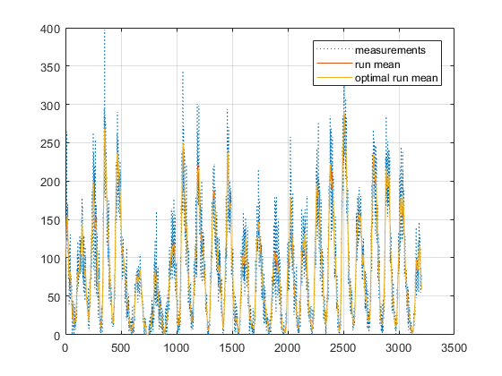
Published with MATLAB® R2017b

