Laboratory work 13
Joint assimilation of navigation data coming from different sources 1
Group 5: Andrei Chemikhin, Ruslan Agishev, Valery Nevzorov 1

Joint assimilation of navigation data coming from different sources

Group 5: Andrei Chemikhin, Ruslan Agishev, Valery Nevzorov
Skoltech, 2017
% trajectory generation
close all;
clear;
N = 500;
T = 2;
vx1=100;
vy1=100;
sigmaA = 0.3;
sigmab1 = 0.004;
sigmab2 = 0.001;
sigmaD = 50;
x1 = 1000;
y1 = 1000;
P0 = 10e10*eye(4);
t=1:N;
[x,y, b,D, bm,Dm] = trajgen_acc(sigmaA, N, T, x1,y1,...
vx1, vy1, sigmab1,sigmab2,sigmaD);
X0 = zeros(4,1);
x1m = Dm(1)*sin(bm(1));
x3m = Dm(3)*sin(bm(3));
y1m = Dm(1)*cos(bm(1));
y3m = Dm(3)*cos(bm(3));
X0(1) = x3m;
X0(2) = (x3m-x1m)/(2*T);
X0(3) = y3m;
X0(4) = (y3m-y1m)/(2*T);
[F,G] = state_space(T);
Q = G*G'*sigmaA^2;
R1 = diag([sigmaD^2 sigmab1^2]);
R2 = sigmab2^2;
[Xpr,Ppr,Xfl,Pfl,K] = extended_kalman_filter(X0,P0,F,Q,R1,R2,b,D);
xfl = Xfl(1,:);
yfl = Xfl(3,:);
figure
plot(x,y, xfl(1:2:(N-1)),yfl(1:2:(N-1)))
grid on
title('Cartesian coordinates')
xlabel('x')
ylabel('y')
legend('real', 'filtered')
[Dfl, bfl] = cartesian2polar(xfl,yfl);
figure
polarplot(b,D, bm(1:2:(N-1)),Dm(1:2:(N-1)), bfl,Dfl)
% final error
% generation of M=500 realiztions of trajectories
px = nan(1,N);
py = nan(1,N);
for i=1:(N-1)
px(i) = sqrt(Pfl{i}(1,1));
py(i) = sqrt(Pfl{i}(3,3));
end
M=500;
b = cell(1,M);
D = cell(1,M);
bm = cell(1,M);
Dm = cell(1,M);
for i=1:M
[~,~, b{i},D{i}, bm{i},Dm{i}] = trajgen_acc(sigmaA, N, T, x1,y1, vx1, vy1, sigmab1,sigmab2,sigmaD);
end
% Kalman-filtration of generated trajectories
bfl = cell(1,M);
Dfl = cell(1,M);
bpr = cell(1,M);
Dpr = cell(1,M);
Xfl_ = cell(1,M);
Xpr_ = cell(1,M);
xfl = cell(1,M);
yfl = cell(1,M);
xpr = cell(1,M);
ypr = cell(1,M);
for i=1:M
[Xpr_{i},~,Xfl_{i},~,~] = extended_kalman_filter(X0,P0,F,Q,R1,R2,bm{i},Dm{i});
xfl{i} = Xfl_{i}(1,:);
yfl{i} = Xfl_{i}(3,:);
[Dfl{i}, bfl{i}] = cartesian2polar(xfl{i},yfl{i});
xpr{i} = Xpr_{i}(1,:);
ypr{i} = Xpr_{i}(3,:);
[Dpr{i}, bpr{i}] = cartesian2polar(xpr{i},ypr{i});
end
fleb = final_error(bfl, b);
fleD = final_error(Dfl, D);
preb = final_error(bpr, b);
preD = final_error(Dpr, D);
figure
plot(t,fleb, t,preb, t,sigmab1*ones(1,N));
legend('final error betta', 'prediction error betta', 'sigma_b');
ylabel('Final error Betta')
xlabel('Time step')
title('Comparison of errors')
ylim([0,0.01])
grid on;
figure
plot(t,fleD, t,preD, t,sigmaD*ones(1,N));
legend('final error distance', 'predicted error distance', 'sigma_D');
ylabel('Final error Distance')
xlabel('Time step')
title('Comparison of errors')
ylim([0,100])
grid on;
Warning: Matrix is close to singular or
badly scaled. Results may be inaccurate.
RCOND = 1.875707e-16.
Warning: Matrix is close to singular or
badly scaled. Results may be inaccurate.
RCOND = 1.718407e-16.
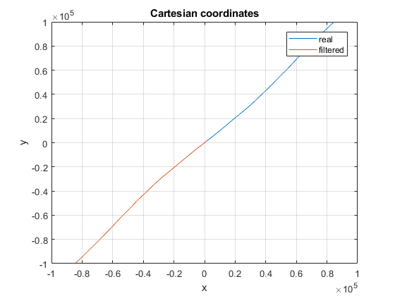
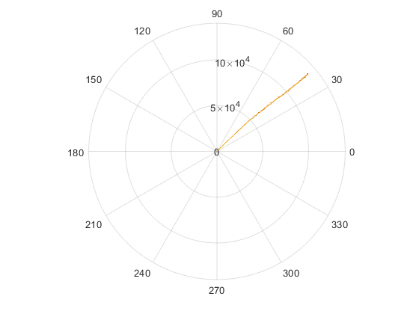
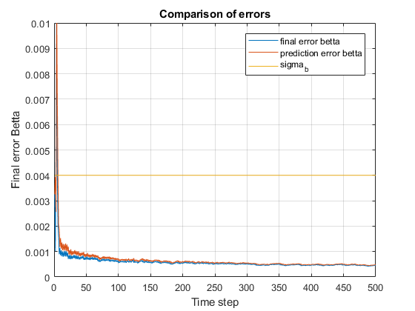
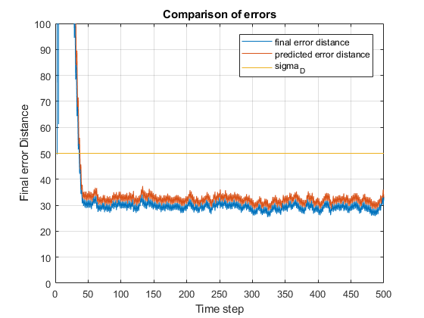
Published with MATLAB® R2017b

