Laboratory work 9 1
Development of tracking filter of a moving object 1
when measurements and motion model are in different coordinate systems 1
Group 5: Ruslan Agishev, Andrei Chemikhin, Valery Nevzorov 1
Skoltech, 2017 1
Processing with 1 trajectory 1
Processing over M=500 random trajectories 6

Laboratory work 9

Development of tracking filter of a moving object

when measurements and motion model are in different coordinate systems

Group 5: Ruslan Agishev, Andrei Chemikhin, Valery Nevzorov

Skoltech, 2017

Processing with 1 trajectory
close all;
clear;
[N,M,T,vx1,vy1, x1,y1, sigmaD,sigmab, t, D1,b1, X0,P0, F,H] = init();
[x, y, D,b, Dm,bm] = trajgen(x1,y1, N, T, vx1, vy1, D1,b1, sigmaD,sigmab);
figure(1)
polar(b,D);
title('Polar coordinates (b,D): real values')
figure(2)
polar(bm,Dm);
title('Polar coordinates (bm,Dm): measured values')
[xm,ym] = polar2cartesian(Dm,bm);
Z = [xm; ym];
R = covarMatrix(Dm,bm, sigmaD,sigmab);
[Xpr,Ppr,Xfl,Pfl,K] = kalman_filter(X0,P0,F,H,R,Z);
xfl = Xfl(1,:);
yfl = Xfl(3,:);
vxfl = Xfl(2,:);
vyfl = Xfl(4,:);
figure(3)
plot(xm,ym, x,y, xfl(2:end),yfl(2:end));
legend('measure','real', 'filter')
% xlim([7000,11000])
% ylim([7000,11000])
grid on
[Dfl,bfl] = cartesian2polar(xfl,yfl);
figure(4)
polar(bfl(2:end),Dfl(2:end))
title('Polar coordinates (bfl,Dfl): filtered values')
% conditional values of covariance matrix for each tim moment
cv = nan(size(R));
for i=1:length(cv)
cv(i) = cond(R{i});
end
figure(5)
plot(t,cv)
xlim([1,26])
xlabel('time')
ylabel('cond(R)')
title('Conditional number of covariance matrix')
grid on
% cond(R) is relativelly small and decreases over time. This means that
% measurements are accurate enough.
% analysis of filter gain K(1,1)
k = nan(1,N-1);
for i=1:(N-1)
k(i) = K{i+1}(1,1);
end
figure(6)
plot(t(2:N),k,'o');
xlabel('time')
ylabel('K(1,1)')
title('Kalman filter gain over time')
grid on
% For some moments of time K>1. This is related to the fact that matrix ð?‘…
% depends on polar measurements that have errors.
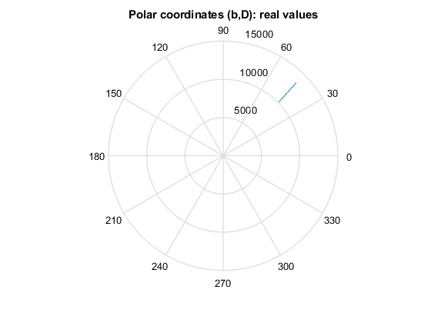
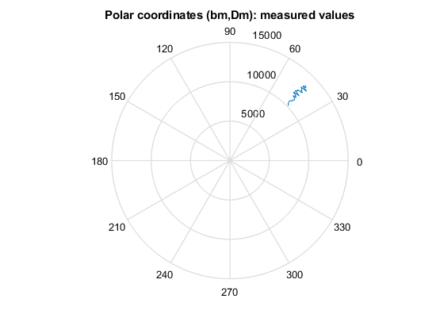
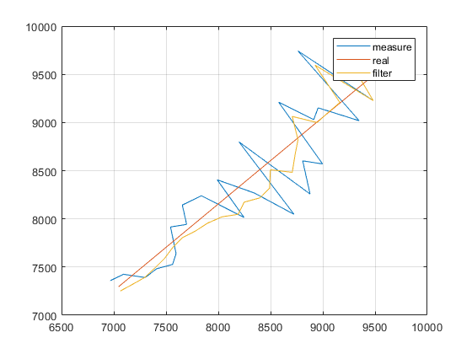
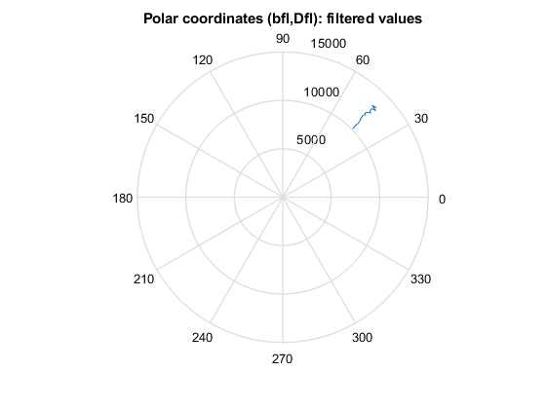
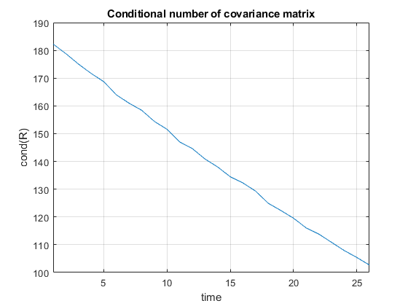
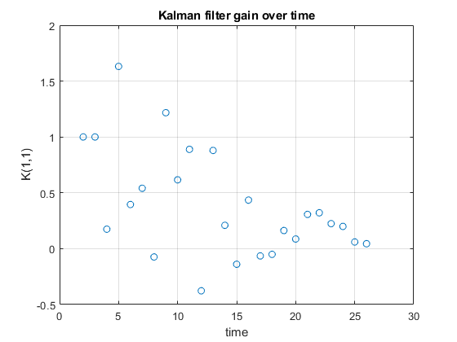

Processing over M=500 random trajectories
close all;
clear;
[N,M,T,vx1,vy1, x1,y1, sigmaD,sigmab, t, D1,b1, X0,P0, F,H] = init();
% generation of M=500 realiztions of trajectories
X = cell(1,M);
Y = cell(1,M);
Xm = cell(1,M);
Ym = cell(1,M);
D = cell(1,M);
b = cell(1,M);
Dm = cell(1,M);
bm = cell(1,M);
R = cell(1,M);
Z = cell(1,M);
for i=1:M
[X{i},Y{i}, D{i},b{i}, Dm{i},bm{i}] = trajgen(x1,y1, N, T, vx1, vy1, D1,b1, sigmaD,sigmab);
[Xm{i},Ym{i}] = polar2cartesian(Dm{i},bm{i});
R{i} = covarMatrix(Dm{i},bm{i}, sigmaD,sigmab);
Z{i} = [Xm{i}; Ym{i}];
end
% Kalman-filtration of generated trajectories
Xfl = cell(1,M);
Dfl = cell(1,M);
bfl = cell(1,M);
for i=1:M
[Xpr,Ppr,Xfl,Pfl,K] = kalman_filter(X0,P0,F,H,R{i},Z{i});
[Dfl{i}, bfl{i}] = cartesian2polar(Xfl(1,:),Xfl(3,:));
end
feD = final_error(Dfl, D);
figure(1)
plot(t(2:end),feD(2:end))
ylabel('fe(D)')
xlabel('Time step')
title('Final error of Distance')
grid on;
feb = final_error(bfl, b);
figure(2)
plot(t(2:end),feb(2:end))
ylabel('fe(b)')
xlabel('Time step')
title('Final error of Angle')
grid on;
[x, y, D,b, Dm,bm] = trajgen(x1,y1, N, T, vx1, vy1, D1,b1, sigmaD,sigmab);
figure(3)
plot(b,x)
grid on
xlabel('b')
ylabel('x')
xlim([0.76, 0.79])
title('x(b) = D*sin(b) - linear')
% x = D sin(b)
% x(b)-dependence is close to linear.
% It means that linearization errors don't accumulate over time quickly.
% new, closer initial conditions
x1 = 3500/sqrt(2);
y1 = 3500/sqrt(2);
% generation of M=500 realiztions of trajectories
X = cell(1,M);
Y = cell(1,M);
Xm = cell(1,M);
Ym = cell(1,M);
D = cell(1,M);
b = cell(1,M);
Dm = cell(1,M);
bm = cell(1,M);
R = cell(1,M);
Z = cell(1,M);
for i=1:M
[X{i},Y{i}, D{i},b{i}, Dm{i},bm{i}] = trajgen(x1,y1, N, T, vx1, vy1, D1,b1, sigmaD,sigmab);
[Xm{i},Ym{i}] = polar2cartesian(Dm{i},bm{i});
R{i} = covarMatrix(Dm{i},bm{i}, sigmaD,sigmab);
Z{i} = [Xm{i}; Ym{i}];
end
% Kalman-filtration of generated trajectories
Xfl = cell(1,M);
Dfl = cell(1,M);
bfl = cell(1,M);
for i=1:M
[Xpr,Ppr,Xfl,Pfl,K] = kalman_filter(X0,P0,F,H,R{i},Z{i});
[Dfl{i}, bfl{i}] = cartesian2polar(Xfl(1,:),Xfl(3,:));
end
feD2 = final_error(Dfl, D);
figure(4)
plot(t(2:end),feD(2:end), t(2:end),feD2(2:end))
legend('bad i.c.', 'closer i.c.')
ylabel('fe(D)')
xlabel('Time step')
title('Final error of Distance')
grid on;
feb2 = final_error(bfl, b);
figure(5)
plot(t(2:end),feb(2:end), t(2:end),feb2(2:end))
legend('bad i.c.', 'closer i.c.')
ylabel('fe(b)')
xlabel('Time step')
title('Final error of Angle')
grid on;
% Linear approximation leads to error accumulation in azimuth at the end of
% time period: x(b) = D sin(b) - non-linear function.
[x, y, D,b, Dm,bm] = trajgen(x1,y1, N, T, vx1, vy1, D1,b1, sigmaD,sigmab);
figure(6)
plot(b,x)
grid on
xlabel('b')
ylabel('x')
title('x(b) = D*sin(b) - linear')
% New dependence (with closer initial conditions) becomes not close to
% linear at the right part of time period.
% It means that linearization errors increase over time rapidly.
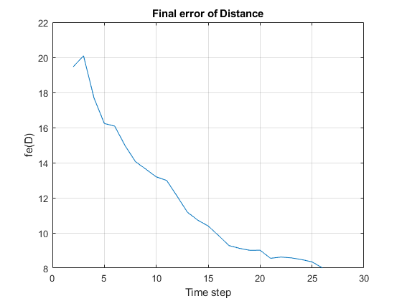
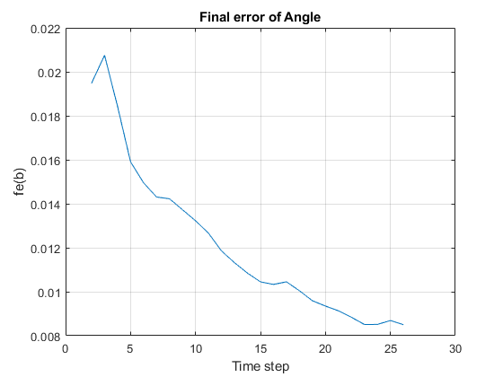
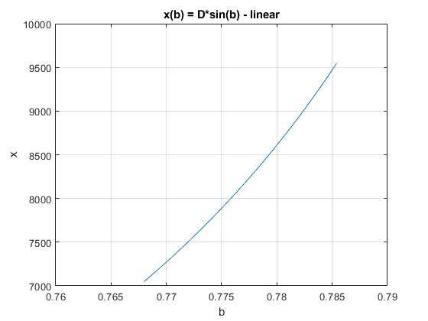
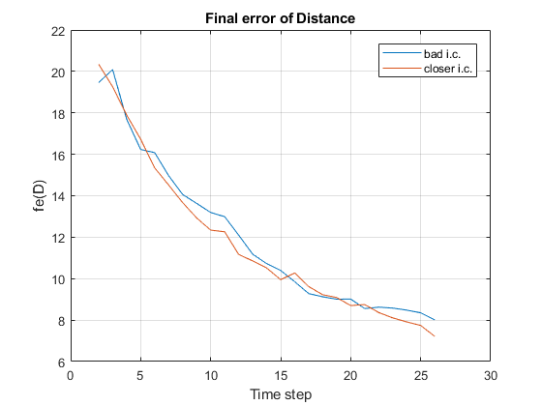
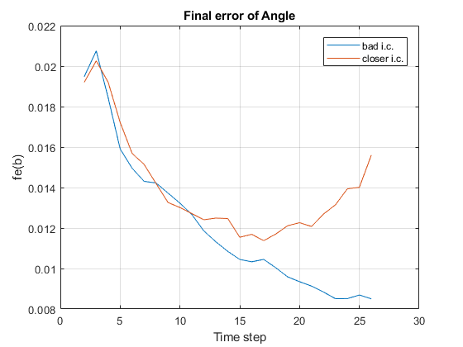
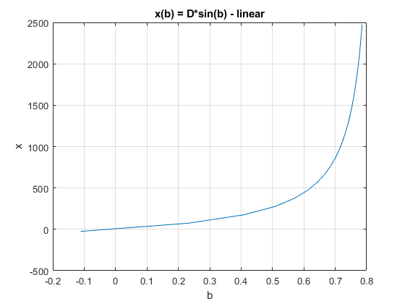
Published with MATLAB® R2017b

