1. SELECT * FROM Pet WHERE Nick = 'Partizan';



1. SELECT Nick, Breed FROM Pet ORDER BY Age;

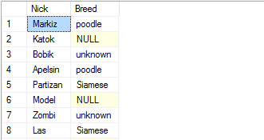

1. SELECT * FROM Pet WHERE Description IS NOT NULL AND Description != '';

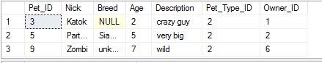

1. SELECT AVG(Age) FROM Pet WHERE Breed = 'poodle';
2. SELECT COUNT(DISTINCT Owner_ID) FROM Pet;

---Клички и возраст с возрастом в диапазане 6 и 15

SELECT Nick, Age FROM Pet WHERE Age BETWEEN 6 AND 15;

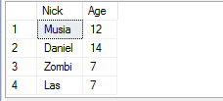

---Клички, начинающиеся с буквы 'М'

SELECT Nick FROM Pet WHERE Nick LIKE 'M%';

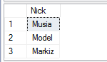

---Информация про питомцев с возрастом 5, 10 или 15

SELECT * FROM Pet WHERE Age IN (5, 10, 15);

