1. SELECT Pet.Nick, Pet_Type.Name FROM Pet, Pet_Type WHERE Pet.Pet_Type_ID = Pet_Type.Pet_Type_ID AND Pet.Nick = 'Partizan';



1. SELECT Pet.Nick, Pet.Breed, Pet.Age FROM Pet JOIN Pet_Type ON Pet.Pet_Type_ID = Pet_Type.Pet_Type_ID WHERE Pet_Type.Name = 'DOG';

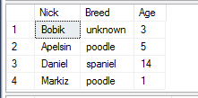

1. SELECT AVG(CONVERT(DECIMAL,Pet.Age)) FROM Pet, Pet_Type WHERE Pet.Pet_Type_ID = Pet_Type.Pet_Type_ID AND Pet_Type.Name = 'CAT';



1. SELECT Order1.Time_Order, Person.Last_Name FROM Order1

JOIN Employee ON Order1.Employee_ID = Employee.Employee_ID

JOIN Person ON Employee.Person_ID = Person.Person_ID

WHERE Order1.Is_Done = 0;

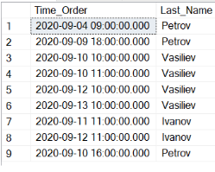

1. SELECT Person.First_Name, Person.Last_Name, Person.Phone FROM Pet, Pet_Type, Owner, Person

WHERE Pet.Pet_Type_ID = Pet_Type.Pet_Type_ID AND Pet.Owner_ID = Owner.Owner_ID AND Owner.Person_ID = Person.Person_ID

AND Pet_Type.Name = 'DOG';

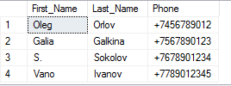

1. SELECT Pet_Type.Name, Pet.Nick FROM Pet_Type LEFT JOIN PET ON Pet.Pet_Type_ID = Pet_Type.Pet_Type_ID;

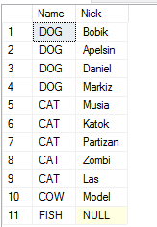

1. SELECT Pet.Nick, Pet.Breed FROM Pet

JOIN Pet_Type ON Pet.Pet_Type_ID = Pet_Type.Pet_Type_ID

JOIN Vaccine ON Vaccine.Pet_ID = Pet.Pet_ID

JOIN Vaccine_Type ON Vaccine.Vaccine_Type_ID = Vaccine_Type.Vaccine_Type_ID

WHERE Pet_Type.Name = 'CAT' AND Vaccine_Type.Vaccine_Type = 'Rabies';

