1. INSERT INTO Person SELECT MAX(Person_ID) + 1, 'Name', 'Surname', '+79999999999', 'Srednii pr VO, 1' FROM Person;

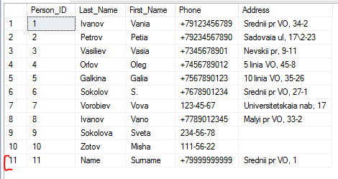

1. UPDATE Order1 SET Comments = '(s) ' + Order1.Comments WHERE Order1.Employee_ID IN (SELECT Employee_ID FROM Employee WHERE Spec = 'student');

--- При добавлении к NULL ничего не происходит, строка остаётся NULL

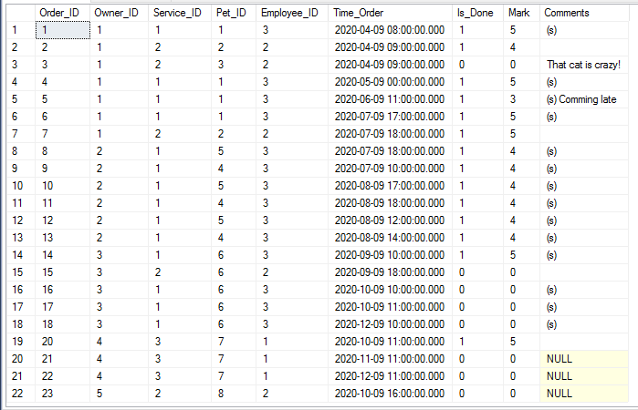

3.

CREATE TABLE Documents(

Document_ID INTEGER NOT NULL,

Type VARCHAR(20),

Serial_Number VARCHAR(20) NOT NULL,

Person_ID INTEGER NOT NULL,

CONSTRAINT Documents_PK PRIMARY KEY (Document_ID)

);

ALTER TABLE Documents ADD CONSTRAINT FK_Documents_Person

FOREIGN KEY (Person_ID)

REFERENCES Person (Person_ID)

ON DELETE CASCADE

;

INSERT INTO Documents SELECT 1, 'Паспорт', '1234 123456', MAX(Person_ID) FROM Person;

INSERT INTO Documents SELECT 2, 'ИНН', '111100001111', MAX(Person_ID) FROM Person;

--- DELETE FROM Person WHERE Person_ID = MAX(Person_ID);

