Rudenko Ruslan, SE-TE 2.01

**Task:**

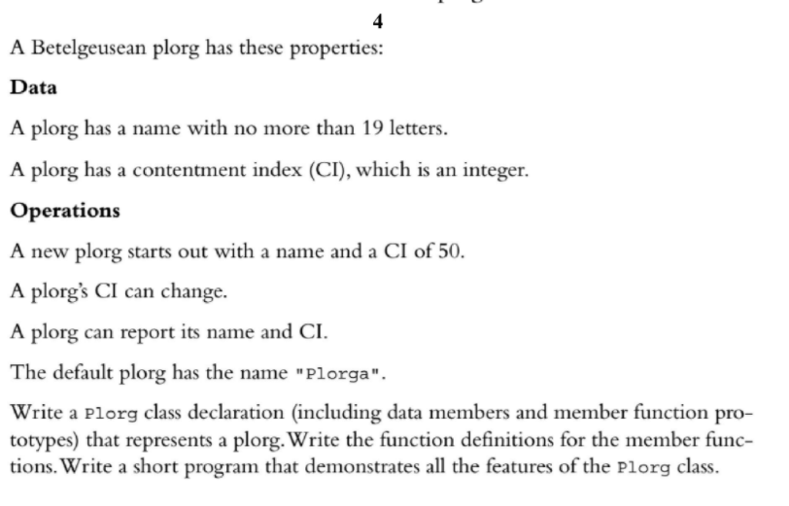

**Code:**

#include <iostream>

#include <cstring>

class Plorg {

static const int LEN = 19;

char name_[LEN];

int cI_;

public:

Plorg(const char* name = "Plorga", int cI = 50);

void setCi(int newCi);

void showPlorg();

};

Plorg::Plorg(const char* name, int cI) {

strncpy(this->name_, name, this->LEN);

this->cI_ = cI;

}

void Plorg::setCi(int newCi) {

this->cI_ = newCi;

}

void Plorg::showPlorg() {

using std::cout;

using std::endl;

cout << "Name: " << this->name_ << endl;

cout << "CI: " << this->cI_ << endl;

}

int main() {

using std::cout;

Plorg plorg;

plorg.showPlorg();

plorg.setCi(1);

plorg.showPlorg();

plorg = Plorg("MyPlorg");

plorg.showPlorg();

plorg = Plorg("Another Plorg", 20);

plorg.showPlorg();

return 0;

}

**Results**

