Rudenko Ruslan, SE-TE 2.01

Task:

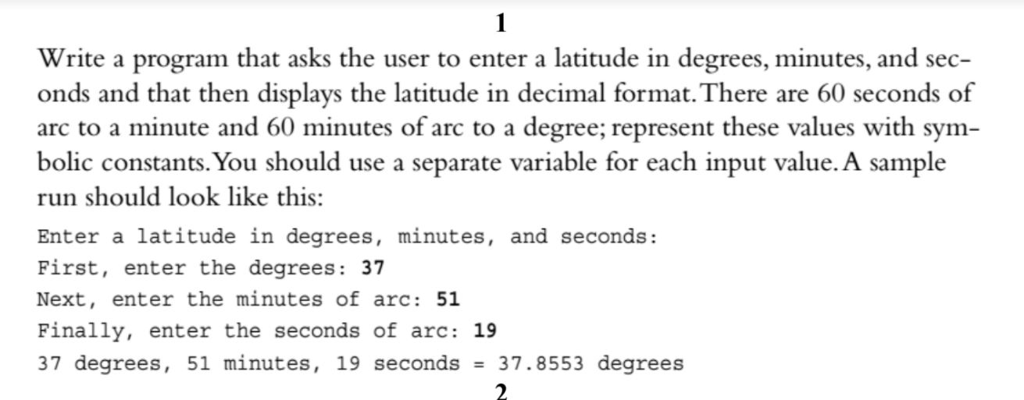

Code:

#include <iostream>

using namespace std;

int main()

{

int latitudeDegrees = 0, minutes = 0, seconds = 0;

std::cout << "Enter latitude degrees, minutes, seconds\n";

cin >> latitudeDegrees;

cin >> minutes;

cin >> seconds;

float degreesM = (minutes / static_cast<float>(60));

float degreesS = (seconds / static_cast<float>(3600));

cout << latitudeDegrees << endl;

cout << degreesM << endl;

cout << degreesS << endl;

cout << "\n\nResult: " << latitudeDegrees + degreesM + degreesS << "\n\n";

}

Results

