Rudenko Ruslan, SE-TE 2.01

Task:

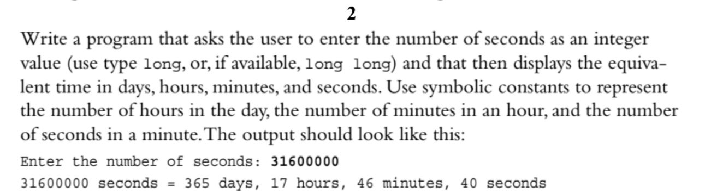

Code:

#include <iostream>

using namespace std;

void ConvertSectoDay(long long n)

{

int day = n / (24 \* 3600);

n = n % (24 \* 3600);

long long hour = n / 3600;

n %= 3600;

long long minutes = n / 60;

n %= 60;

long long seconds = n;

cout << day << " " << "days " << hour

<< " " << "hours " << minutes << " "

<< "minutes " << seconds << " "

<< "seconds " << endl;

}

int main()

{

long long n = 0;

cout << "Seconds: ";

cin >> n;

cout << "\n\n";

ConvertSectoDay(n);

return 0;

}

Results

