Rudenko Ruslan, SE-TE 2.01

Task:

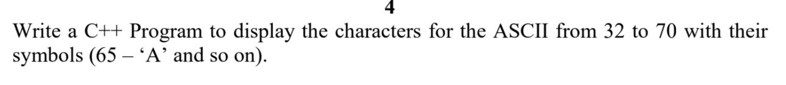

Code:

#include <iostream>

using namespace std;

int main()

{

cout << "For integer number from 32 till 70,\n";

cout << "their representation for\n";

cout << "characters is shown below\n\n";

cout << "integer character\n";

cout << "------- ---------\n";

for (int i = 32; i <= 70; i++)

cout << i << "\t\t" << (char)i << "\n";

return 0;

}

Results

