Rudenko Ruslan, SE-TE 2.01

Task:

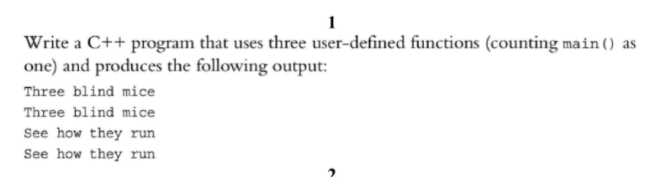

Code:

#include <iostream>

void output1();

void output2();

int main()

{

output1();

output1();

output2();

output2();

}

void output1()

{

std::cout << "Three blind mice\n";

}

void output2()

{

std::cout << "See how they run\n";

}

Results

