Rudenko Ruslan, SE-TE 2.01

Task:

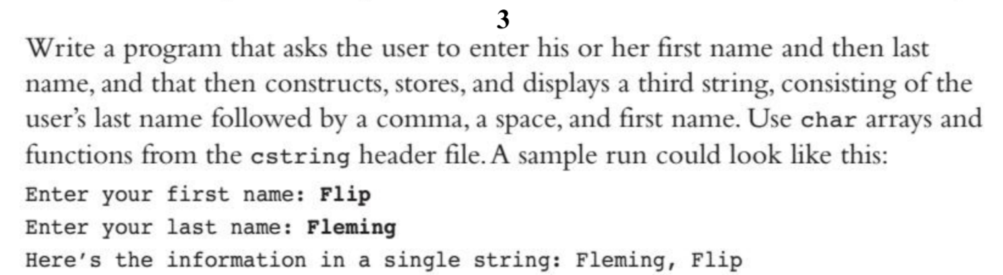

Code:

#include <iostream>

#include<cstring>

using namespace std;

int main()

{

const int MAX_ARRAY_SIZE = 20;

char first_name[MAX_ARRAY_SIZE];

char last_name[MAX_ARRAY_SIZE];

char full_name[MAX_ARRAY_SIZE];

std::cout << "What is your first name? ";

cin.getline(first_name, sizeof(first_name));

std::cout << "What is your last name? ";

cin.getline(last_name, sizeof(last_name));

strcpy(full_name, "");

strcat(full_name, first_name);

strcat(full_name, ", ");

strcat(full_name, last_name);

std::cout << "Full Name: " << full_name << endl;

}

Results

