Rudenko Ruslan, SE-TE 2.01

Task:

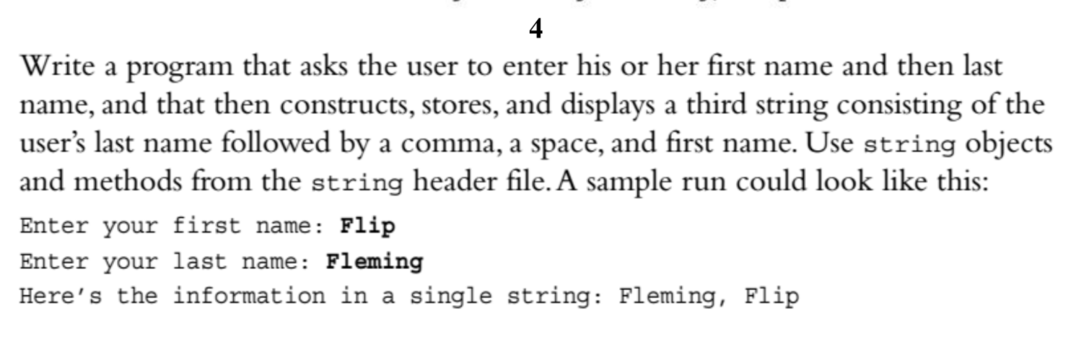

Code:

#include <iostream>

#include<string>

using namespace std;

int main()

{

string first_name;

string last_name;

string full_name;

std::cout << "What is your first name? ";

getline(cin, first_name);

std::cout << "What is your last name? ";

getline(cin, last_name);

full_name = last_name + ", " + first_name;

std::cout << "Full Name: " << full_name << endl;

}

Results

