Rudenko Ruslan, SE-TE 2.01

Task:

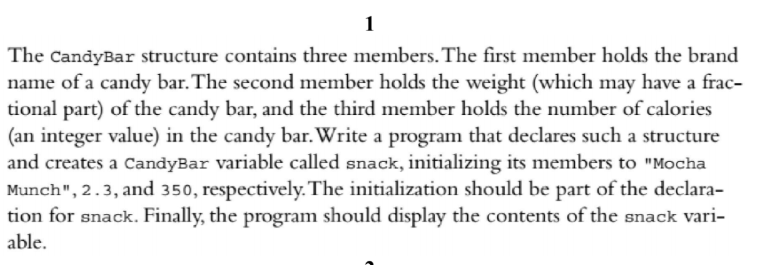

Code:

#include <iostream>

struct CandyBar {

char name[20];

double weight;

int calories;

};

using namespace ::std;

int main()

{

CandyBar snack = {

"Mocha Munch",

2.3,

350

};

cout << "Name: " << snack.name << endl;

cout << "Weight: " << snack.weight << endl;

cout << "Calories: " << snack.calories << endl;

}

Results

