Rudenko Ruslan, SE-TE 2.01

Task:

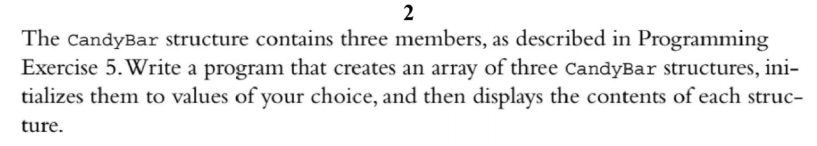

Code:

#include <iostream>

struct CandyBar {

char name[20];

double weight;

int calories;

};

using namespace ::std;

int main()

{

CandyBar snack[3] = {

{

"Mocha Munch",

2.3,

350

},

{

"Mocha Obey",

9.1,

550

},

{

"Oreo Trio",

4.7,

299

}

};

for (int i = 0; i < 3; i++)

{

cout << "Name: " << snack[i].name << endl;

cout << "Weight: " << snack[i].weight << endl;

cout << "Calories: " << snack[i].calories << endl;

cout << "___________________________________" << endl;

}

}

Results

