Rudenko Ruslan, SE-TE 2.01

Task:

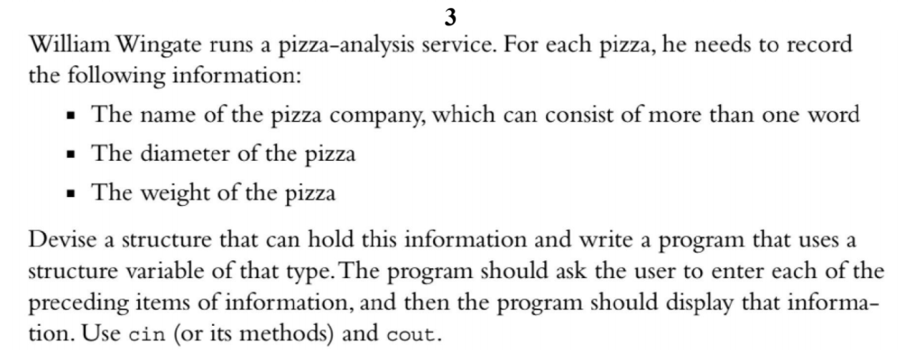

Code:

#include <iostream>

#include <string>

using namespace ::std;

struct Pizza {

string name;

double diameter;

double weight;

};

int main()

{

Pizza snack;

cout << "Enter name: ";

getline(cin, snack.name);

cout << "Enter diameter: ";

cin >> snack.diameter;

cout << "Enter weight: ";

cin >> snack.weight;

cout << "\n\n";

cout << "Name: " << snack.name << endl;

cout << "Weight: " << snack.diameter << endl;

cout << "Calories: " << snack.weight << endl;

}

Results

