Rudenko Ruslan, SE-TE 2.01

Task:

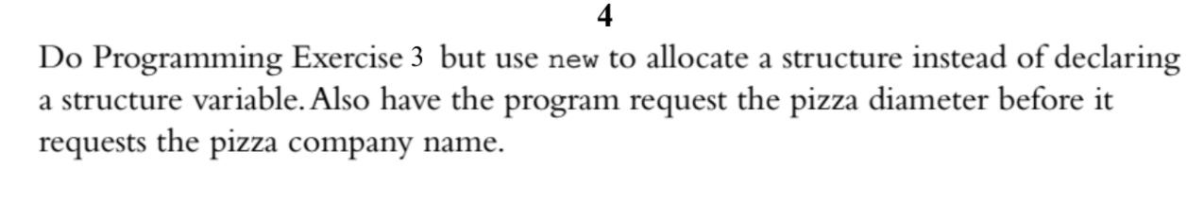

Code:

#include <iostream>

#include <string>

using namespace ::std;

struct Pizza {

string name;

double diameter;

double weight;

};

int main()

{

Pizza \* snack = new Pizza;

cout << "Enter diameter: ";

cin >> snack->diameter;

cin.ignore();

cout << "Enter name: ";

getline(cin, snack->name, '\n');

cout << "Enter weight: ";

cin >> snack->weight;

cout << "\n\n";

cout << "Name: " << snack->name << endl;

cout << "Diameter: " << snack->diameter << endl;

cout << "Calories: " << snack->weight << endl;

}

Results

