Rudenko Ruslan, SE-TE 2.01

Task:

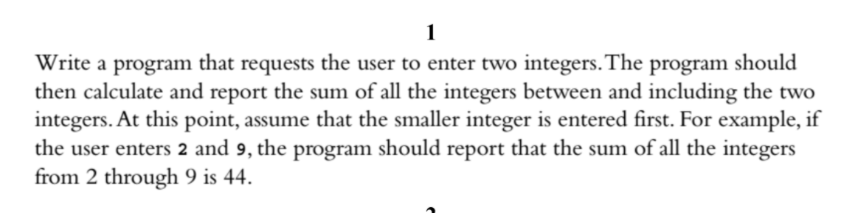

Code:

#include <iostream>

using namespace ::std;

int main()

{

int a = 0, b = 0;

start:

cout << "Enter an a: " << endl;

cin >> a;

cout << "Enter a b: " << endl;

cin >> b;

if (a > b) {

cout << "Please, enter a valid number..." << endl;

goto start;

}

else if (a == b) {

cout << a << endl;

}

else {

cout << "\n\nResult: " << ((b - a + 1) \* (a + b)) / 2 << endl << endl;

}

}

Results

