Rudenko Ruslan, SE-TE 2.01

Task:

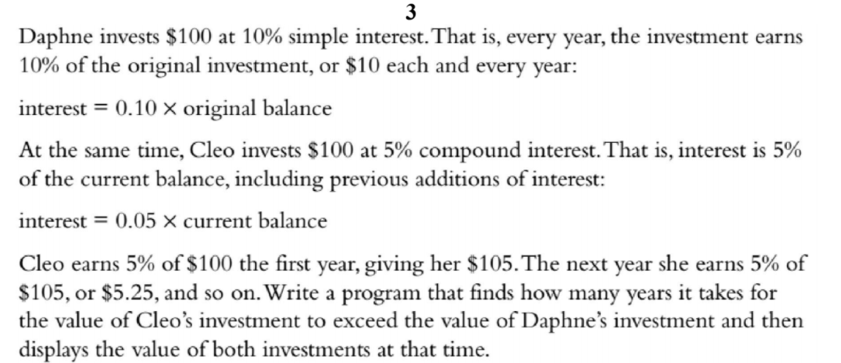

Code:

#include <iostream>

#include <array>

int main() {

using namespace std;

int initialSum = 100;

double daphensInvestment = initialSum;

double cleosInvestment = initialSum;

int Years;

double interest10 = 0.1;

double interest5 = 0.05;

for (Years = 0; cleosInvestment <= daphensInvestment; Years++) {

daphensInvestment = (initialSum \* interest10) + daphensInvestment;

cleosInvestment = (cleosInvestment \* interest5) + cleosInvestment;

}

cout << "Years taken for Cleos investment to exceed Daphnes: " << Years << endl;

cout << "Daphnes investment: " << daphensInvestment << endl;

cout << "Cleos investment: " << cleosInvestment << endl;

return 0;

}

Results

