Rudenko Ruslan, SE-TE 2.01

Task:

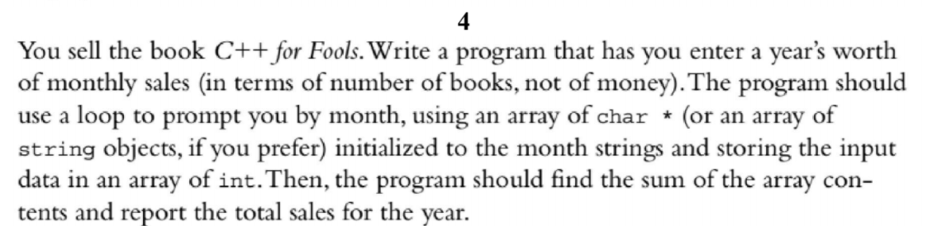

Code:

#include <iostream>

#include <string>

using namespace std;

int main() {

string months[]{

"January",

"February",

"March",

"April",

"May",

"June",

"July",

"August",

"September",

"October",

"November",

"December"

};

int sales[12]{ 0 };

for (int i = 0; i < 12; i++) {

cout << "Enter the number of books sold in " + months[i] + ": ";

cin >> sales[i];

}

int totalSales = 0;

for (int i = 0; i < 12; i++) {

totalSales += sales[i];

}

cout << "Total sales for the year: " << totalSales << endl;

return 0;

}

Results

