Rudenko Ruslan, SE-TE 2.01

Task:

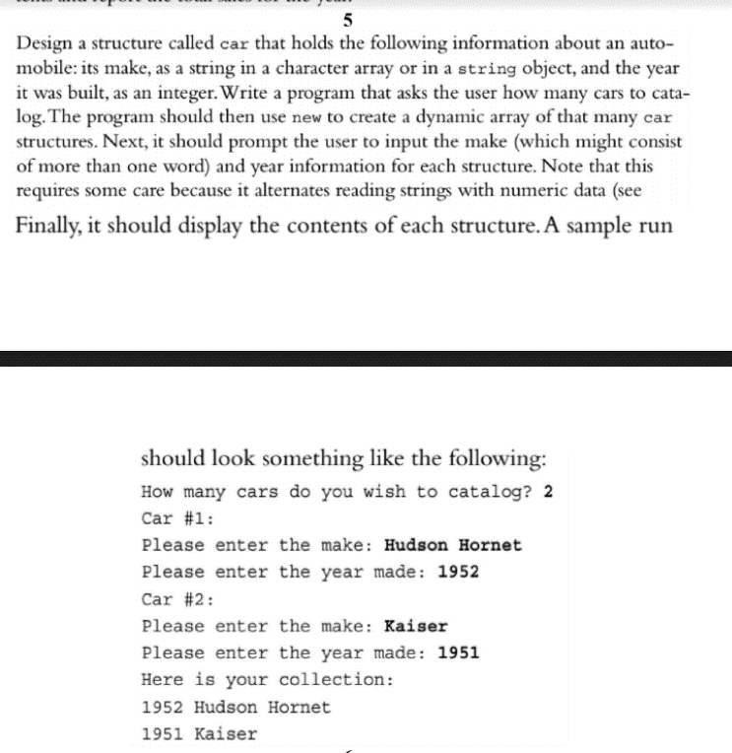

Code:

#include <iostream>

#include <string>

#include <cstring>

#include <cstdio>

using namespace std;

struct car

{

string make;

int year;

};

int main()

{

int num;

cout << "How many cars do you wish to catalog? ";

cin >> num;

car\* catalog = new car[num];

for (int i = 0; i < num; ++i) {

cout << "Please enter the make: " << endl;

cin.ignore(1, '\n');

getline(cin, catalog[i].make);

cout << "Please enter the year made: " << endl;

cin >> catalog[i].year;

}

cout << "Here's your collection: " << endl;

for (int i = 0; i < num; ++i) {

cout << catalog[i].year << " " << catalog[i].make << endl;

}

delete[] catalog;

return 0;

}

Results

