Rudenko Ruslan, SE-TE 2.01

Task:

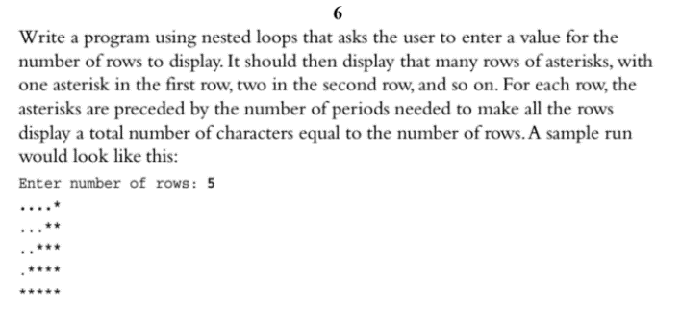

Code:

Results