Rudenko Ruslan, SE-TE 2.01

Task:

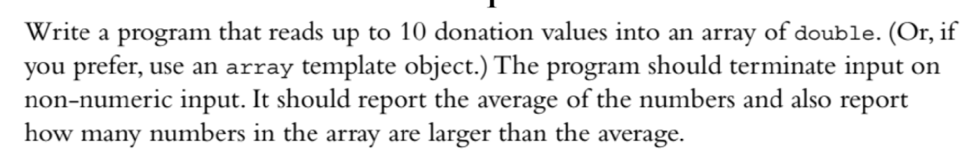

Code:

#include <iostream>

using namespace std;

int largerThanAverage(int count, double donations[], double average)

{

int largerThanAverage = 0;

for (int j = 0; j < count; j++) {

if (donations[j] > average) {

largerThanAverage++;

}

}

return largerThanAverage;

}

int main() {

const int MAX_DONATIONS = 10;

double donations[MAX_DONATIONS];

cout << "Enter your donations.\nYou can enter a maximum of " << MAX_DONATIONS << " donations. <Enter q to terminate>" << endl;

int count = 0;

cout << "Donation #1: ";

while (count < MAX_DONATIONS && cin >> donations[count]) {

if (++count < MAX_DONATIONS) {

cout << "Donation #" << count + 1 << ": ";

}

}

double totalDonations = 0;

for (int i = 0; i < count; i++) {

totalDonations += donations[i];

}

double average = totalDonations / count;

cout << "Average Donation: " << average << endl;

cout << "Number of donations larger than the average: " << largerThanAverage(count, donations, average) << endl;

return 0;

}

Results

