Rudenko Ruslan, SE-TE 2.01

Task:

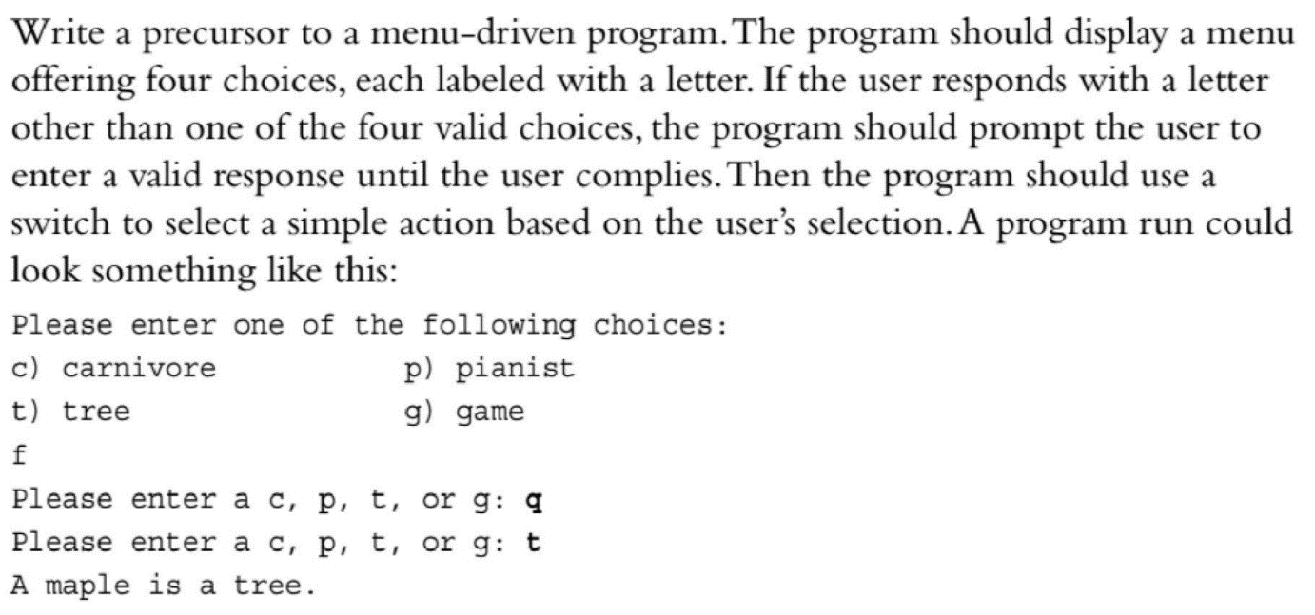

Code:

#include <iostream>

int main(int argc, char\*\* argv) {

using namespace std;

cout << "Please enter one of the following choices:\n";

cout << "c) carnivore p) pianist\n";

cout << "t) tree g) game\n";

char selection;

while (cin >> selection && selection != 'c' && selection != 'p' && selection != 't' && selection != 'g') {

cout << "Please enter a c, p, t, or g: ";

}

switch (selection) {

case 'c':

cout << "A tiger is a carnivore" << endl;

break;

case 'p':

cout << "John Legend is a pianist." << endl;

break;

case 't':

cout << "A maple is a tree." << endl;

break;

case 'g':

cout << "Monopoly is a game" << endl;

break;

}

return 0;

}

Results

