Rudenko Ruslan, SE-TE 2.01

Task:

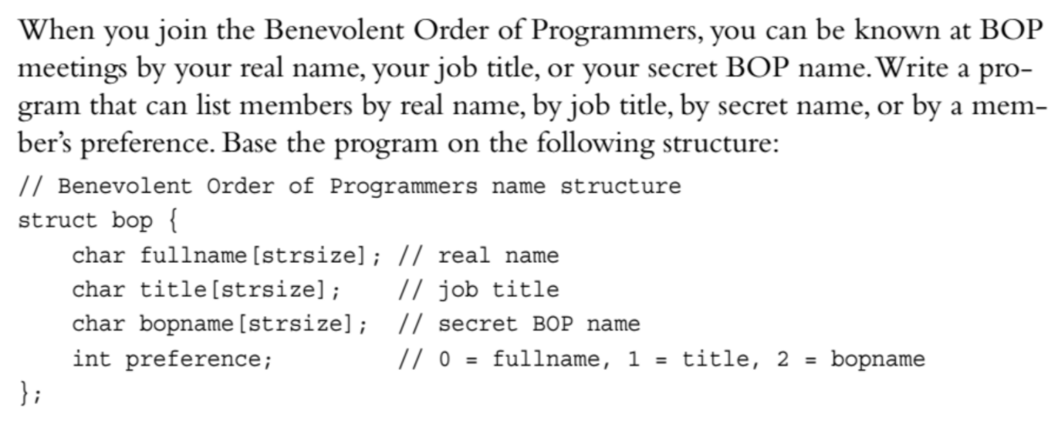

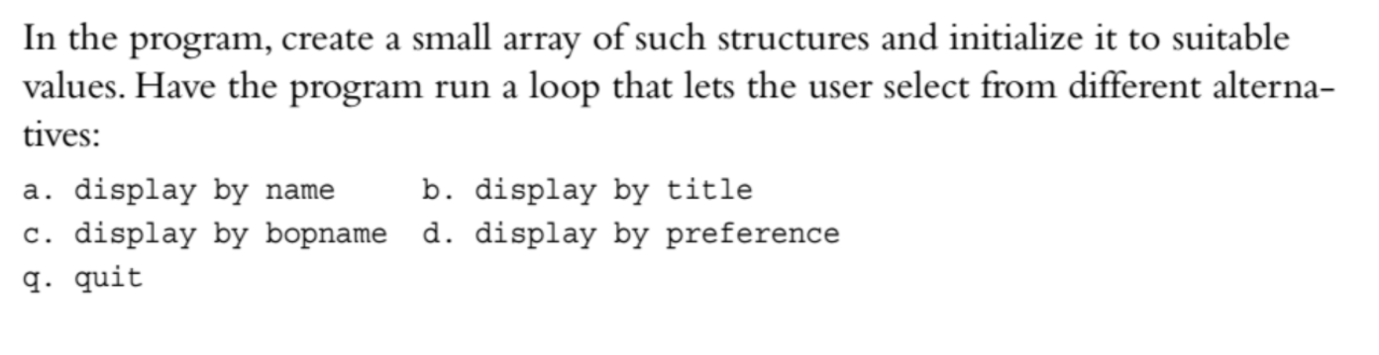

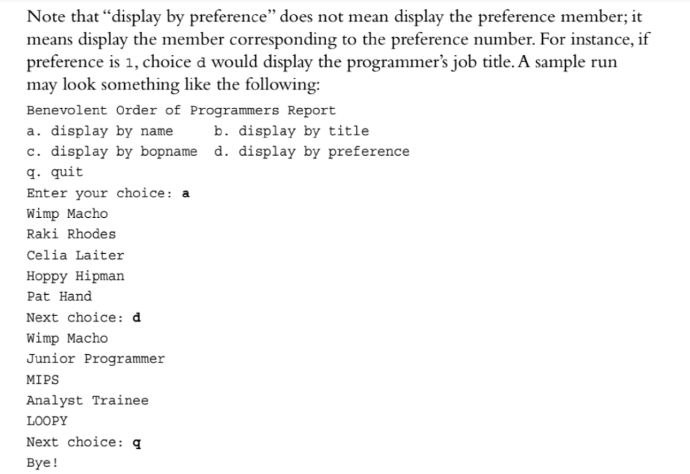

Code:

#include <iostream>

const int StrSize = 25;

struct bop

{

char fullName[StrSize];

char title[StrSize];

char bopName[StrSize];

int preference;

};

int main()

{

bop member[4] = { "Scott Doe", "Hacker", "Amarok", 2,

"Jessica Doe", "Gamer", "Laelith", 0,

"Sammy Farha", "Dog", "Samson", 1,

"Albert Einstein", "Genius", "Relativity", 2 };

std::cout << "Benevolent Order of Programmers Report\n";

std::cout << "a) display name b) display title\n";

std::cout << "c) display bopname d) display preference\n";

std::cout << "q) quit\n";

char choice;

do

{

std::cout << ">>> ";

std::cin >> choice;

choice = tolower(choice);

for (int i = 0; i < 4; i++)

{

switch (choice)

{

case 'a': std::cout << member[i].fullName << std::endl; break;

case 'b': std::cout << member[i].title << std::endl; break;

case 'c': std::cout << member[i].bopName << std::endl; break;

case 'd': switch (member[i].preference)

{

case 0: std::cout << member[i].fullName << std::endl; break;

case 1: std::cout << member[i].title << std::endl; break;

case 2: std::cout << member[i].bopName << std::endl; break;

};

}

}

} while (choice != 'q');

std::cout << "\nBye!\n";

return 0;

}

Results

