Rudenko Ruslan, SE-TE 2.01

Task:

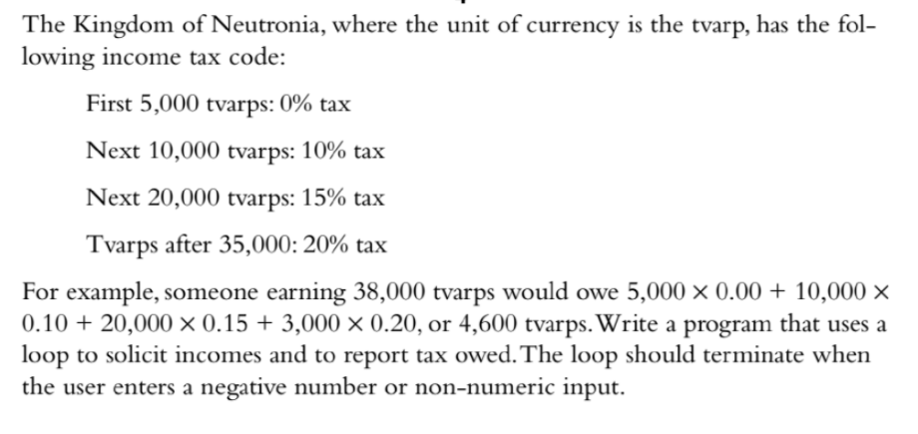

Code:

#include <iostream>

int main(int argc, char\*\* argv) {

using namespace std;

double income;

cout << "Enter your income: ";

while (cin >> income && income >= 0) {

double totalTax = 0;

double taxable = 0;

if (income > 35000) {

taxable = income - 35000;

income = 35000;

totalTax += (0.2 \* taxable);

}

if (income > 15000) {

taxable = income - 15000;

income = 15000;

totalTax += (0.15 \* taxable);

}

if (income > 5000) {

taxable = income - 5000;

income = 5000;

totalTax += (0.1 \* taxable);

}

cout << "Your total tax is " << totalTax << " tvarps" << endl;

cout << "Enter next income amount: ";

}

return 0;

}

Results

