Rudenko Ruslan, SE-TE 2.01

Task:

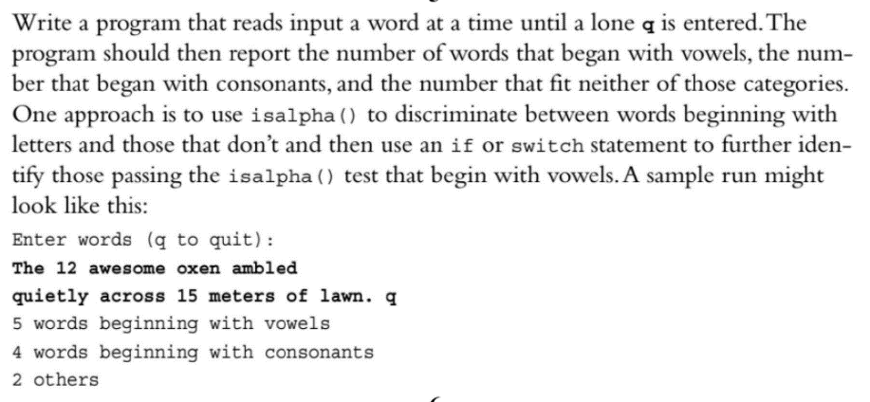

Code:

#include <iostream>

#include <cstring>

#include <cctype>

int main()

{

using namespace std;

string a;

cout << "Enter words (q to quit)\n";

int others = 0;

int vowels = 0;

int consonant = 0;

cin >> a;

while (a != "q")

{

cin >> a;

if (isalpha(a[0])) {

switch (a[0]) {

case 'a':

case 'i':

case 'u':

case 'e':

case 'o':

vowels++;

break;

default:

consonant++;

break;

}

}

else {

others++;

}

}

cout << vowels << " words beginning with vowels\n";

cout << consonant << " words beginning with consonant\n";

cout << others << " others";

return 0;

}

Results

