Rudenko Ruslan, SE-TE 2.01

Task:

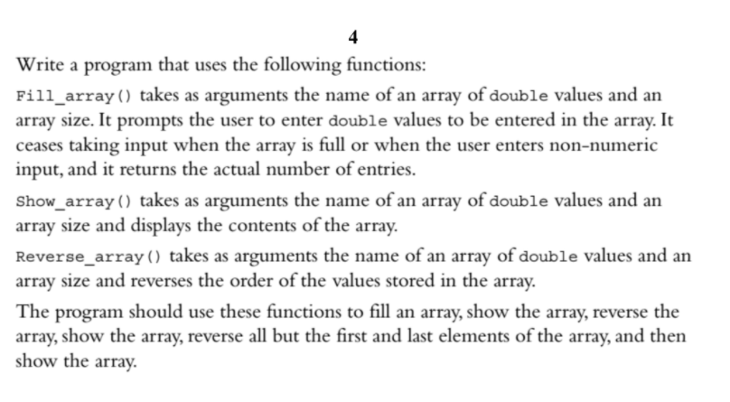

Code:

#include <iostream>

const int MAX_VALUES = 100;

int Fill_array(double*, int);

void Show_array(double*, int);

void Reverse_array(double*, int);

int main() {

double values[MAX_VALUES];

int numValues = Fill_array(values, MAX_VALUES);

Show_array(values, numValues);

Reverse_array(values, numValues);

Show_array(values, numValues);

if (numValues > 2) {

Reverse_array(&values[1], numValues - 2);

Show_array(values, numValues);

}

}

int Fill_array(double* values, int size) {

double value = 0;

int numValues = 0;

std::cout << "Enter a value (q to quit): ";

while (std::cin >> value && numValues < size) {

values[numValues++] = value;

std::cout << "Enter another value (q to quit): ";

}

return numValues;

}

void Show_array(double* values, int size) {

for (int i = 0; i < size; i++) {

std::cout << values[i];

if ((i + 1) < size) {

std::cout << ", ";

}

}

std::cout << std::endl;

}

void Reverse_array(double* values, int size) {

double temp = 0;

for (int i = 0; i < (size / 2); i++) {

temp = values[i];

values[i] = values[size - i - 1];

values[size - i - 1] = temp;

}

}

Results

