Rudenko Ruslan, SE-TE 2.01

Task:

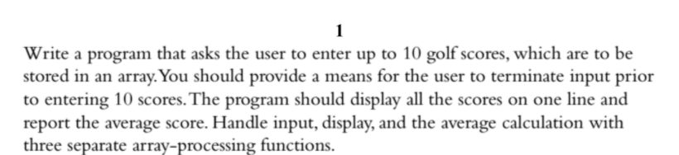

Code:

#include <iostream>

bool input(double arr[], int n);

void display(const double arr[], int n);

double avg(const double arr[], int n);

using namespace std;

const int NUM = 10;

int main()

{

double point;

double score[NUM];

if (!input(score, NUM))

return 0;

avg(score, NUM);

display(score, NUM);

return 0;

}

bool input(double arr[], int n)

{

int i = 0;

double score[NUM];

cout << "Please, enter 10 golf scores: " << endl;

while (cin && i < NUM)

{

cout << "\n#" << i + 1 << ": ";

cin >> arr[i];

if (arr[i] < 0)

return false;

++i;

}

if (i == NUM)

return true;

else

return false;

}

void display(const double arr[], int n)

{

cout << "The scores are: ";

for (int i = 0; i < NUM; i++)

cout << arr[i] << " ";

cout << "The average score is " << avg(arr, n) << "." << endl;

}

double avg(const double arr[], int n)

{

double total = 0;

for (int i = 0; i < n; i++)

total += arr[i];

return total / NUM;

}

Results

