Rudenko Ruslan, SE-TE 2.01

Task:

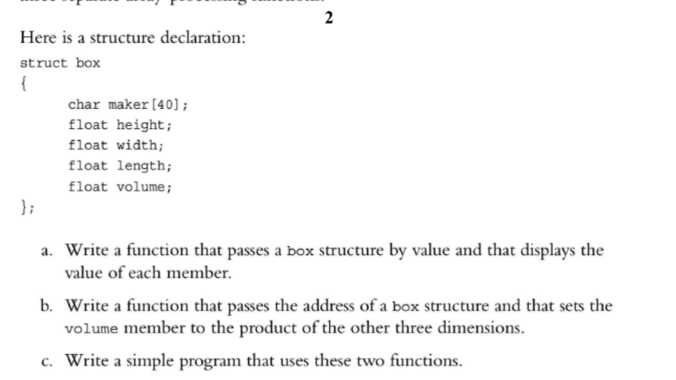

Code:

#include <iostream>

using namespace std;

struct Box

{

char maker[40];

float height;

float width;

float length;

float volume;

};

void showValue(Box);

void setVolume(Box\*);

int main()

{

Box box = { "Will Smith", 2.5, 3.3, 5.0, 0 };

showValue(box);

setVolume(&box);

cout << "\n\nWith volume calculated: \n";

showValue(box);

return 0;

}

void showValue(Box ourStruct)

{

cout << "Struct details\n";

cout << "Struct maker: " << ourStruct.maker << endl;

cout << "Struct height: " << ourStruct.height << endl;

cout << "Struct width: " << ourStruct.width << endl;

cout << "Struct length: " << ourStruct.length << endl;

cout << "Struct volume: " << ourStruct.volume << endl;

}

void setVolume(Box\* ourStruct)

{

ourStruct->volume = ourStruct->height \* ourStruct->width \* ourStruct->length;

}

Results

