Rudenko Ruslan, SE-TE 2.01

Task:

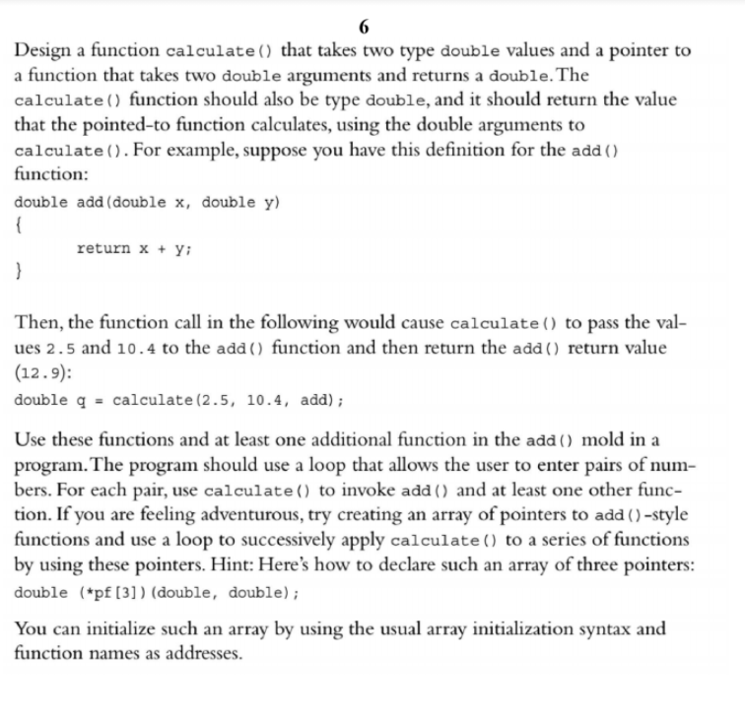

Code:

#include <iostream>

using namespace std;

const int NUM_CALCULATIONS = 3;

double add(double, double);

double product(double, double);

double difference(double, double);

double calculate(double, double, double (*pf)(double, double));

int main() {

double (*pf[NUM_CALCULATIONS])(double, double) = { add, product, difference };

const char* type[NUM_CALCULATIONS] = { "Add", "Product", "Difference" };

double x = 0, y = 0;

cout << "Enter x and y (q to quit): ";

while (cin >> x >> y) {

for (int i = 0; i < NUM_CALCULATIONS; i++) {

cout << type[i] << ": " << calculate(x, y, (*pf[i])) << endl;

}

cout << "Enter x and y (q to quit): ";

}

return 0;

}

double add(double x, double y) {

return x + y;

}

double product(double x, double y) {

return x * y;

}

double difference(double x, double y) {

return x - y;

}

double calculate(double x, double y, double (*pf)(double, double)) {

return (*pf)(x, y);

}

Results

**SEE BELOW!**

