Rudenko Ruslan, SE-TE 2.01

Task:

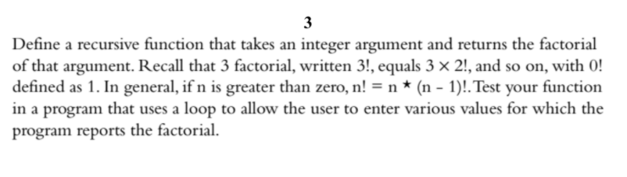

Code:

#include <iostream>

using namespace std;

int factorial(int n);

int main()

{

int number = 0;

cout << "Enter a number(0 to quit): ";

while (cin >> number && number!= 0)

{

cout << "Here is the factorial of the number: " << factorial(number) << ". \n"

"Enter next number(0 to quit): ";

}

return 0;

}

int factorial(int n)

{

if (n == 0)

return 1;

else

return n \* factorial(n - 1);

}

Results

