Rudenko Ruslan, SE-TE 2.01

Task:

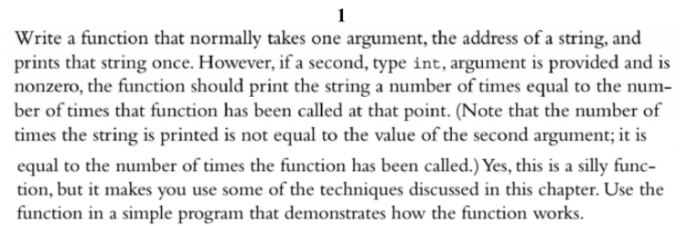

Code:

#include <iostream>

using namespace std;

void printString(const char\*, int n = 0);

int main() {

const char\* aString = "A String.";

printString(aString);

cout << endl;

printString(aString);

cout << endl;

printString(aString, 5);

cout << endl;

printString(aString, -1);

return 0;

}

void printString(const char\* aString, int n) {

static int numCalled = 0;

numCalled++;

if (n != 0) {

for (int i = 0; i < numCalled; i++) {

cout << aString << endl;

}

}

else {

cout << aString << endl;

}

}

Results

