Rudenko Ruslan, SE-TE 2.01

Task:

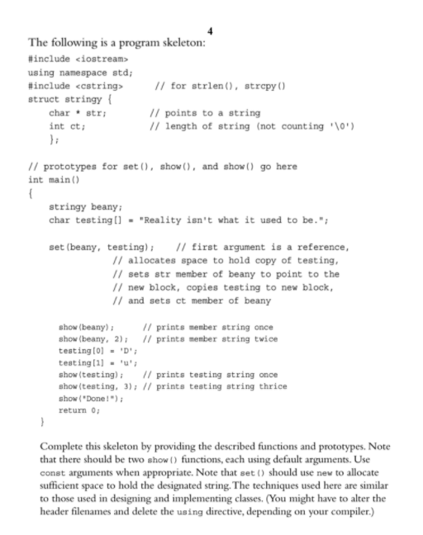

Code:

#include <iostream>

using namespace std;

#include <cstring>

struct stringy {

char\* str;

int ct;

};

void set(stringy&, const char\*);

void show(const char\*, int n = 1);

void show(const stringy&, int n = 1);

int main() {

stringy beany;

char testing[] = "Reality isn't what it used to be.";

set(beany, testing);

show(beany);

show(beany, 2);

testing[0] = 'D';

testing[1] = 'u';

show(testing);

show(testing, 3);

show("Done!");

return 0;

}

void set(stringy& aStringy, const char\* aString) {

int stringLength = sizeof(aString) / sizeof(char);

aStringy.str = new char[stringLength];

aStringy.ct = stringLength;

strcpy(aStringy.str, aString);

}

void show(const char\* aString, int n) {

for (int i = 0; i < n; i++) {

cout << aString << endl;

}

}

void show(const stringy& aStringy, int n) {

for (int i = 0; i < n; i++) {

cout << aStringy.str << endl;

}

}

Results

