Rudenko Ruslan, SE-TE 2.01

Task:

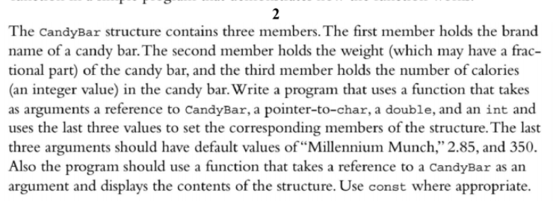

Code:

#include <iostream>

#pragma GCC diagnostic ignored "-Wwrite-strings"

using namespace std;

struct CandyBar {

char * brand;

double weight;

int calories;

};

void setValues(CandyBar&, const char* brand = "Millennium Munch", double weight = 2.85, int calories = 350);

void printCandyBar(const CandyBar&);

int main() {

CandyBar candyBar;

cout << "Set and show default values." << endl;

setValues(candyBar);

printCandyBar(candyBar);

cout << "Set and show non-default values." << endl;

setValues(candyBar, "A Brand", 1.5, 100);

printCandyBar(candyBar);

return 0;

}

void setValues(CandyBar& candyBar, const char* brand, double weight, int calories) {

candyBar.brand = const_cast<char*>(brand);

candyBar.weight = weight;

candyBar.calories = calories;

}

void printCandyBar(const CandyBar& candyBar) {

cout << "Brand: " << candyBar.brand << endl;

cout << "Weight: " << candyBar.weight << endl;

cout << "Calories: " << candyBar.calories << endl << endl;

}

Results

