Rudenko Ruslan, SE-TE 2.01

Task:

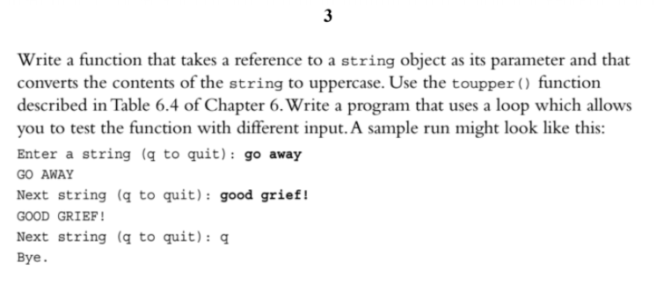

Code:

#include <iostream>

#include <string>

#include <cctype>

using namespace std;

void toUppercase(string&);

int main() {

string aString;

cout << "Enter a string (q to quit): ";

while (getline(cin, aString) && aString != "q") {

toUppercase(aString);

cout << aString << endl;

cout << "Next string (q to quit): ";

}

return 0;

}

void toUppercase(string& aString) {

for (unsigned i = 0; i < aString.size(); i++) {

aString[i] = toupper(aString[i]);

}

}

Results

