EVENT STUDIO
Design Patterns in a Java Swing Booking Application
Final Project Report
Six integrated patterns • Booking, event management, services and export
Team: Ruslankyzy Aldina • Abilkhaiyr Akmaral • Konys Ramazan

1. Introduction
Event Studio is a desktop application for managing events and seat bookings. Users can create and edit events, choose a ticket-pricing strategy, create or change bookings, configure optional service packages, review the event summary and export it to TXT, JSON or HTML. Booking data is stored in JSON so the application can restore it after restart.
The design combines six patterns: Strategy and Observer for pricing and booking updates; Builder and Decorator for event construction and optional services; Factory Method for report exporters; and Facade as the GUI-facing entry point to the application services.
Project area | Responsibility
Events and participants | Event details, capacity, ticket price, date, location and booking customers.
Bookings | Create, confirm and cancel bookings; enforce capacity; release seats on cancellation.
Pricing and services | Switch pricing policy and compose optional package services.
Persistence and reports | Restore event/booking state from JSON and export a selected event summary.

2. Architecture
The application has a single Java/Swing entry point. The UI calls EventFacade for coordinated operations. The facade delegates booking and persistence rules to BookingService/Repository, pricing to PriceCalculator, event construction to EventBuilder, service composition to ServicePackage, and report creation to ExporterFactory. BookingService publishes status changes to Observer listeners. JsonStorage saves the event and booking snapshot; service packages are currently kept in facade memory for the running session.
Layer | Main classes | Role
UI | BookingFrame, EventListPanel, PackagePanel, SummaryPanel | Collect input, display tables, notifications and summary.
Facade | EventFacade | One entry point for UI workflows; delegates to domain services.
Domain | Event, EventBuilder, Booking, Participant, ServicePackage, pricing classes | Models, validation, pricing and package composition.
Booking / storage | BookingService, BookingListener, Repository, JsonStorage | Booking lifecycle, event notifications and JSON persistence.
Export | ExporterFactory, ReportExporter, TXT/JSON/HTML exporters, Summary | Create a selected export product and write a summary snapshot.

Class diagram: all six patterns
The UML class diagram below names the principal roles and shows how each pattern participates in the application.

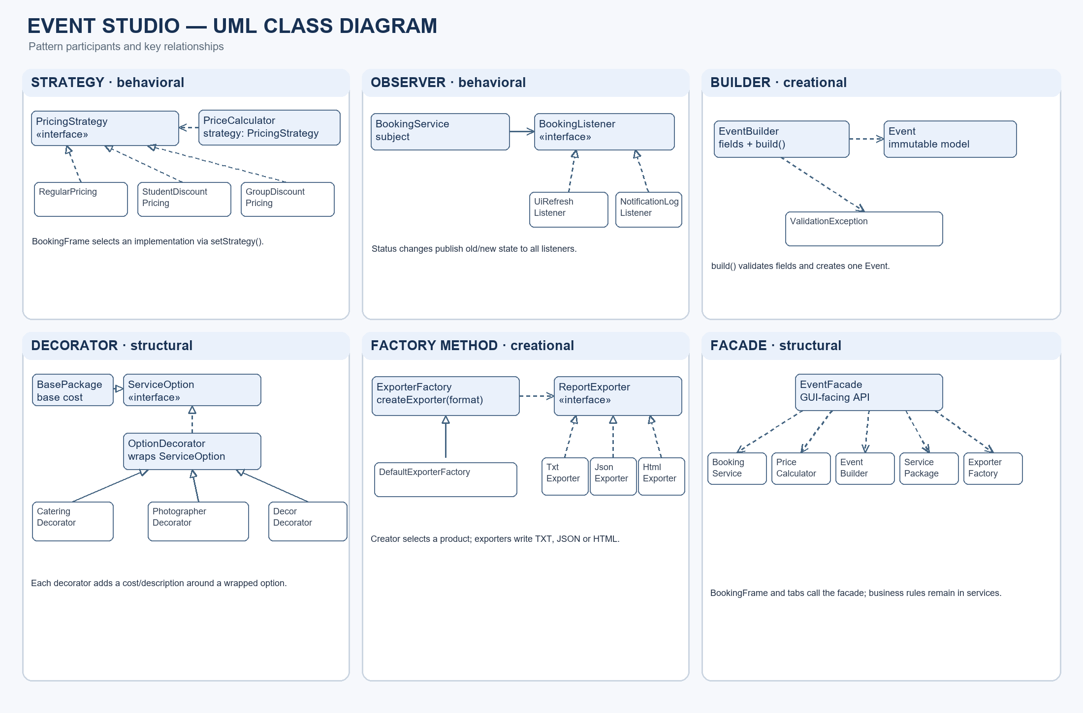

3. Pattern table and implementation
Pattern / type | Participants | How it works in Event Studio
Strategy  Behavioral | PricingStrategy; RegularPricing; StudentDiscountPricing; GroupDiscountPricing; PriceCalculator | BookingFrame maps the selection to a strategy and calls setStrategy(). The same booking can be priced under different rules without changing Booking.
Observer  Behavioral | BookingListener; BookingService; UiRefreshListener; NotificationLogListener | BookingService notifies subscribers after create/confirm/cancel. UI refresh and notification logging are separate reactions.
Builder  Creational | EventBuilder; Event; ValidationException | Form values are set step by step. build() validates the collected values and creates the immutable Event.
Decorator  Structural | ServiceOption; BasePackage; OptionDecorator; CateringDecorator; PhotographerDecorator; DecorDecorator | Optional services wrap a base package. Each wrapper adds cost and description, allowing combinations without a subclass for every combination.
Factory Method  Creational | ExporterFactory; DefaultExporterFactory; ReportExporter; TxtExporter; JsonExporter; HtmlExporter | The creator’s factory method selects an exporter product for the requested format; export logic uses the common ReportExporter interface.
Facade  Structural | EventFacade; BookingService; PriceCalculator; EventBuilder; ServicePackage; ExporterFactory | The GUI calls a small application-facing API. The facade coordinates existing services without copying their validation or storage rules.

Java excerpts

Strategy — replaceable price calculation
public interface PricingStrategy {
BigDecimal calculate(Booking booking);
}
calculator.setStrategy(new StudentDiscountPricing());
BigDecimal price = calculator.calculate(booking);

Observer — publish booking status changes
public interface BookingListener {
void onStatusChanged(Booking booking, BookingStatus oldStatus,
BookingStatus newStatus);
}
service.subscribe(new NotificationLogListener());
service.subscribe(new UiRefreshListener(this::refreshView));

Builder and Decorator — validated creation and package composition
Event event = new EventBuilder().name(name).date(date).location(location)
.capacity(capacity).price(ticketPrice).build();
ServiceOption option = new BasePackage(baseCost);
if (catering) option = new CateringDecorator(option);
if (photographer) option = new PhotographerDecorator(option);

Factory Method and Facade — select exporter behind one API
public abstract class ExporterFactory {
public abstract ReportExporter createExporter(String format);
public final void export(Summary summary, Path path, String format)
throws IOException { createExporter(format).export(summary, path); }
}
Summary summary = facade.getSummary(eventId);
exporterFactory.export(summary, path, "json");

4. Main user scenarios
# | Scenario | Expected result / documented outcome
1 | Create event, configure package, book seats, confirm, edit event and restart. | Builder validates and creates the event; package total updates; booking and event data restore from JSON. Documented scenario test: passed.
2 | Calculate the same five-seat booking at 1,000 KZT under three pricing strategies. | Regular 5,000; student 4,500; group 4,250 KZT. Strategy tests cover the three prices.
3 | Switch the selected strategy in the booking UI. | Price preview changes to the selected pricing rule. Automated strategy-selection test documented.
4 | Create, confirm and cancel a booking. | Listeners receive CREATED, CONFIRMED and CANCELLED transitions; the UI and log react.
5 | Create an event with a blank name. | ValidationException reports the invalid name; no event is persisted. Documented test: passed.
6 | Submit zero/negative capacity or ticket price. | Input is rejected and stored data remains unchanged. Documented validation test: passed.
7 | Export an event summary in TXT, JSON and HTML using student pricing. | Documented result: 4,500.00 KZT total, five seats occupied, three available; three formats are produced.
8 | Try to book one seat beyond event capacity, then cancel a booking. | Over-capacity booking is rejected; cancellation releases capacity; stored state and notifications remain consistent.

5. Sequence diagram: create and confirm a booking
This main flow shows the UI selecting a pricing strategy, creating a booking, persisting the change, notifying observers, and then delegating an optional summary export.

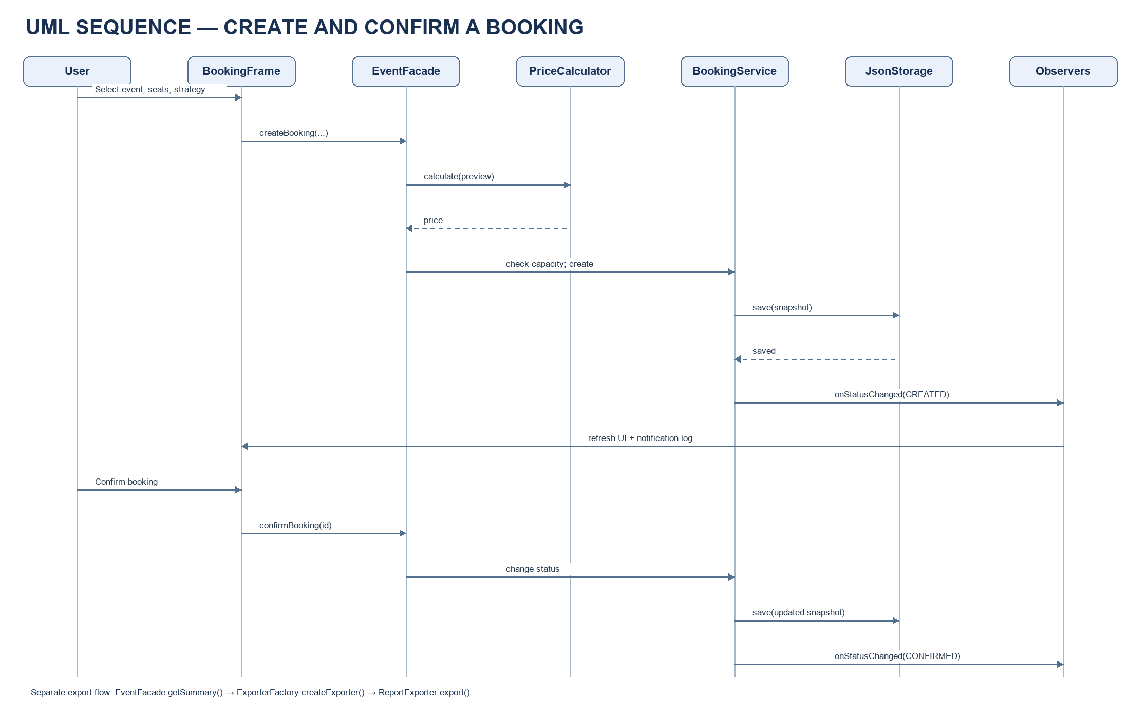

6. Interface screenshots
Screenshots were captured from the running Event Studio interface. The booking image is cropped to show the event, seat count and pricing-strategy controls without displaying customer names or booking identifiers.
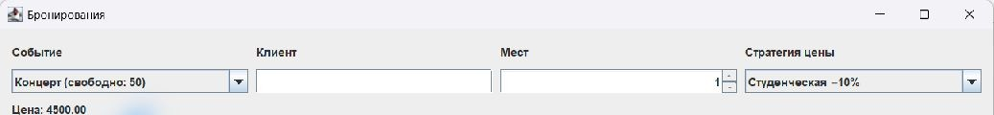
Figure 1. Booking controls with strategy selection and live price preview.
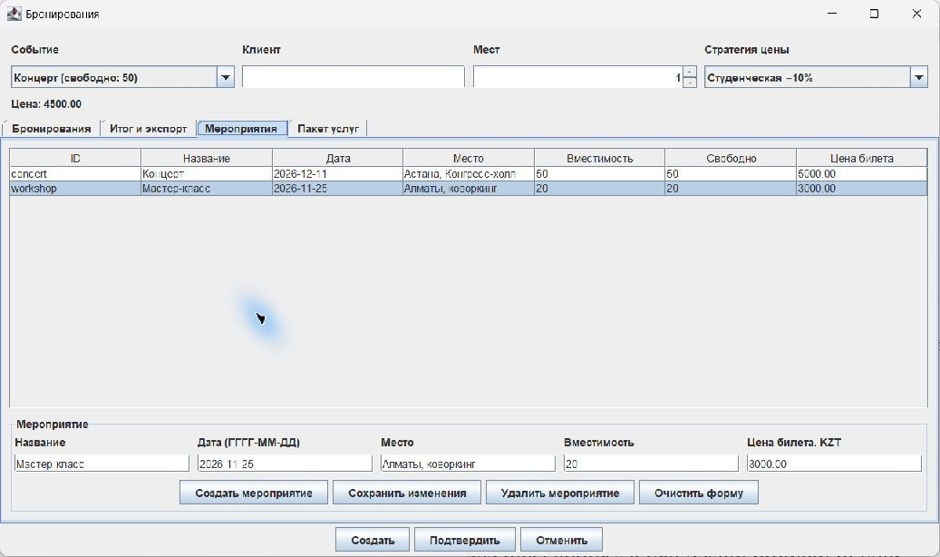
Figure 2. Event management tab showing event fields, capacity and ticket price.

7. Test results
The full integrated project was tested on 12 November 2026 with JDK 25 and Maven 3.9.11. The command mvn clean test completed successfully: 59 tests, 0 failures, 0 errors, and 0 skipped. This run includes booking, pricing, Builder, Decorator, Factory Method, Facade, export, validation, and Swing UI test classes.
Test area | Coverage / expected result | Recorded result
Strategy | Three prices for one booking; changing UI option changes active policy. | Passed in the documented booking test suite.
Observer | Creation/confirmation/cancellation notify the log and refresh listeners. | Passed in the documented booking test suite.
Persistence and capacity | Restart restores booking state; over-capacity action fails; cancellation frees seats. | Passed in the documented booking test suite.
Builder and validation | Valid Event construction; blank name, invalid date/capacity/price rejected. | Passed in the full 59-test run.
Decorator | Base package plus optional services adds costs independent of order. | Test class and expected total documented.
Factory Method / Facade / export | Exporter selection, formats, summary totals, errors and integration. | Passed in the full 59-test run (12 November 2026).

Evidence sources: the project test run on 12 November 2026 and repository files docs/report-booking.md, docs/report-gui-facade.md, and docs/report-model-builder.md on branch feature/booking-storage. The earlier 33-test result in the Facade report covers a previous integration stage.

8. Individual contributions
Team member | Contribution | Pattern ownership
Abilkhaiyr Akmaral | Event and participant models, input validation, event-management UI, service package configuration and associated tests. | Builder; Decorator
Ruslankyzy Aldina | Booking lifecycle and capacity rules, pricing selection, status notifications, repository/JSON persistence, booking UI and tests. | Strategy; Observer
Konys Ramazan | Summary view and export integration, exporter factory, common export interface, TXT/JSON/HTML products and facade integration/tests. | Factory Method; Facade

9. Conclusion
Event Studio applies six patterns to separate responsibilities across event creation, pricing, booking updates, optional services and report export. The UI uses the facade, pricing rules remain interchangeable, booking changes notify independent subscribers, and exporter formats share one product interface. JSON persistence supports restart recovery for events and bookings.

10. Future Work
- Persist configured service packages alongside events and bookings.
- Keep the integrated test suite current and expand manual checks of file chooser and overwrite dialogs in a graphical environment.
- Add CSV export and optionally retain the selected pricing policy per booking.
- Introduce stable participant identifiers instead of treating a name as the participant identity in summary views.
- Add screenshots for summary/export and service-package tabs using a clean demonstration dataset.

References and tools
Project repository: https://github.com/Ruslankyzy-Aldina/final_sdp (branch feature/booking-storage). This report is based on the public README and the three contributor reports listed in Test Results.

