RIGA TECHNICAL UNIVERSITY

FACULTY OF ELECTRONICS AND TELECOMMUNICATION

[](https://www.google.com/url?sa=i&rct=j&q=&esrc=s&source=images&cd=&cad=rja&uact=8&ved=2ahUKEwj9zKXEs6fgAhWF1iwKHceJAlAQjRx6BAgBEAU&url=https://lv.wikipedia.org/wiki/Att%C4%93ls:RTU_logo_2017.svg&psig=AOvVaw2YftzNrZHl3gHZWIEXy3Ih&ust=1549552627423236)

5G Wireless Technologies

Laboratory work 6

**Equalization**

Ruslans Babajans, 171REB152, REGV0

Riga, 2021

**Mērķis**

The current work studies dynamic systems development and implementation. The systems are based on a single adjustment parameter compensation.

**Mājas darbs**

Show analytically that an amplitude of the complex Gaussian process is Rayleigh distributed. A complex Gaussian process is a random signal whose real and imaginary parts are normally distributed.

Take the 2 orthogonal Gaussian processes as x and y, their probability density functions:

rho open parentheses x close parentheses equals fraction numerator 1 over denominator sigma square root of 2 straight pi end root end fraction e to the power of negative 1 half open parentheses fraction numerator x minus mu over denominator sigma end fraction close parentheses squared end exponent
rho open parentheses y close parentheses equals fraction numerator 1 over denominator sigma square root of 2 straight pi end root end fraction e to the power of negative 1 half open parentheses fraction numerator y minus mu over denominator sigma end fraction close parentheses squared end exponent

Vidējā vērtība ir paņemta *µ*=0. Divu procesu sadalījuma blīvuma funkcija:

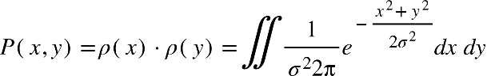

Parejot uz polāro koordināšu sistēmu:

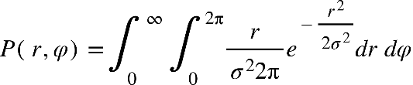

Nointegrējot pa fāzi iegūsim amplitūdas sadalījuma blīvuma funkciju:

P open parentheses r comma phi close parentheses equals integral subscript 0 superscript infinity integral subscript 0 superscript 2 straight pi end superscript fraction numerator r over denominator sigma squared 2 straight pi end fraction e to the power of negative fraction numerator r squared over denominator 2 sigma squared end fraction end exponent d r space d phi space equals
P open parentheses r comma phi close parentheses equals integral subscript 0 superscript infinity r over sigma squared e to the power of negative fraction numerator r squared over denominator 2 sigma squared end fraction end exponent d r space space
rho open parentheses r close parentheses equals r over sigma squared e to the power of negative fraction numerator r squared over denominator 2 sigma squared end fraction end exponent

Nointegrējot pa amplitūdu iegūsim fāzes sadalījuma blīvuma funkciju:

P open parentheses r comma phi close parentheses equals integral subscript 0 superscript 2 straight pi end superscript integral subscript 0 superscript infinity fraction numerator r over denominator sigma squared 2 straight pi end fraction e to the power of negative fraction numerator r squared over denominator 2 sigma squared end fraction end exponent space d r space d phi space left enclose table row cell u equals negative fraction numerator r squared over denominator 2 sigma squared end fraction end cell row cell d u equals negative r over sigma squared times d r end cell end table end enclose
P open parentheses r comma phi close parentheses equals integral subscript 0 superscript 2 straight pi end superscript integral subscript 0 superscript infinity minus fraction numerator 1 over denominator 2 straight pi end fraction times e to the power of u space d u space d phi
P open parentheses r comma phi close parentheses equals integral subscript 0 superscript 2 straight pi end superscript minus fraction numerator 1 over denominator 2 straight pi end fraction times e to the power of negative fraction numerator r squared over denominator 2 sigma squared end fraction end exponent left enclose table row infinity row 0 end table end enclose space space d phi
P open parentheses r comma phi close parentheses equals integral subscript 0 superscript 2 straight pi end superscript minus fraction numerator 1 over denominator 2 straight pi end fraction times open parentheses 0 minus 1 close parentheses space space d phi
P open parentheses r comma phi close parentheses equals integral subscript 0 superscript 2 straight pi end superscript fraction numerator 1 over denominator 2 straight pi end fraction space space d phi
rho open parentheses phi close parentheses equals fraction numerator 1 over denominator 2 straight pi end fraction

Optional Show analytically that an amplitude of the complex Gaussian process with mean values µx and µy of its real and imaginary parts, respectively, is Rice distributed. Hint: use the same approach as for the Rayleigh distribution. Exploit the following definition of the zeroth-order modified Bessel function of the first kind:

rho open parentheses x close parentheses equals fraction numerator 1 over denominator sigma square root of 2 straight pi end root end fraction e to the power of negative 1 half open parentheses fraction numerator x minus mu subscript x over denominator sigma end fraction close parentheses squared end exponent
rho open parentheses y close parentheses equals fraction numerator 1 over denominator sigma square root of 2 straight pi end root end fraction e to the power of negative 1 half open parentheses fraction numerator y minus mu subscript x over denominator sigma end fraction close parentheses squared end exponent

Vidējā vērtības ir mu subscript x un mu subscript y. Divu procesu sadalījuma blīvuma funkcija:

P open parentheses x comma y close parentheses equals rho open parentheses x close parentheses times rho open parentheses y close parentheses equals double integral fraction numerator 1 over denominator sigma squared 2 straight pi end fraction e to the power of negative fraction numerator open parentheses x minus mu subscript x close parentheses squared plus open parentheses y minus mu subscript y close parentheses squared over denominator 2 sigma squared end fraction end exponent d x space d y
P open parentheses x comma y close parentheses equals double integral fraction numerator 1 over denominator sigma squared 2 straight pi end fraction e to the power of negative fraction numerator x squared minus mu subscript x x plus mu subscript x squared plus y squared minus mu subscript y y plus mu subscript y squared over denominator 2 sigma squared end fraction end exponent d x space d y

Pārejot uz polārām koordinātēm:

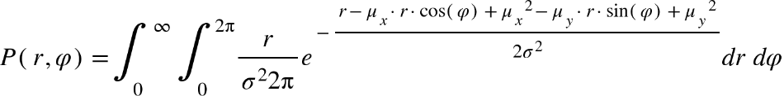

Nointegrējot pa fāzi iegūsim amplitūdas sadalījuma blīvuma funkciju:

P open parentheses r comma phi close parentheses equals integral subscript 0 superscript infinity integral subscript 0 superscript 2 straight pi end superscript fraction numerator r over denominator sigma squared 2 straight pi end fraction e to the power of negative fraction numerator r minus mu subscript x times r times cos open parentheses phi close parentheses plus mu subscript x squared minus mu subscript y times r times sin open parentheses phi close parentheses plus mu subscript y squared over denominator 2 sigma squared end fraction end exponent d r space d phi
P open parentheses r comma phi close parentheses equals integral subscript 0 superscript infinity r over sigma squared times fraction numerator 1 over denominator 2 straight pi end fraction times e to the power of fraction numerator negative open parentheses r plus mu subscript x squared plus mu subscript y squared close parentheses over denominator 2 sigma squared end fraction end exponent space d r integral subscript 0 superscript 2 straight pi end superscript e to the power of r over sigma squared times open parentheses mu subscript x times cos open parentheses phi close parentheses plus mu subscript y times sin open parentheses phi close parentheses close parentheses end exponent space d phi

Pārveidosim un vienkāršosim mu subscript x times cos open parentheses phi close parentheses plus mu subscript y times sin open parentheses phi close parentheses:

mu subscript x times cos open parentheses phi close parentheses plus mu subscript y times sin open parentheses phi close parentheses equals square root of mu subscript x squared plus mu subscript y squared end root times open parentheses fraction numerator mu subscript x over denominator square root of mu subscript x squared plus mu subscript y squared end root end fraction times cos open parentheses phi close parentheses plus fraction numerator mu subscript y over denominator square root of mu subscript x squared plus mu subscript y squared end root end fraction times sin open parentheses phi close parentheses close parentheses equals left enclose fraction numerator mu subscript x over denominator square root of mu subscript x squared plus mu subscript y squared end root end fraction equals sin open parentheses psi close parentheses end enclose
equals square root of mu subscript x squared plus mu subscript y squared end root times open parentheses sin open parentheses psi close parentheses times cos open parentheses phi close parentheses plus cos open parentheses psi close parentheses times sin open parentheses phi close parentheses close parentheses equals
equals square root of mu subscript x squared plus mu subscript y squared end root times sin open parentheses phi plus psi close parentheses equals
equals square root of mu subscript x squared plus mu subscript y squared end root times cos open parentheses phi plus psi minus straight pi over 2 close parentheses

Tad ievietojam to iepriekšējā izteiksmē:

P open parentheses r comma phi close parentheses equals integral subscript 0 superscript infinity r over sigma squared times fraction numerator 1 over denominator 2 straight pi end fraction times e to the power of fraction numerator negative open parentheses r plus mu subscript x squared plus mu subscript y squared close parentheses over denominator 2 sigma squared end fraction end exponent space d r integral subscript 0 superscript 2 straight pi end superscript e to the power of r over sigma squared times open parentheses square root of mu subscript x squared plus mu subscript y squared end root times cos open parentheses phi plus psi minus straight pi over 2 close parentheses close parentheses end exponent space d phi
P open parentheses r comma phi close parentheses equals integral subscript 0 superscript infinity r over sigma squared times fraction numerator 1 over denominator 2 straight pi end fraction times e to the power of fraction numerator negative open parentheses r plus mu subscript x squared plus mu subscript y squared close parentheses over denominator 2 sigma squared end fraction end exponent space d r integral subscript 0 superscript 2 straight pi end superscript e to the power of fraction numerator r times square root of mu subscript x squared plus mu subscript y squared end root over denominator sigma squared end fraction times cos open parentheses phi plus psi minus straight pi over 2 close parentheses end exponent space space d phi


Izteiksme 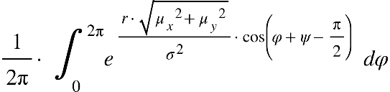 atbilst modificētai 0. kārtas Beseļa funkcijai 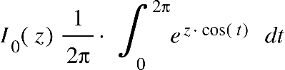 . Tad iegūstam:

P open parentheses r comma phi close parentheses equals integral subscript 0 superscript infinity r over sigma squared times e to the power of fraction numerator negative open parentheses r plus mu subscript x squared plus mu subscript y squared close parentheses over denominator 2 sigma squared end fraction end exponent times I subscript 0 open parentheses fraction numerator r times square root of mu subscript x squared plus mu subscript y squared end root over denominator sigma squared end fraction close parentheses d r


Un amplitūdas sadalījuma blīvuma funkcija ir:

rho open parentheses r close parentheses equals r over sigma squared times e to the power of fraction numerator negative open parentheses r plus mu subscript x squared plus mu subscript y squared close parentheses over denominator 2 sigma squared end fraction end exponent times I subscript 0 open parentheses fraction numerator r times square root of mu subscript x squared plus mu subscript y squared end root over denominator sigma squared end fraction close parentheses


**MATLAB simulācija**

Tika uztaisīts modelis

**Divu staru izplatīšanas kanāla modelis**

**Secinājumi**

The current work studied dynamical systems capable of compensating different signal distortions: DC offset, gain distortion, IQ phase impairment. The said dynamical systems were developed in MATLAB software. Different distortions were applied to the signal, and all were successfully compensated. This work was especially useful in understanding concepts and performance behind AGC. The extra task with IQ impairment was challenging, and there were 2 approaches taken in implementing dynamical compensation, both successful.