1. An FPGA and a quadrature modulator are used to create a QAM signal. The bandwidth of the QAM modulated signal is 25 MHz. In the FPGA, the signal is formed using four samples per symbol.

* Bandwidth Bw of the in-phase and quadrature channels in the baseband is 12.5 MHz for I and 12.5 MHz for Q components.
* Sampling frequency Fs is 25 MHz *2 = 50 MHz.
* Nyquist frequency Fn is equal to 25 MHz
* Symbol rate is Sr = Fn/Bw= 2 Mbaud
* Symbol length St = 1/Sr = 0.5 * 10^(-6) s

1. Calculate the minimal allowed QAM modulation (4-QAM, 8-QAM, 16-QAM, etc.) for each bandwidth! (bandwidths 500 MHz, 1 GHz, and 2 GHz)

* 4-QAM is 1.0000 2.0000 4.0000 Gbps
* 8-QAM is 1.5000 3.0000 6.0000 Gbps
* 16-QAM is 2.0000 4.0000 8.0000 Gbps

Bits= [2,3,4];

Bw = [500e6,1e9,2e9];

at=kron(Bits,Bw)

1. In the QAM communication system, in-phase and quadrature channels are PAM signals. I-channel uses a ternary system for symbol coding; therefore, its symbol alphabet is {−2; 0; 2}. Q-channel uses a binary system. Its symbols are from the set {−3; −1; 1; 3}. Draw the constellation of such QAM modulation. Name this modulation! 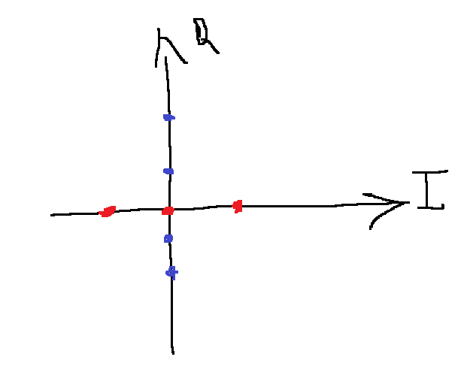

This is just to mark the points on the axis

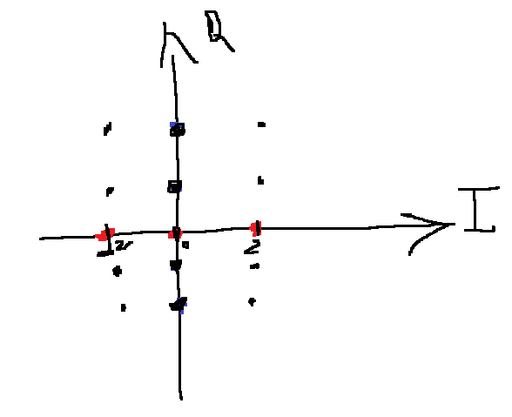

This is the constelation

**Rectangular modulaion**