**Task 5** Ruslans Babajans

Name all the distorting effects that are applied to the signals, whose constellations are as follows. Two different effects were used to obtain each of the constellations.

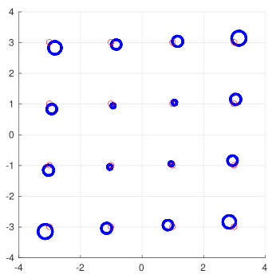

Case 1

Distortions: Carrier frequency offset and Tx, Rx IQ-imbalance phase. Carrier recovery and AGC are ON.

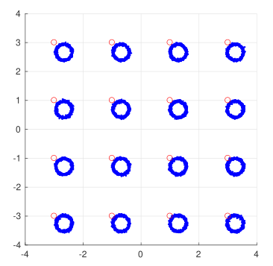

Case 2

Distortions: Carrier frequency offset and Tx, Rx IQ-imbalance DC-offset. Carrier recovery and AGC are ON.

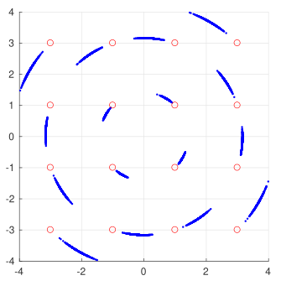

Case 3

Distortions: AM/PM nonlinearity and phase noise standard deviation.

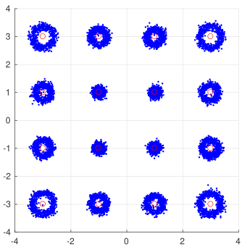

Case 4

Distortions: carrier offset, Rx IQ-imbalance I-component gain, low AWGN signal-to-noise ratio.

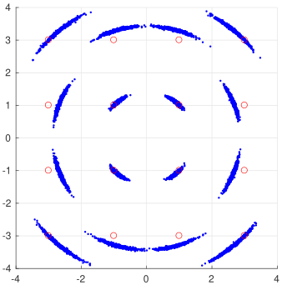

Case 5

Distortions: phase noise standard deviation and Rx IQ-imbalance Q-component gain

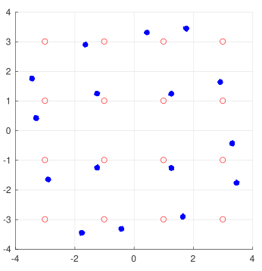

Case 6

Distortions: AM/AM and PM/AM nonlinearities

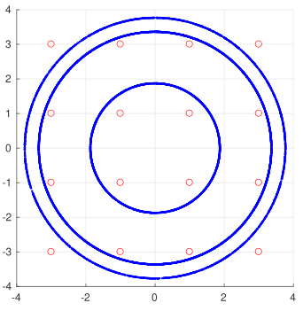

Case 7

Distortions: AM/AM nonlinearity and frequency offset (without carrier recovery).

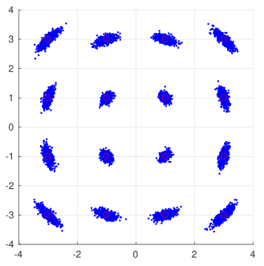

Case 8

Distortions: phase noise standard deviation and Rx IQ-imbalance I-component DC-offset.

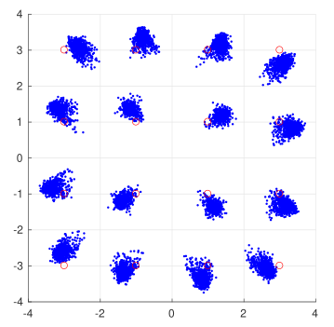

Case 9

The process that caused the following distortion is clipping with some added AM/AM and PM/AM nonlinearities.

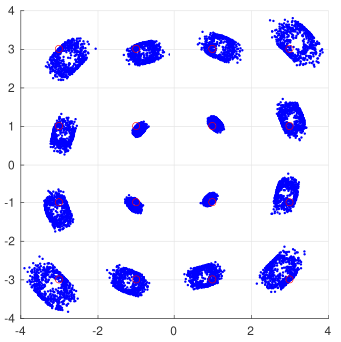

Case 10

The five applied phenomena for this distortion are: carrier offset, IQ-imbalance phase in radians, AM/AM nonlinearity, phase noise, IQ-imbalance I-component gain.