Smart Campus Room Availability Checker
  - Software Engineering Assignment 04
Rakhimov Ruslan
6 November 2026

Purpose and result
This report documents the reconstruction and evolution of a minimal room availability checker. A working one-room baseline was extended to four rooms, capacity and equipment filters, and refreshed room-specific results. The final solution separates data, domain rules, filtering, derived state and presentation. All 55 automated checks pass: 41 unit and regression checks plus 14 real-browser checks.
A minimal single-room baseline was reconstructed and preserved under baseline/ and in Git commit 164529c. It provides the starting point for the feature extension and before-and-after comparison.

Scope and fictional catalog
Room | Seats | Equipment | Status
A101 Quiet Study | 8 | Whiteboard | Open
B204 Collaboration Lab | 20 | Whiteboard, Projector | Open
C310 Computer Studio | 30 | Projector, Computers | Open
D105 Seminar Hall | 60 | Whiteboard, Projector, Microphone | Blocked

Availability contract
The fixed demo date is 6 November 2026 and current time is 09:00. Input uses same-day HH:mm times. Start must be at or after now, end must be later, and duration must be no more than 120 minutes. Bookings use half-open intervals [start, end), so touching endpoints do not overlap. Checks never create or modify bookings. There is no login, payment, database or live API.
Requirements AC1–AC6 cover time validity, duration, blocked rooms, overlap rules, immutable bookings and responsive feedback.

Codebase analysis and implementation plan
The assistant received the assignment PDF, repository map, acceptance criteria and constraints. Before feature edits, docs/plan-before-changes.md recorded the risks and priorities. Baseline tests passed 8/8, and the analysis was saved in commit 3cce6da before the feature implementation commit 21e8f70.

Maintainability risks in the reconstructed baseline
Reference | Risk | Planned improvement
baseline/app.js  preview and check | Duration validity and the 120-minute predicate are repeated. | One validateInterval function used by rendering and availability.
baseline/app.js  room and now | Fixture data and time policy share a file with DOM events. | Separate the immutable catalog and fixed clock.
baseline/app.js  check | Default argument silently selects the global room. | Require the room explicitly; derive selection from current matches.
baseline/app.js  DOM listeners | Presentation and domain behavior change in the same module. | Keep DOM work in app.js and test rules without a browser.

Priorities before editing
1. Preserve a working single-room version and its regression evidence.
2. Extract shared interval validation; add four-room fixtures and pure filtering.
3. Derive matching rooms, selection and availability together to prevent stale results.
4. Add a responsive interface with explicit errors and room-specific bookings.
5. Run unit and real-browser checks, review changes and commit each completed step.
6. Record measured quality changes, limitations, diagrams and AI-use evidence.

Suggestion rejected or modified
A framework scaffold, component library and global state store were considered by the assistant. The implementation instead uses browser-native ES modules and one small derived-state function. Four static rooms and one screen do not justify the added framework configuration.

Refactoring and final architecture
The baseline combined data, validation and DOM events in one production JavaScript module. The final application has five modules with direct dependencies and no service layer, state library or build pipeline. The preserved baseline remains runnable at /baseline/.
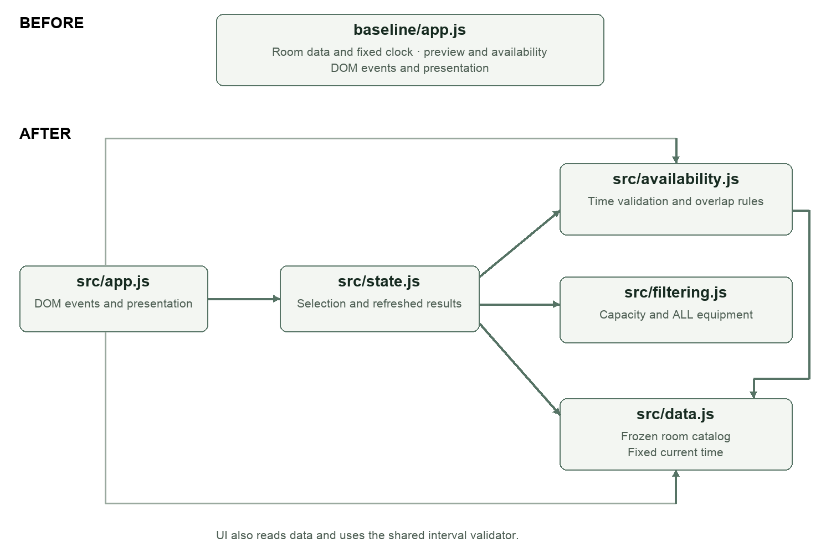

Design decisions
1. Use pure rules and one interval validator. src/availability.js validates time once for both UI feedback and availability checks. src/filtering.js requires capacity greater than or equal to attendees and uses every() to require all selected equipment. Small functions can be exercised without a browser.
2. Recompute derived state after every input and selection change. src/state.js obtains matches, retains the selected room only if it still matches, and calculates that room’s result. If filtering removes the selection, it selects the first match; if no rooms match, it clears the result.
3. Freeze fixture data at every nested level. Room records, equipment arrays, booking arrays and booking objects are frozen. Checks only read them. src/app.js handles events and rendering; CSS and semantic HTML define presentation. A small static server is development infrastructure rather than an extra product layer.

Behavior preserved
Original AC1–AC5 checks remain executable, and an eight-case parity loop compares baseline and final boolean availability on identical room/time inputs. Error wording improves, while valid-time, duration, blocked-room, overlap and immutability outcomes remain consistent. New room and filtering behavior is tested separately.

Automated testing and requirement coverage
Recorded environment: macOS arm64, Node.js v25.2.1, Playwright 1.62.1 and headless Chromium. The declared project requirement is Node.js 22 or later. Browser tests start their own local server on port 4174; application runtime code uses no external dependencies.
Command | Actual result | Evidence
npm run test:baseline | 8 / 8 passed | baseline-tests.txt
npm test | 41 / 41 passed | final-unit-tests.txt
npm run test:ui | 14 / 14 passed | browser-tests.txt
npm run test:all | 55 / 55 passed | final-all-tests.txt

The final 41-check unit suite includes the eight preserved baseline checks and 33 new domain/state checks. The 14 browser checks are additional. Counts represent executable test cases; individual assertions and the parity loop are not counted as separate tests.
Requirement | Executable evidence
AC1 Valid time | Strict HH:mm, past/current start, missing input, equal/reverse/overnight endpoints; browser input errors.
AC2 Duration | One minute and exactly 120 minutes accepted; 121 minutes rejected in domain and UI.
AC3 and F3 Blocked room | D105 is never available and displays maintenance in the browser.
AC4 Overlap | Touching either endpoint allowed; one-minute, contained, containing and identical overlap rejected.
AC5 Immutable data | Snapshot comparison after checks and filtering; frozen nested objects; submit does not mutate data.
AC6 Clear responsive feedback | Labels, live region, keyboard focus and no overflow at 390px; desktop/mobile captures.
F1 and F2 Filters | Exact/insufficient capacity, ALL-equipment semantics, combined filters and invalid counts.
F4 and F5 Results | Empty state, clearing old result, own-room bookings, filter-driven selection and time changes.

A defect discovered by integration testing
The first browser run passed 10/14 cases. A button with id="reset" shadowed the native form.reset method. Renaming it to reset-requirements fixed the product defect. The test error collector was also cleared before each case, removing three misleading follow-on failures. Both the failed log and corrected 14/14 log are retained. This is concrete evidence that browser tests affected the implementation.

Quality evaluation with measured evidence
Measures are taken from executable logs and direct source inspection. The larger final suite includes new requirements; it should not be interpreted as the same 55 tests being run against the one-room baseline.
Measure | Baseline | Final | How measured
Automated tests passed / total | 8 / 8 | 55 / 55 | Raw Node and Chromium outputs; final includes baseline tests.
Duration validation locations | 2 | 1 | preview and check repeat the baseline predicate; final uses validateInterval.
Duplicated logic locations removed | Not applicable | 1 | Direct inspection of the duration predicates in preview, check and validateInterval.
Production JS modules | 1 | 5 | baseline/app.js versus five files in src/; server and tests excluded.
Responsibilities | Data, rules and DOM combined | Data; rules; filters; state; UI | Module imports and exported functions inspected.
Real-browser coverage | Not recorded | 14 passing cases | tests/ui.test.mjs; 1440px desktop and 390px mobile viewports.

What the change means
The five modules separate independent responsibilities with direct imports. Availability and filtering are pure, while state derivation provides one place to refresh the chosen room. The duplicate-duration count is deliberately narrow and reproducible: two baseline predicates become one final predicate. evidence/quality-metrics.json records the method and observed values.

Remaining limitations
The product handles one fixed fictional day and does not support recurring or overnight bookings. Checks do not reserve a room or persist changes. Multi-user booking conflicts and authorization are outside scope. The static server is for local coursework, not production hosting.
Automated browser coverage uses Chromium only. A 390px overflow assertion and visual captures support the responsive claim for the tested sizes, not every device. Labels, keyboard behavior and live-region attributes are checked, but no human screen-reader audit has been performed.

Next improvements
First obtain human accessibility feedback and test another browser engine. If requirements expand to dates or actual bookings, define date/time policy, authorization and concurrency rules before adding storage.

Demonstration of the final interface
The final screen shows the requirements panel, filtered room catalog, selected room bookings and a live availability result. The image below shows the application captured in Chromium at a 1440px viewport.
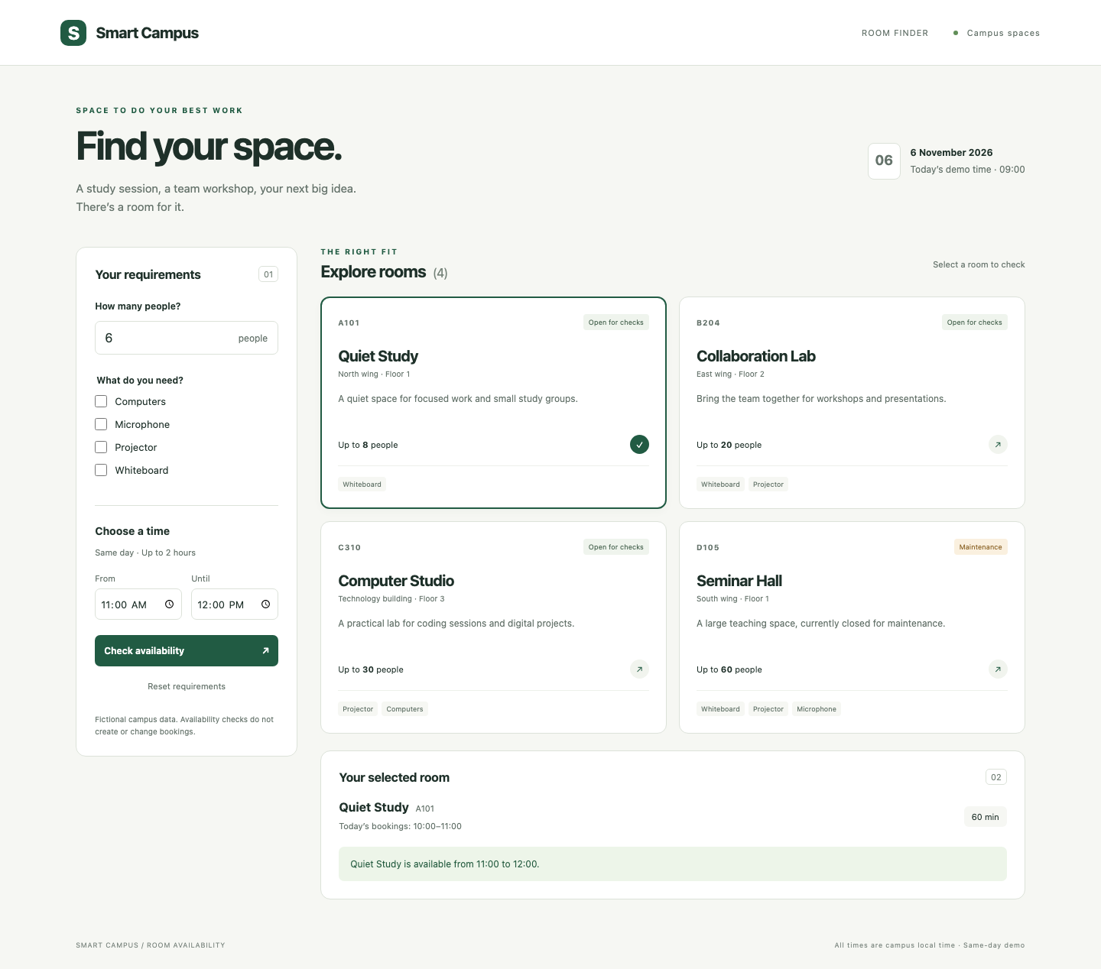

Repeatable scenarios
Successful filtering: choose Projector and Whiteboard to retain B204 and D105. Unsuccessful filtering: choose Computers and Microphone to show the empty state. Room switching: at 11:00–12:00, A101 is available and C310 is booked. D105 always displays maintenance.
Additional captures in evidence/ show filtered.png, empty.png, switched.png, blocked.png and mobile.png. Browser tests verify these interactions, and mobile.png records the single-column layout with C310 selected.

AI use record and verification appendix

Tool and context
AI assistant: OpenAI Codex desktop, GPT-6 family. Date: 6 November 2026. Development and verification tools: Node.js test runner, Playwright Chromium and local source inspection.
The assistant received the repository map, acceptance criteria and constraints before implementation. The implementation request was summarized as: reconstruct a working single-room baseline; extend it to four fictional rooms; preserve availability rules; separate responsibilities; and provide executable tests and measured quality evidence.

Outputs used and decisions
Output | Evidence or decision
Working reconstruction | baseline/ and commit 164529c; eight passing checks before extension.
Structured analysis | docs/plan-before-changes.md and commit 3cce6da recorded before feature edits.
Feature and refactoring | Four-room catalog, pure domain/filter modules and derived state; commit 21e8f70.
Verification and correction | 55 passing tests; browser reset defect fixed in commit 7295cf0.
Report and reflection | Analysis, diagrams, quality comparison and reflection based on source files and recorded results.

Verification sources
The assignment PDF, pages 5–21, defines the implementation and evaluation requirements. Verification evidence consists of tests/baseline.test.js, tests/domain.test.js, tests/ui.test.mjs, execution logs in evidence/, quality-metrics.json, screenshots and Git history.

Verification performed
Codex executed baseline, domain and browser tests; compared baseline and final availability outcomes; inspected desktop and mobile screenshots; and checked the report against the recorded results. The first browser failure and the corrected passing run are both preserved in evidence/.

Reflection on the AI assisted workflow
The AI assistant received the assignment requirements, a map of the reconstructed repository, and explicit constraints: fictional data, a fixed current time, no database, and preservation of the existing availability rules. This context kept the work focused on extending a small application rather than replacing it with an unrelated system.
The most useful suggestions were separating the room catalog from availability rules, extracting a shared interval validator, and deriving selection and availability together. These changes made it possible to test filtering independently and prevented an old room result from remaining visible after a selection change. A framework and global state store were considered but rejected because browser modules and one state function were sufficient for four rooms.
Verification during this session included baseline regression tests, boundary checks, before and after outcome comparisons, and automated interaction with a real Chromium browser. Codex executed these checks and inspected desktop and mobile screenshots.
Tests directly influenced the implementation. Browser testing found that a button identifier shadowed the form reset method. Renaming the button fixed the actual defect, while resetting the browser error collector between tests prevented misleading follow-on failures. The unsuccessful run was retained alongside the passing results.
The next improvements would be a human accessibility review, additional browser coverage, and an explicit date model if the product scope expands beyond a single day. Persistence would require separate requirements for authorization and concurrent booking conflicts.
Word count: 232.

References
Lesson 08 Software Engineering Assignment 04. Implementation tasks and quality evaluation: pages 5–21. AI-use record and required project evidence: pages 25–27. Local sources: README.md, docs/plan-before-changes.md and evidence/verification.md.

