# Capture-the-Flag Project

## Overview

The goal of this project is to program Jet to traverse a map and find a flag. Two robots will compete simultaneously, and the first robot to reach their flag wins after penalties have been assessed.

## Physical Design

A sample layout for the course is shown in Figure . The course can be made by using cardboard boxes for the green obstacles. Add green-colored construction paper around the boxes, to make it easier for the robots to identify the obstacles. The flags can be colored construction paper (red and blue) that is taped directly to the ground.

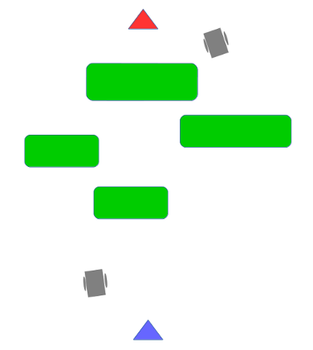

Competition Layout

## Requirements

The robot has "captured" the flag when any portion of the robot is over the flag.

At no time during the competition may a robot collide with another robot. To make identifying robots easier, you can attach an orange cone to the robots.

During the competition, the robots must operate autonomously with no remote control.

If a robot hits an obstacles, a ten second penalty will be given to that robot.