# Color Following Robot

## Overview

The goal of this project is to program Jet to follow an object of a specific color. Students will perform basic image processing operations and use image information to make movement decisions.

## Requirements

When Jet sees a sample of a certain color, it turns until the color sample is centered in the image, as in Figure . When the color sample is centered in the field of view, Jet will drive towards the color sample, as in Figure .

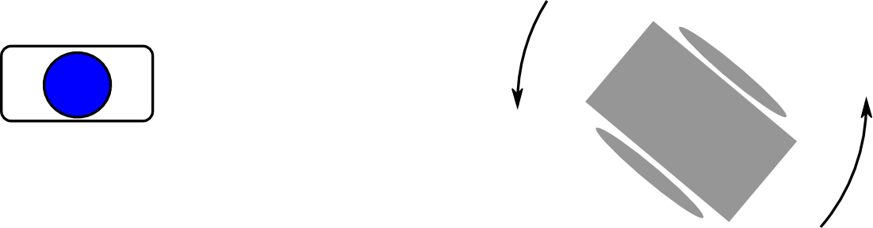

Color Follower turning

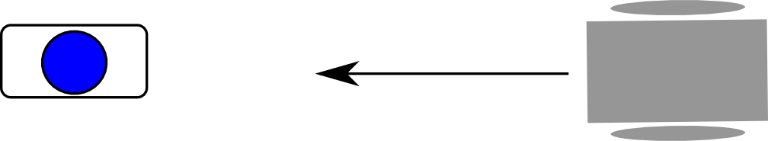

Color Follower moving