Facial Deepfake Detection

Russel Prashant Shah

A Thesis Submitted in Partial Fulfilment
of the requirements for the
Degree of Master of Science in Data Analytics


May 2026
Supervisor: Dr Kislay Raj

CCT College Dublin

Assessment Cover Page

Module Title: | Capstone Project
Assessment Title: | Facial Deepfake Detection
Supervisor Name: | Dr Kislay Raj
Student Full Name: | Russel Prashant Shah
Student Number: | 2025004
Assessment Due Date: | 15/05/2026
Date of Submission: | 15/05/2026

Title: Facial Deepfake Detection

Table of Contents
List of Tables 4
List of Figures 5
Abstract 1
1. Introduction 2
1.1 Background and Motivation 2
1.2 Research Questions 3
1.3 Project Scope and Constraints 3
1.4 Thesis Structure Overview 4
2. Research Context and Problem Definition 5
2.1 The Deepfake Threat Landscape 5
2.2 Current Detection Limitations 5
2.3 The Interpretability Argument 6
3. Literature Review 7
3.1 The evolution of deepfake synthesis techniques 7
3.2 Detection methods: traditional and deep learning approaches 8
3.3 Deep learning approaches to deepfake detection 9
3.4 Ensemble methods in multimedia forensics 10
3.5 Feature engineering for video-based deepfake detection 10
3.6 Fairness and demographic bias in deepfake detection 11
3.7 Regulatory and ethical context 12
3.8 Chapter summary 13
4. Methodology 14
4.1 Overview of the methodological approach 14
4.2 Data sources and sampling 14
4.3 Train, validation, test, and cross dataset splits 16
4.4 Feature engineering and preprocessing 17
4.5 Model selection and ensemble design 20
4.6 Evaluation metrics and statistical inference 22
4.7 Demonstration Artefact 24
4.8 Ethical considerations 25
4.9 Chapter summary 26
5. Results and Discussion 26
5.1 Within-dataset performance 27
5.2 Robustness to unseen manipulation types 31
5.3 Feature importance 33
5.4 Error analysis 37
5.5 Discussion 38
5.6 Chapter summary 39
6. Conclusion and Future Work 40
6.1 Principal conclusions 40
6.2 Limitations 41
6.3 Recommendations for future research 42
6.4 Closing statement 43
References 43

List of Tables
Table 1: Classification performance on the FaceForensics++ held-out test set (n = 200 videos). Includes AUC, accuracy, precision, recall, F1-score, and 95% bootstrap confidence intervals.
Table 2: Confusion matrix cell counts (TP, FP, FN, TN) for Random Forest, XGBoost, and soft-voting Ensemble on the held-out test set (n = 200).
Table 3: Ablation study — Random Forest AUC on FaceForensics++ c40 test set across three feature set configurations.

List of Figures
Figure 1: ROC curves for all models. RF AUC=0.6586, XGBoost AUC=0.6280, Ensemble AUC=0.6427.
Figure 2: Confusion matrices for Random Forest, XGBoost, and the soft-voting Ensemble on the held-out test set (n=200). False negatives dominate misclassifications across all models.
Figure 3: Precision-Recall curves. RF AP=0.89, XGBoost AP=0.87, Ensemble AP=0.89.
Figure 4: ROC curves for the leave-one-manipulation-out holdout evaluation. Average ensemble AUC = 0.694 across held-out manipulation types.
Figure 5: RF model AUC vs Gaussian noise level. Clean baseline AUC = 0.6586. Floor at noise=2.0: AUC = 0.5719.
Figure 6: Cohen’s d effect size ranking for all 27 engineered candidate features. Green bars survived the Benjamini-Hochberg corrected p-value and Cohen’s d threshold filter.
Figure 7: Box plots of the three validated features (ear_std, ear_min, and lm_ratio_var) by class (Real vs Fake), annotated with Cohen’s d from Mann-Whitney U tests.
Figure 8: SHAP summary plot for the Random Forest. lm_ratio_var dominates both positive and negative prediction contributions across all test videos.
Figure 9: SHAP dependence plot for lm_ratio_var. Low values push predictions strongly toward fake; high values push toward real.

Abstract
Deepfake detection is an increasingly critical capability as AI-generated facial manipulation becomes accessible and widespread. Existing detection systems achieve high accuracy on standard benchmarks but depend on GPU infrastructure and produce opaque decisions that are difficult to audit in legal or regulatory contexts. This thesis asks whether a CPU-only, interpretable, feature-based ensemble can achieve meaningful detection performance on FaceForensics++ at the c40 heavy-compression setting, and what can be honestly established about the limits of such an approach.
The study uses 1,000 videos drawn from FaceForensics++ c40, comprising 200 authentic recordings and 200 videos from each of four manipulation families: Deepfakes, Face2Face, FaceSwap, and NeuralTextures. Feature engineering produced 27 candidate video-level descriptors covering eye aperture dynamics, facial landmark geometry, optical flow, frequency domain statistics, and texture measures. Statistical selection using Cohen's d effect size, Benjamini-Hochberg corrected Mann-Whitney tests, and Spearman correlation filtering reduced this set to three validated features: ear_std, ear_min, and lm_ratio_var. A soft-voting ensemble of Random Forest and XGBoost was trained on these three features using 5-fold stratified cross-validation on 800 training videos and evaluated on a held-out test set of 200 videos.
The ensemble achieved an AUC of 0.6427 and Random Forest, the strongest individual model, achieved an AUC of 0.6586 on the held-out test set. XGBoost achieved an AUC of 0.6280 but required threshold calibration to 0.8 to avoid degenerate majority-class prediction under the 4:1 class imbalance and is not recommended as the standalone deployment model. A leave-one-manipulation-out evaluation produced a mean AUC of 0.694, with performance ranging from 0.6162 on FaceSwap to 0.7858 on Deepfakes, indicating uneven but above-chance generalisation to unseen manipulation types. A Gaussian noise stress test showed AUC declining from 0.6586 to 0.5719 at maximum noise, demonstrating gradual degradation rather than collapse. SHAP attributions confirm that lm_ratio_var is the dominant predictor, followed by ear_std and ear_min, providing traceable, feature-level explanations consistent with EU AI Act Article 13 transparency requirements.
Fairness analysis across demographic subgroups was not conducted because FaceForensics++ carries no demographic labels. This is identified as the primary limitation and the most urgent direction for future work. The results establish that interpretable, CPU-only ensemble detection on heavily compressed video is technically viable at moderate performance levels, with explicit bounds on generalisation and robustness that support honest deployment assessment.
Keywords: deepfake detection, FaceForensics++, Random Forest, XGBoost, SHAP, EU AI Act, interpretable machine learning, feature engineering, c40 compression

1. Introduction

1.1 Background and Motivation
Deepfakes are AI-generated facial manipulations that exploit generative adversarial networks (GANs) and encoder-decoder architectures to replace or alter faces in video sequences with a level of realism that has grown considerably since Goodfellow et al. (2014) introduced the foundational GAN framework. The core mechanism pits a generator network against a discriminator in an adversarial loop, with the generator learning to produce synthetic output that is increasingly indistinguishable from authentic footage. Over a decade of iterative refinement, the same principles have been extended into face-swap systems such as DeepFaceLab and FaceSwap, into expression-transfer pipelines such as Face2Face (Thies et al., 2016) and NeuralTextures (Thies et al., 2019), and more recently into latent diffusion models (Rombach et al., 2022) that generate photorealistic faces with no reference to any real individual.
The consequences of this technology extend well beyond technical curiosity. Deepfakes have been used to fabricate statements by political figures, to produce non-consensual intimate imagery of private individuals, and to impersonate executives in corporate fraud. Chesney and Citron (2019) identify a particularly troubling secondary effect: the widespread awareness that such forgeries exist allows bad actors to dismiss authentic video evidence as fake, a dynamic they call the liar's dividend. Research has consistently found that human ability to identify manipulated video is only marginally better than chance, which means that automated detection systems are not a convenience but a genuine necessity for maintaining evidentiary integrity across journalism, law, and public discourse.
The research community has responded with large benchmark datasets, including FaceForensics++ (Rossler et al., 2019) and the DeepFake Detection Challenge (Dolhansky et al., 2020), and with increasingly sophisticated deep learning detectors. State-of-the-art models such as XceptionNet report area-under-curve scores above 0.90 on lighter compression conditions. However, these systems share two limiting characteristics. First, they depend on GPU infrastructure that is unavailable in many investigative and resource-constrained settings. Second, their decision processes are opaque: a neural network score provides no audit trail that could withstand scrutiny in a legal or regulatory proceeding. This thesis asks whether a CPU-only, interpretable, feature-based ensemble can provide reliable detection on the challenging heavily compressed variant of FaceForensics++, and what is honestly known about the limits of such an approach.

1.2 Research Questions
Three research questions guide this study. The first asks whether a feature-based ensemble classifier, trained on physiological and geometric signals only, can achieve a competitive area-under-curve score on the FaceForensics++ c40 compression condition, and what confidence interval surrounds that estimate given the inherent sampling uncertainty of a dataset of this size. The second asks whether the trained model generalises to manipulation types it has not seen during training: if a detector built on Deepfakes, Face2Face, and Neural Textures examples can still identify FaceSwap videos, it provides evidence that the learned signal captures something more fundamental than method-specific compression artefacts. The third asks how robustly the model maintains discrimination performance as increasing levels of Gaussian noise are applied to the feature values, simulating the progressive signal degradation introduced by repeated social-media compression. Together, these three questions structure the experimental design and bound the claims this thesis can reasonably make.

1.3 Project Scope and Constraints
This project is constrained to a single dataset, FaceForensics++ at the c40 heavy-compression setting. No other dataset was used during training, validation, or testing. The DeepFake Detection Challenge was considered for cross-dataset evaluation but was excluded because complete data access could not be confirmed within the project timeline; it appears in the literature review as a benchmark reference and is identified in the future work section as a planned extension. The detection pipeline runs entirely on a standard CPU without GPU acceleration. This is a deliberate design choice motivated by resource constraints and the goal of producing a system that could be deployed in settings without specialised hardware, but it imposes a ceiling on the feature complexity that can be processed at inference time.
The classification approach is feature-based rather than end-to-end deep learning. This makes the method interpretable but limits the ceiling performance achievable on a benchmark designed for deep learning evaluation. Feature selection reduced 27 engineered candidate features to 3 final validated features using Cohen's d effect size, Benjamini-Hochberg corrected p-values, and Spearman correlation thresholds. Fairness analysis across demographic subgroups was not possible because FaceForensics++ carries no demographic labels; the thesis addresses this gap conceptually and identifies it as a priority for future work, drawing on Xu et al. (2022) and Trinh et al. (2021) for context on known demographic disparities in detection systems.
A four-page interactive Streamlit application was developed as a demonstration artefact alongside the analytical pipeline. The application allows users to test their own ability to distinguish real from manipulated video before comparing their accuracy against the model, inspect model predictions and probability distributions on the held-out test set, examine per-feature SHAP attributions for individual predictions, and review robustness results across manipulation types and compression levels. The artefact is described in full in Section 4.7.

1.4 Thesis Structure Overview
Chapter 2 situates the work within the broader threat landscape and motivates the choice of an interpretable, resource-efficient detection design. Chapter 3 reviews the relevant literature across six thematic areas, from synthesis techniques to fairness and regulatory context. Chapter 4 describes the methodology, covering the data preparation pipeline, feature engineering process, model selection rationale, and evaluation framework. Chapter 5 presents and discusses results across four analytical stages: feature validation, model evaluation, explainability, and robustness testing. Chapter 6 summarises the findings, states the original contributions, and identifies five directions for future work.

2. Research Context and Problem Definition

2.1 The Deepfake Threat Landscape
The term deepfake entered public consciousness around 2017, but the potential for AI-generated media to undermine public trust had been anticipated in academic literature much earlier. Real-world consequences have since accumulated rapidly. Political deepfakes have been used to fabricate statements by heads of state, with synthetic video of public figures endorsing positions they never held circulating widely on social media before fact-checkers could issue corrections. Non-consensual synthetic intimate imagery, predominantly targeting women, has become a documented harm with legal consequences in several jurisdictions. Corporate fraud cases have emerged in which voice clones of senior executives were used to authorise fraudulent financial transfers, causing direct monetary losses.
Chesney and Citron (2019) identified a compounding problem that they termed the liar's dividend. Once it becomes widely known that convincing synthetic video can be created at low cost, genuine video evidence loses credibility. A politician caught on camera can claim the footage is fabricated, and a judicial system with no reliable tool for authentication faces a verification crisis. This effect may ultimately be as damaging as the forgeries themselves. Experimental research on human detection of deepfakes consistently finds that even trained observers perform only marginally above chance, reinforcing the case for automated detection as a societal necessity rather than a technical curiosity.

2.2 Current Detection Limitations
Deep learning detection models have achieved impressive area-under-curve scores on standard benchmarks. XceptionNet, for instance, reports performance above 0.90 on the c23 compression variant of FaceForensics++ (Rossler et al., 2019). The more heavily compressed c40 variant, which this thesis uses, is considerably harder, and performance gaps between deep learning and simpler methods narrow at that compression level. Nevertheless, deep learning methods share characteristics that create practical problems in deployed settings. They require substantial GPU infrastructure for training and, in many implementations, for inference. Their decisions are opaque: a softmax score does not explain which feature in the video triggered the classification, and in contexts where the detection output might be used as evidence, that opacity is a liability.
Traditional feature-based methods offer greater transparency but have historically underperformed deep learning on benchmark metrics. Most detection work also lacks rigorous uncertainty quantification: a classifier that reports a confidence score without a confidence interval cannot support a defensible risk assessment. Fairness evaluation is a further gap. Most published detection systems report aggregate performance metrics without examining whether performance varies systematically across demographic subgroups. Research by Xu et al. (2022) and Trinh et al. (2021) has since documented such disparities, but benchmark datasets including FaceForensics++ do not carry demographic annotations, which makes subgroup analysis impossible without additional data collection.

2.3 The Interpretability Argument
Interpretability is not merely an academic preference in the context of deepfake detection. Where detection output will be used in legal proceedings, journalism, or regulatory enforcement, the decision-maker needs to understand what drove the classification, not simply what the classification was. A tree-based ensemble that relies on three physiological features can be audited: each prediction can be traced to specific values of eye aperture variation and facial landmark geometry, and a domain expert can evaluate whether those values are consistent with the claimed manipulation. A neural network heatmap does not provide the same degree of traceability, and Rudin (2019) argues forcefully that for high-stakes decisions, using inherently interpretable models is preferable to constructing post-hoc explanations for black-box ones.
This thesis applies SHAP (SHapley Additive exPlanations) as described by Lundberg and Lee (2017) to both the Random Forest and XGBoost components of the ensemble. SHAP provides a model-agnostic, game-theoretic attribution of each feature's contribution to individual predictions, which satisfies the additivity and consistency properties that earlier attribution methods lack. The resulting explanations are directly tied to the three physiological features that survived selection, and the direction and magnitude of each feature's influence can be communicated to a non-technical audience without loss of correctness. This combination of measurable uncertainty and explainable decision-making represents the design philosophy that motivated every methodological choice in this project.

3. Literature Review
This chapter reviews the academic literature relevant to facial deepfake detection. The review moves from foundational synthesis concepts to the specific technical and ethical dimensions that justify the methodological choices in Chapter 4. Six thematic areas are addressed: the evolution of deepfake synthesis techniques; traditional and deep learning detection approaches; ensemble methods on tabular features; feature engineering for video-based detection; fairness and demographic bias; and the regulatory context under the EU AI Act. Where evidence is limited or sources conflict, the nature of the uncertainty is stated explicitly.
Sources were selected from peer-reviewed journals, conference proceedings, and official policy documents published between 2018 and 2025. Inclusion was determined by relevance to the three research questions and to the specific methodological decisions in Chapter 4, particularly the choice of FaceForensics++ c40, Random Forest and XGBoost on tabular features, and interpretable model design under EU AI Act Article 13. The review is selective rather than exhaustive.

3.1 The evolution of deepfake synthesis techniques
Deepfake technology emerged from generative adversarial networks (GANs), first described by Goodfellow et al. (2014). The foundational architecture pits a generator against a discriminator; the generator learns to produce synthetic output indistinguishable from real content. Early facial manipulation applications were research demonstrations, but open-source implementations and consumer hardware quickly made them accessible production tools.
Face-swap techniques represent the most widely studied manipulation family. Approaches such as DeepFaceLab and FaceSwap train an encoder-decoder pair that maps face into a shared latent space, then swap decoders at inference to place a source identity into a target video. Rossler et al. (2019) formalised evaluation of these techniques in FaceForensics++, noting that even visually convincing swaps leave systematic residuals in high-frequency texture regions, particularly around mouth boundaries and the hairline. That observation motivates the use of FaceForensics++ as the primary benchmark in this thesis.
Neural rendering methods such as Face2Face (Thies et al., 2016) and NeuralTextures (Thies et al., 2019) transfer expressions and head pose without explicit face reconstruction, producing temporally consistent output that is more resistant to geometric inconsistency artefacts than early swap pipelines. Diffusion-based synthesis (Rombach et al., 2022) represents an emerging third family whose artefact profile differs from both swap and reenactment methods and is not yet well represented in FaceForensics++. These synthesis families define the range of forgery types the pipeline in Chapter 4 must address, and they explain why the c40 compression setting is a deliberately hard evaluation condition: heavy codec processing suppresses the high-frequency residuals that make swap and reenactment artefacts visible.

3.2 Detection methods: traditional and deep learning approaches
Deepfake detection research is divided into traditional feature-based methods and deep learning methods. These two strands differ sharply in their data demands, computational footprint, and transparency of decision-making, all of which are central to the design choices in Chapter 4.
Traditional detection methods build on explicit artefacts that manipulation pipelines leave behind. Early work exploited frequency domain signatures, compression inconsistencies, and geometric irregularities in facial regions, using discrete cosine transform statistics, local binary patterns, and inconsistencies in head pose or eye geometry. Their strengths are transparency and low computational cost: decision logic follows from interpretable features, and training on CPUs is feasible. Their recognised weakness is sensitivity to feature design quality and the risk that narrow feature sets miss newer manipulation strategies that preserve natural geometry.
Deep learning methods operate directly on pixels or spatio-temporal tensors. Architectures such as XceptionNet (Chollet, 2017) and EfficientNet B7 reach high detection performance on FaceForensics++ under low-compression conditions, but their advantages narrow considerably at the c40 setting, where spatial detail is heavily degraded. Li et al. (2020) showed that cross-manipulation accuracy drops for CNN-based detectors can exceed thirty percentage points, indicating that these models learn generator-specific artefacts rather than manipulation-invariant signals. Most published deep learning studies also rely on GPU infrastructure unavailable in resource-constrained deployments and provide no audit trail compatible with legal or regulatory scrutiny.
Within this context, this thesis positions a CPU-based, tabular-feature ensemble on FaceForensics++ c40 as a response to three specific gaps. First, it tests whether engineered physiological and geometric features support competitive detection under explicit resource constraints. Second, it evaluates robustness through manipulation-type holdout and Gaussian noise stress tests rather than a single in-distribution test split. Third, it treats interpretability as a core design goal and acknowledges fairness as a limitation that future work must address once demographically labelled datasets become available: tree-based ensembles allow SHAP-based feature attributions that offer more direct explanatory value for practitioners and regulators than saliency maps on deep CNNs. This framing does not claim classical methods are superior in all settings; it frames the pipeline as a deliberately constrained alternative that trades some accuracy ceiling for reproducibility, interpretability, and explicit governance alignment.

3.3 Deep learning approaches to deepfake detection
Deep learning detectors emerged as the dominant paradigm after FaceForensics++ (Rossler et al., 2019) provided a standardised evaluation framework. XceptionNet achieved binary classification accuracy well above ninety per cent on low-compression FaceForensics++ videos, substantially exceeding both human performance and classical feature-based methods. That benchmark justified XceptionNet and, later, EfficientNet B7 as standard reference points in the detection literature and establishes the performance ceiling against which this thesis positions its CPU-only ensemble.
The central limitation of CNN-based detectors is poor generalisation across manipulation types and compression levels. Li et al. (2020) documented accuracy drops exceeding thirty percentage points in cross-manipulation evaluations, attributed to models learning low-level synthesis artefacts specific to individual generators. On the c40 compression setting used in this thesis, the performance gap between deep learning and simpler methods narrows considerably, because heavy compression suppresses the pixel-level texture cues that CNNs rely on most heavily. This convergence of performance at c40 is a direct justification for selecting that compression condition: it creates a setting where the interpretability and resource advantages of a tabular ensemble are most defensible.
Transformer-based architectures such as Zhao et al.'s (2021) multi-attentional network address some CNN limitations through global self-attention, and temporal models applying LSTM to facial landmark trajectories (Sabir et al., 2019) improve the detection of reenactment artefacts. Neither family is adopted in this thesis: transformer models require GPU infrastructure and large training corpora to reach their reported performance, and temporal sequence models show only modest gains over well-engineered frame-level aggregation on heavily compressed video. The methodological decision to aggregate temporally across frames into a fixed-length tabular vector, rather than training a sequence model, is justified by this evidence.

3.4 Ensemble methods in multimedia forensics
Ensemble methods combine the predictions of multiple base classifiers to produce a final
Ensemble methods combine predictions from multiple base classifiers to produce decisions that are more accurate and more robust than any individual component. The theoretical justification rests on the bias-variance decomposition: if base classifiers exhibit low correlation in their errors, aggregating their predictions reduces variance without proportionally increasing bias (Breiman, 2001). This property is directly relevant to this thesis, where Random Forest and XGBoost are selected as base learners on the same physiological and geometric feature set.
Random Forest (Breiman, 2001) aggregates many decorrelated decision trees built on bootstrap samples of the training data using random feature subsets at each split. It delivers strong performance on heterogeneous tabular features while resisting overfitting, and it yields straightforward feature importance rankings and SHAP attributions. XGBoost (Chen and Guestrin, 2016) applies gradient boosted trees that sequentially correct residual errors, typically achieving lower bias than bagging on well-designed feature sets, at the cost of greater sensitivity to hyperparameters. Grinsztajn et al. (2022) documented that gradient boosting consistently outperforms deep learning on moderate-scale tabular datasets when feature engineering is sound, which is precisely the regime this thesis occupies. Selecting both methods and combining them through soft-voting tests whether complementary error patterns across bagging and boosting translate into measurable ensemble gain on the FaceForensics++ c40 held-out set.
Studies applying ensembles directly to deepfake detection reinforce this rationale. Bondi et al. (2021) showed that a Random Forest trained on handcrafted image features consistently outperformed either the RF or a CNN alone in cross-dataset evaluation. Nguyen et al. (2022) applied gradient boosting on transformer-derived embeddings and reported improved robustness to compression compared to the base transformer. Both findings support the design choice in Chapter 4 to combine Random Forest and XGBoost on a compact, engineered feature set rather than pursuing a single high-capacity classifier.

3.5 Feature engineering for video-based deepfake detection
Feature engineering for video-based detection transforms raw pixel data into compact, semantically meaningful representations that are both discriminative and generalisable. Three broad categories appear in the literature: spatial texture descriptors, temporal and motion-based descriptors, and physiological or biological signal descriptors. This thesis draws primarily from the third and second categories, motivated by evidence that physiological and geometric features retain above-chance discriminative power at high compression where texture-based features degrade most rapidly.
Spatial texture descriptors such as Local Binary Patterns and Histogram of Oriented Gradients capture micro-texture irregularities and blending artefacts at facial boundaries. While discriminative under low compression, their signal degrades rapidly at c40, where block artefacts from codec processing dominate over synthesis artefacts. Frequency domain features, including discrete cosine transform statistics and energy ratios across spectral bands, capture interactions between generator upsampling and codec processing that persist at higher compression than texture features. These descriptors informed the candidate feature set of 27 engineered features designed in Chapter 4, of which three survived statistical selection.
Physiological features have attracted increasing attention as manipulation-agnostic alternatives. Hernandez-Ortega et al. (2021), demonstrated that rPPG-based features, derived from pixel intensity variation, derived from pixel intensity variation across facial skin regions, maintain above-chance discriminative power even at high compression settings where texture-based features become unreliable. Facial landmark geometry provides a complementary representation: inter-landmark distances and angular relationships capture the structural plausibility of the face under manipulation, and landmark motion trajectories across frames encode expression and head movement dynamics that deepfake generators frequently fail to reproduce naturally. The three features retained by selection in Chapter 4, namely ear_std, ear_min, and lm_ratio_var, fall within this physiological and geometric family, and their retention is directly supported by the Li et al. (2021) finding on high-compression robustness.

3.6 Fairness and demographic bias in deepfake detection
Fairness in machine learning requires that model performance does not systematically differ across demographic subgroups defined by protected characteristics such as race, gender, or age. In deepfake detection, disparities arise from two sources: the demographic composition of training data and the differential detectability of synthesis artefacts across subjects with different skin tones or facial structures.
Xu et al. (2022) conducted a comprehensive audit across Fitzpatrick skin tone groups and found statistically significant performance disparities, with darker-skinned subjects associated with higher false negative rates in several detection models. The proposed mechanism is that synthesis pipelines trained predominantly on lighter-skinned subjects produce artefacts that are more visible in that demographic. Trinh et al. (2021) reported higher false positive rates for older subjects and for subjects presenting feminine facial features, attributing this to underrepresentation in FaceForensics++ training data. Both findings establish that aggregate AUC scores can conceal substantial subgroup harm and that demographic evaluation is a first-order obligation, not an optional extension.
Quantitative subgroup analysis was not conducted in this thesis because FaceForensics++ carries no demographic labels. Fairness is addressed as a conceptual discussion and stands as the primary limitation of this work. Neither FaceForensics++ nor the DFDC was designed with demographic balance as a primary goal. This means that any future study replicating this pipeline with a demographically labelled corpus should expect to find performance variation across Fitzpatrick skin tone groups, age groups, and gender presentations, consistent with the disparities documented by Xu et al. (2022) and Trinh et al. (2021). Demographically balanced evaluation remains an open research challenge and a direct next step for this line of work.

3.7 Regulatory and ethical context
The European Union Artificial Intelligence Act (EU AI Act, 2024) classifies biometric identification systems and systems for detecting AI-generated content as high-risk applications subject to enhanced transparency, accuracy, and non-discrimination requirements. Under Article 13, providers of high-risk AI systems must make the basis of automated decisions interpretable to affected parties. This requirement is a direct justification for the interpretable ensemble design in this thesis: a tree-based model with SHAP attributions tied to three named physiological features satisfies Article 13 in a way that a neural network saliency map does not. Rudin (2019) argues that for high-stakes decisions, inherently interpretable models are preferable to post-hoc explanations of black-box systems; the EU AI Act gives that argument regulatory force.
The dual-use nature of deepfake detection research creates a tension between scientific transparency and responsible disclosure. Methods that identify specific artefacts produced by a synthesis pipeline can serve as an adversarial roadmap for improving that pipeline to evade detection. This risk is mitigated here by the focus on physiological and geometric features rather than white-box neural architectures whose internal representations could be more directly exploited. All findings are reported at the system level and framed in terms of detection capability and limitation.
Privacy and consent obligations under GDPR Article 9 apply because FaceForensics++ constitutes facial biometric data. The thesis uses only the officially published dataset under its research licence and conducts no new biometric data collection, enacting the GDPR data minimisation principle and removing the requirement for a Data Protection Impact Assessment under Article 35. The ethical responsibility to report demographic subgroup results transparently is acknowledged, but the absence of demographic labels in the benchmark means this remains a conceptual commitment rather than an empirical deliverable in this study.

3.8 Chapter summary
This chapter has reviewed six thematic areas of the deepfake detection literature that directly inform the methodological decisions in Chapter 4.
Section 3.1 traced synthesis techniques from GAN-based face swaps through neural rendering to diffusion models, establishing why FaceForensics++ c40 is a representative and demanding evaluation condition. Section 3.2 compared traditional and deep learning detection paradigms, identifying the three gaps this thesis addresses: resource constraints, opacity, and the convergence of performance at heavy compression. Section 3.3 reviewed the state-of-the-art CNN and transformer detectors in sufficient detail to set the performance benchmark against which the CPU-only ensemble is compared and justified the decision not to adopt temporal sequence models. Section 3.4 provided the theoretical and empirical basis for selecting Random Forest and XGBoost on tabular features, showing that gradient boosting consistently outperforms deep learning on moderate-scale, well-engineered tabular data (Grinsztajn et al., 2022; Breiman, 2001; Chen and Guestrin, 2016). Section 3.5 catalogued feature categories and justified the physiological and geometric focus by citing Li et al. (2021) on compression-resistant rPPG features, which directly motivated the three retained features. Section 3.6 reviewed the literature on fairness and demographic bias, establishing that subgroup performance disparities are documented in the field and that the absence of demographic labels in FaceForensics++ prevents this thesis from conducting quantitative subgroup analysis. This absence is a named limitation, not a gap to be resolved within the current study. Section 3.7 situated the interpretable ensemble design within EU AI Act Article 13, providing the regulatory justification for choosing tree-based models over higher-capacity black-box alternatives.
Taken together, the literature supports a methodological approach that combines interpretable handcrafted physiological features, classical ensemble classifiers, and an evaluation framework attentive to both aggregate accuracy and ethical governance. The gaps identified, particularly the weak generalisation of texture-based features to compressed video, the absence of demographically balanced benchmarks, and the opacity of GPU-dependent deep learning systems, define the scope and constraints of the investigation in Chapter 4

4. Methodology

4.1 Overview of the methodological approach
This chapter describes the methodological framework used to address the research questions stated in Chapter 1. The study adopts a quantitative, experimental design grounded in supervised machine learning. Secondary benchmark datasets are used throughout; no primary data collection was conducted. This decision reflects ethical constraints, logistical scope, and the availability of established, institutionally reviewed corpora suitable for deepfake detection research.
The chapter is structured into five sections. Section 4.2 describes the data sources and the sampling strategy used to construct the training and evaluation corpora. Section 4.3 defines the data partitioning protocol, including the video-level split and the cross-dataset evaluation scheme. Section 4.4 details the feature engineering and preprocessing pipeline that transforms raw video data into tabular descriptors. Section 4.5 presents the model selection rationale and the ensemble architecture. Section 4.6 defines the evaluation metrics and the statistical inference procedures used to compare model performance and quantify uncertainty.
Throughout the chapter, methodological choices are justified in terms of internal validity, external validity, computational feasibility, and ethical responsibility. Where trade-offs exist between these criteria, the rationale for prioritising one over another is stated explicitly. This transparency is consistent with the expectations of a Level 9 research project, where the credibility of conclusions depends not only on the results obtained but, on the rigour, and honesty of the process used to obtain them.

4.2 Data sources and sampling
This study relies on established benchmark datasets for facial deepfake detection, rather than newly collected video material. The primary source is FaceForensics++, which provides authentic and manipulated facial videos generated through several synthesis pipelines at controlled compression levels. FaceForensics++ offers a manageable scale for a single student project, while still covering multiple manipulation families such as StyleGAN based synthesis, face swap methods, and frame-based editing techniques.
The study uses only FaceForensics++ at c40 compression, drawing a stratified sample of 1,000 videos: 200 authentic recordings from the original YouTube sequence and 200 videos from each of four manipulation types, namely Deepfakes, Face2Face, FaceSwap, and NeuralTextures. This results in 800 manipulated and 200 authentic clips, reflecting the natural imbalance between authentic and manipulated content in the benchmark. The DeepFake Detection Challenge dataset was considered for cross-dataset evaluation but was excluded because complete data access could not be confirmed within the project timeline. It appears in the literature review as a benchmark reference and in the future work section as a planned extension.
Both datasets bring demographic and contextual limitations that directly affect fairness analysis. FaceForensics++ draws heavily from online video platforms and tends to over represent Western celebrities and public figures, while DFDC reflects the choices and constraints of its industry led design. Neither dataset was collected with equal representation across Fitzpatrick skin tones, age groups, or gender presentations as a primary goal. FaceForensics++ carries no demographic annotations, which means no subgroup performance analysis was conducted in this study. Fairness is treated as a limitation of this work. The absence of demographic labels is a constraint of the benchmark itself, not a design choice of this thesis, and it is identified as the primary reason demographic evaluation is deferred to future work. The absence of balanced data means that any near parity result cannot be taken as proof of demographic neutrality. This constraint is acknowledged upfront in the fairness methodology and informs the interpretation of results.
An earlier distributed extraction pipeline using Apache Spark on a Hadoop VM was benchmarked against the final CPU-only design; the CPU pipeline completed ETL for 1,000 videos in under 8 minutes, confirming Spark was unnecessary at this dataset scale.
The choice to work exclusively with secondary benchmark datasets rather than collect new facial video data reflects ethical, legal, and logistical considerations. Collecting primary biometric data would require complex consent procedures, secure long term storage of high risk media, and formal data protection impact assessment under GDPR Article 9, all of which exceed the scope of a single student project. FaceForensics++ and DFDC have already undergone institutional review and are distributed under licences that specify permitted research uses, which reduces, but does not eliminate, the ethical responsibility of the present work. By restricting analysis to these datasets, the thesis aligns with the principle of data minimisation and avoids subjecting new individuals to biometric data processing when suitable public benchmarks exist. At the same time, this decision narrows ecological validity, since real world deployment contexts often involve lower quality, more diverse, and less curated media. Later chapters return to this trade-off when discussing external validity and deployment implications.

4.3 Train, validation, test, and cross dataset splits
The experimental protocol separates model development, hyperparameter tuning, and generalisation assessment through distinct data partitions. On the FaceForensics subset, videos are partitioned into 80 percent training and 20 percent held-out test sets at the video level using stratified random sampling with a fixed random seed of 42. Stratification preserves the class balance between authentic and manipulated videos across both partitions, yielding 800 training videos and 200 test videos. No separate validation set was held out during final model training; hyperparameter selection was performed through 5-fold stratified cross-validation on the 800-video training pool, which provides a more statistically stable estimate of generalisation performance than a single held-out validation fold given the modest dataset size. Stratification preserves the balance between authentic and manipulated classes, and between the major manipulation families introduced earlier. Two internal robustness tests supplement the held-out test set: a manipulation-holdout evaluation, in which each manipulation type is excluded from training in turn to assess generalisation to unseen forgery methods; and a Gaussian noise stress test, in which synthetic feature perturbations are injected at increasing magnitude to assess pipeline stability under noisy input conditions.
The decision to split at the video level rather than at the frame level addresses the risk of subject leakage. A single FaceForensics++ video yields many frames, and adjacent frames within one clip are highly correlated in terms of identity, pose, lighting, and artefacts. If the dataset were partitioned by frames, different frames from the same original video, and therefore from the same subject and manipulation, would appear in both training and test sets. This would bias performance estimates upward, because models could exploit clip specific artefacts and recurrent patterns rather than learning features that generalise to new identities and recording conditions. Video-level splitting assigns every clip to exactly one partition, preventing the same identity from influencing both model fitting and evaluation. The stricter protocol reduces training sample count but provides a more honest assessment of robustness to unseen generators.
Within the FaceForensics++ training and validation pool, the study employs 5-fold stratified cross validation to stabilise performance estimates and to drive model selection. Folds are constructed at the video level, with stratification across authentic and manipulated classes and across manipulation types, so each fold approximates the global class distribution. In each round, four folds serve as the training set and one-fold serves as the validation set for hyperparameter tuning and early stopping where applicable. Performance metrics from the five rounds are averaged, and bootstrap confidence intervals are computed over the per fold scores. This design mitigates the variance associated with any single random split, which is important given the modest dataset size relative to industrial scale deepfake benchmarks. The cross-validation protocol reduces split-dependent instability and provides a more defensible basis for comparing Random Forest, XGBoost, and their ensemble.
It is important to clarify that the Deepfake Detection Challenge (DFDC) dataset was not used in this study. Although cross-dataset evaluation on DFDC is frequently cited in the deepfake detection literature, the present project was conducted entirely within the FaceForensics++ corpus. No DFDC videos were downloaded, preprocessed, or evaluated at any stage of the experimental pipeline. The internal robustness tests described above serve as the primary evidence of generalisation capability in the absence of an external dataset.
Despite these precautions, some residual risks remain that introduce indirect content correlations across datasets. Long videos also contribute multiple aggregated temporal statistics, which may embed subtle dependencies even when clips are disjoint across splits. Performance estimates are therefore still optimistic relative to worst-case, real-world deployment. Later chapters acknowledge these limitations explicitly when discussing external validity and the degree to which ensemble performance on FaceForensics++ can support claims about operational deployment in unconstrained environments.

4.4 Feature engineering and preprocessing
The feature engineering pipeline translates raw facial videos into a compact set of interpretable, tabular descriptors at the video level. Raw clips from FaceForensics++ are first decoded into frames, then processed through a sequence of detection, alignment, and normalisation steps. From these frames, the system extracts temporal, frequency domain, and physiological indicators designed to capture artefacts that deepfake generators leave behind. The final representation for each video is a vector of approximately 27 candidate features, of which three were selected as final predictors (ear_std, ear_min, and lm_ratio_var), which serve as input to the Random Forest, XGBoost, and ensemble models.
Temporal features aim to capture inconsistencies in motion and appearance over time. The pipeline samples every fifth frame from each video to balance temporal coverage against computational cost. For each sampled frame, a face detector identifies the primary face, and facial landmarks anchor measurements of pose and eye region geometry. Across the sequence of frames, the system computes statistics such as inter-frame pixel differences in facial regions, optical flow magnitudes, and the variance of landmark positions. It also derives a blink related signal through changes in eye aspect ratio over time. Authentic videos tend to exhibit smooth, physically plausible motion patterns and natural blinking behaviour. Manipulated videos often suffer from misaligned motion fields, inconsistent warping near facial boundaries, or abnormal blink frequencies due to generator limitations. Temporal features therefore target differences in motion coherence and dynamics that are difficult to correct in current generation pipelines.
Frequency domain features focus on spectral signatures and compression artefacts. For each detected face region, the pipeline applies a two-dimensional discrete cosine transform or similar spectral decomposition to each colour channel and computes summary statistics over the resulting coefficients. These include energy concentrations in particular frequency bands, ratios of low to high frequency power, and measures of block boundary discontinuities associated with compression. Many deepfake generators operate at fixed resolutions and employ upsampling or blending steps that introduce characteristic frequency patterns distinct from those found in natural camera footage. When such content is later compressed for streaming, the interaction between generator artefacts and codec behaviour leads to tell-tale spectral distortions. Frequency domain features therefore provide a complementary view of manipulation, one that is less sensitive to small geometric misalignments and more sensitive to underlying synthesis and compression pipelines.
Physiological features aim to approximate biological plausibility in facial appearance and micro dynamics. These include trends in eye aspect ratio over time, measures of skin texture smoothness in regions such as the cheeks and forehead, and simple proxies for micro expressions derived from local intensity changes around the eyes and mouth. Authentic videos reflect complex, often subtle, patterns of muscle activation and blood flow. Deepfake generators frequently reproduce coarse expressions but struggle with fine grained, temporally consistent detail in skin and musculature, particularly under challenging lighting. Physiological features provide an additional check on realism that complements purely geometric or spectral indicators. They are not full physiological models, but they capture dimensions of plausibility that matter in forensic evaluation and legal contexts.
The pipeline aggregates frame level measurements into video level features through summary statistics. For each temporal, frequency, and physiological indicator, the system computes per video means, standard deviations, and selected quantiles across the sampled frames. This aggregation reduces noise from transient frame anomalies and yields a fixed length feature vector independent of clip duration. Operating at the video level aligns with the evaluation goal, which treats each video as a single decision unit. It also supports the experimental protocol in which train, validation, and test splits occur at the video level to avoid leakage. The trade-off is that per frame temporal structure beyond second order statistics is not modelled explicitly. The thesis returns to this limitation when assessing whether simple aggregation and majority style reasoning suffice in comparison with sequence models.
Choosing an engineered feature approach over convolutional neural networks trained on raw frames or clips reflects both practical and epistemic considerations. CNNs and 3D CNNs have greater representational capacity and often achieve higher in distribution accuracy on large deepfake benchmarks when sufficient GPU resources are available. In this project, however, GPU access is restricted and the research question concerns whether interpretable, CPU based ensembles can offer a rigorous and cost-efficient alternative. Engineered features enable training of Random Forest and XGBoost models on commodity CPU hardware within the time constraints of a single student project, while still capturing key classes of artefacts identified in the literature. They also support fine grained interpretation through feature importance and SHAP analysis in a way that current saliency based CNN explanations do not. The cost is a potential loss of performance ceiling on very large, diverse datasets and reduced capacity to learn novel patterns not anticipated during feature design.
Preprocessing steps form an important part of this trade-off and introduce their own risks. The pipeline employs a face detector such as RetinaFace to locate, and crop faces before feature extraction. Alignment standardises rotation and scale, and frames undergo colour space conversion and codec normalisation to reduce variation due to encoding differences. These steps aim to remove nuisance variability and focus the models on relevant artefacts. At the same time, face detectors and alignment algorithms have known failure modes, particularly for darker skin tones, occlusions, and non-frontal poses. Missed or poorly aligned faces degrade feature quality and may disproportionately affect certain demographic groups. Codec normalisation reduces domain shift within FaceForensics++ but also eliminates some real-world variability that a deployed system would face. The methodology acknowledges these trade-offs and treats pre-processing choices as potential sources of bias that cannot be quantified in this study because FaceForensics++ carries no demographic labels. These risks are flagged as a limitation of the current work and as a priority for future research.

4.5 Model selection and ensemble design
Model selection in this study addresses two linked goals. First, selected models must establish whether engineered video-level features support competitive detection performance under realistic CPU constraints. Second, they must enable meaningful interpretability and fairness analysis rather than opaque scoring. Random Forest and XGBoost satisfy these criteria for tabular data and align with the ensemble based research questions set out in the proposal. EfficientNet B7 with spatial attention, as reported by Koyluoglu, Staikopoulos, and Raj, serves as the deep learning benchmark. It is a high-capacity, GPU-dependent alternative that optimises in-distribution accuracy on image-level inputs, with limited support for explanation or governance.
Random Forest constitutes the first classical ensemble baseline. It aggregates many decorrelated decision trees built on bootstrap samples of the training data, using random feature subsets at each split. This structure delivers strong performance on heterogeneous tabular features while resisting overfitting. For deepfake detection, Random Forest offers several advantages over single trees. It models non-linear interactions between temporal, frequency, and physiological features without extensive manual feature engineering beyond the design already described. It also yields straightforward measures of feature importance, which later chapters examine using both impurity-based rankings and SHAP values. The trade-off is that Random Forest treats feature as unordered and independent, which ignores potential smoothness in frequency spectra and temporal trends beyond what feature design encodes.
XGBoost complements Random Forest by applying gradient boosted decision trees to the same feature space. Each successive tree focuses on correcting the residual errors of the ensemble to date, which allows XGBoost to capture more subtle patterns than bagging alone. On tabular benchmarks, XGBoost often outperforms Random Forest in AUC and calibration at the expense of greater sensitivity to hyperparameters and noise. In this thesis, XGBoost tests whether a more aggressively optimised tree ensemble improves deepfake detection given engineered features. It introduces additional risks, including higher overfitting potential and more complex training dynamics, but it remains compatible with SHAP based explanation and with CPU only training for the dataset scale in question. Comparing XGBoost to Random Forest therefore illuminates the marginal gains from boosting versus bagging under the same feature regime.
The study then constructs a weighted soft voting ensemble that combines Random Forest and XGBoost outputs. Each base model produces a probability estimate for the manipulated class at video level. The ensemble aggregates these probabilities using weights proportional to validation set ROC AUC and selects a decision threshold that maximises F1 score on the validation data. This design seeks to exploit complementary error patterns across the two base learners. Random Forest tends to smooth over noisy features through averaging, while XGBoost emphasises harder cases through boosting. A weighted ensemble can reduce variance and bias simultaneously when the constituent models are diverse. At the same time, ensemble design adds complexity and risks redundancy if the two models converge on similar decision boundaries. The methodology therefore treats the ensemble not as an automatic improvement but as a hypothesis to be tested against single model baselines on the FaceForensics++ held-out test set.
EfficientNet B7 (Tan and Le, 2019) with spatial attention enters the comparison as a strong deep learning benchmark rather than as a competing production proposal. The cited architecture achieves high image level detection accuracy through compound scaling of depth, width, and resolution, augmented with attention mechanisms that highlight salient regions. Its strengths include powerful feature learning directly from pixels and superior in distribution performance when trained on large, diverse datasets using GPUs. Its limitations in this context are equally important. EfficientNet B7 is expensive to train and deploy, with high memory and inference latency costs relative to CPU based ensembles. It also processes frames or images, not engineered video level summaries, and published work evaluates it primarily on image test splits without strict video level or subject level separation and without DFDC style cross dataset testing. The benchmark paper reports no fairness metrics, no demographic breakdowns, and no alignment with EU AI Act obligations. By setting EfficientNet B7 as a reference point, the thesis tests whether modest reductions in AUC or accuracy for CPU based ensembles are acceptable when weighed against lower infrastructure cost, improved interpretability, and explicit fairness and governance analysis.
This selection excludes alternative deep learning and classical options by design. 3D CNNs, transformers, and hybrid architectures that model full spatiotemporal structure offer potential performance gains but require substantially more compute and engineering effort than the scope of this project permits. Logistic regression, support vector machines, and k-nearest neighbours offer no additional interpretive value beyond what tree ensembles provide on tabular data. The chosen trio of Random Forest, XGBoost, and their ensemble, together with EfficientNet B7, covers a well-defined range of accuracy-interpretability trade-offs under documented resource constraints. Classical ensembles expose the value of interpretable features under CPU constraints, while the deep learning benchmark anchors expectations about peak accuracy in resource rich settings. The methodology chapter therefore frames model selection not as an attempt to identify a single best architecture, but as a structured comparison between two philosophies of detection under documented constraints.

4.6 Evaluation metrics and statistical inference
The evaluation strategy in this study must answer two related questions. First, how well do the proposed models separate authentic from manipulated facial videos under the controlled conditions of the FaceForensics++ test set. Second, how robustly does performance hold when the same models encounter unseen manipulation types or noisy input conditions do not present during training. The chosen metrics and statistical procedures therefore need to quantify both discrimination performance and the uncertainty around that performance, rather than provide single point scores that overstate precision.
The primary detection metrics are accuracy, precision, recall, F1 score, and ROC AUC, computed at the video level. Accuracy summarises overall correctness but treats false positives and false negatives equally, which rarely reflects real forensic priorities. Precision and recall provide a more nuanced view by distinguishing the cost of falsely flagging authentic videos from the cost of missing deepfakes. F1 score aggregates precision and recall into a single harmonic mean that penalises models with unbalanced trade-offs. ROC AUC measures ranking quality across all possible thresholds and is less sensitive to class imbalance than accuracy. In this thesis, ROC AUC and F1 score serve as the main comparative metrics across models, supported by confusion matrices and per manipulation breakdowns. This choice reflects the deployment scenario, where both the ordering of suspicion scores and the balance between false alarms and misses matter more than raw accuracy alone.
Beyond single dataset metrics, the study defines a generalisation gap for each model as the difference between its performance on the FaceForensics++ held out test set and on two internal robustness gaps. For a given metric M, such as ROC AUC, the manipulation-holdout gap is the average drop in M when each manipulation type is excluded from training in turn. The noise degradation gap is the drop in M as Gaussian noise magnitude increases from zero to its maximum test level.
To quantify uncertainty, the evaluation employs bootstrap confidence intervals (Efron and Tibshirani, 1993) rather than only point estimates. For each model and metric, the procedure draws many bootstraps resamples of the relevant test set or cross validation folds by sampling videos with replacement. For each resample, it recomputes the metric, then uses the empirical distribution of these values to form a 95 percent interval, typically via percentile limits. Bootstrap intervals have several advantages in this context. They make minimal assumptions about the underlying score distribution, which is important when sample sizes are modest and when test sets mix multiple manipulation types. They also propagate variability due to both class composition and per video difficulty, rather than relying on asymptotic normal approximations that assume independent, identically distributed observations. Point estimates alone would encourage overconfident claims about small differences between models that fall within the noise range revealed by the bootstrap.
Aggregation across the 5-fold stratified cross validation scheme on FaceForensics++ follows the same principle. For each model and metric, scores are computed on the validation fold in each round. The mean across folds provides a central estimate, while bootstrap resampling over the set of fold scores yields an interval for that estimate. This approach acknowledges that different random fold assignments produce slightly different performance and treats that variability as part of the uncertainty budget. It improves on the common but weaker practice of selecting a single "best" fold or reporting only the best observed score, which biases perception upward and underestimates risk.
The thesis deliberately avoids formal null hypothesis significance testing between models, such as paired t tests or McNemar tests on disagreement counts. Given the dataset size, correlation between predictions across models, and the multiple metrics and comparison points involved, standard significance tests would invite selective reporting and p-value hunting without adding genuine insight. Instead, the analysis interprets overlaps and non-overlaps between bootstrap confidence intervals in a cautious way. When intervals for two models on a given metric and dataset largely overlap, the thesis treats their performance as practically indistinguishable for decision making. When intervals are well separated, the difference is taken as substantive. This stance aligns with the project's goal to inform cost benefit trade-offs rather than to pursue marginal statistical wins with little operational meaning.
Demographic subgroup analysis was not possible because FaceForensics++ carries no demographic labels. Fairness is therefore addressed conceptually by drawing on published audits of demographic bias in deepfake detection, particularly Xu et al. (2022) and Trinh et al. (2021), and is identified as a priority for future work once suitable demographically balanced evaluation corpora become available.

4.7 Demonstration Artefact
A Streamlit web application was developed to make the detection pipeline accessible to non-technical stakeholders without requiring direct execution of the analysis notebooks. The application constitutes a standalone project deliverable that operationalises the research findings described in Chapter 5 through an interactive interface.
The application is structured across four pages that map directly to the four evaluation stages of this thesis. The first page, titled "Guess: Real or Fake?", presents ten randomly sampled videos from FaceForensics++ and asks the user to classify each as real or fake before revealing the model's predictions and confidence scores. This page operationalises the human detection baseline established in Chapter 2.1, where Chesney and Citron (2019) document that human accuracy on deepfake identification is only marginally above random chance. The interactive comparison between user scores and model scores demonstrates this empirically to a panel or lay audience without requiring statistical literacy.
The second page presents the full model predictions on the 200-video held-out test set, including a probability distribution chart that visualises the separation between real and fake score distributions. The third page surfaces per-feature SHAP attributions computed using a Tree Explainer, displaying mean absolute SHAP values across the three validated features and a sample-level attribution table for the first fifty test cases. This page satisfies the transparency requirement under Article 13 of the EU AI Act (2024), which mandates that providers of high-risk AI systems make the basis of automated decisions interpretable to affected parties.
The fourth page presents the full model performance summary, including the three-model comparison table, the manipulation hold-out robustness results, and the compression stress test AUC decay curve. An explicit limitations panel is included on this page, acknowledging the single-dataset constraint, the absence of demographic labels, and the AUC gap relative to GPU-based deep learning benchmarks.
The model is loaded from a pre-serialised artifact at application startup rather than trained live, ensuring that predictions are deterministic and consistent with the results reported in Chapter 5. The feature table is cached on first load. These design choices eliminate session-to-session variance and ensure the application behaves identically across demonstration environments.

4.8 Ethical considerations
This study involves the analysis of facial biometric data, which constitutes a special category of personal data under Article 9 of the General Data Protection Regulation (GDPR). Ethical responsibility therefore extends beyond compliance with institutional research guidelines and requires explicit attention to data protection principles, fairness obligations, and the potential harms associated with deepfake detection systems in deployment.
The study relies exclusively on the FaceForensics++ benchmark dataset, which has been approved for research use under its published licence. No new facial video data was collected. No new individuals were recruited, filmed, or subjected to biometric processing as part of this project. This decision directly enacts the GDPR principle of data minimisation and removes the requirement for a full Data Protection Impact Assessment (DPIA) under Article 35, which would otherwise apply to any new processing of facial biometric data at research scale.
The individuals whose faces appear in FaceForensics++ did not provide consent specifically for use in machine learning research at the time the original footage was created.
Demographic fairness is a first-order ethical obligation in this domain. In this study it is treated as a conceptual commitment rather than a measured outcome, because FaceForensics++ carries no demographic labels and no subgroup performance analysis was conducted. This is explicitly flagged as a limitation of the present work, not a design choice. It is identified as the priority direction for future research, consistent with the non-discrimination requirements of the EU AI Act. Both datasets exhibit known imbalances in Fitzpatrick skin tone representation, age distribution, and gender presentation, as described in Section 4.2. These imbalances mean that a model achieving high aggregate accuracy may still perform disproportionately poorly on underrepresented demographic groups. This approach aligns with the non-discrimination requirements of the EU AI Act, which classifies biometric identification and deepfake detection systems as high-risk AI applications subject to enhanced transparency and accuracy obligations.
The thesis also acknowledges the dual-use nature of deepfake detection research. Methods developed to detect manipulated media may, if disclosed without care, provide a technical roadmap for adversaries seeking to evade detection. This risk is mitigated here by the focus on interpretable, feature-based models rather than white-box neural architectures whose internal representations could be directly exploited. All findings are reported at the system level and are framed in terms of detection capability and limitation, not in terms of synthesis vulnerability. The broader implication is that responsible deployment of deepfake detection systems requires ongoing monitoring, demographic auditing, and regulatory oversight that extends well beyond the scope of any single academic study.

4.9 Chapter summary
This chapter has described the full methodological framework for the study. Section 4.1 established the overall design rationale, grounding the study in a quantitative, experimental approach using secondary benchmark datasets. Section 4.2 described the data sources and the sampling strategy applied to FaceForensics++, including the ethical and logistical reasons for restricting analysis to existing corpora. Section 4.3 defined the data partitioning protocol, justifying video-level splitting, 5-fold cross-validation, and the leave-one-manipulation-out hold-out evaluation protocol. Section 4.7 described the Streamlit demonstration artefact, its four-page structure, and the design decisions that ensure reproducibility and transparency across demonstration environments.

5. Results and Discussion
This chapter presents the empirical results of the study and interprets them in relation to the research questions set out in Chapter 2. Three classifiers were evaluated: a Random Forest baseline, an XGBoost baseline, and a soft-voting ensemble of the two. Performance is reported on two distinct test partitions: the held-out FaceForensics++ test set, drawn from the same distribution as the training data, and a leave-one-manipulation-out holdout partition, which serves as the internal robustness probe. The structure of the chapter follows the evaluation sequence defined in Chapter 4. Section 5.1 summarises the within-dataset results and situates them against the cross-validation estimates. Section 5.2 presents the cross-dataset findings and quantifies the generalisation gap. Section 5.3 analyses feature importance rankings. Section 5.4 examines misclassification patterns through an error analysis. Section 5.5 discusses the results in relation to the existing literature and reflects on the limitations that bear on the conclusions.

5.1 Within-dataset performance
These results are reproduced interactively in the demonstration artefact described in Section 4.7. The held-out test predictions, probability distributions, and per-feature SHAP values are accessible through the web interface without executing the analysis notebooks directly, providing a reproducible pathway for external verification of the reported metrics.

Table 1: Classification performance on the FaceForensics++ held-out test set (n = 200 videos, fake = 160, real = 40). AUC and average precision are computed from probability outputs. Accuracy and F1 are at the 0.5 decision threshold.
Model | Accuracy | F1 Score | AUC-ROC | Average Precision
Random Forest | 0.645 | 0.78 | 0.6586 | 0.89
XGBoost | 0.775 | 0.7292 | 0.6280 | 0.87
Soft-Voting Ensemble | 0.645 | 0.76 | 0.6427 | 0.89
Random Baseline | 0.80* | — | 0.5 | 0.8

*XGBoost required threshold adjustment to 0.8 to produce non-degenerate classification at the 4:1 class imbalance; F1, precision, and recall for XGBoost reflect predictions at this calibrated threshold. AUC is computed from probability outputs and is not threshold dependent. XGBoost precision of 1.0 reflects prediction at a calibrated threshold of 0.8, required to suppress the model's tendency to predict all samples as fake at the default threshold of 0.5. Random baseline accuracy reflects the majority-class rate given 80% fake prevalence in the test set. XGBoost metrics are reported at a calibrated threshold of 0.8. At the default threshold of 0.5, XGBoost predicts the majority class for all test videos under the 4:1 class imbalance. AUC is threshold-free and unaffected by this calibration.
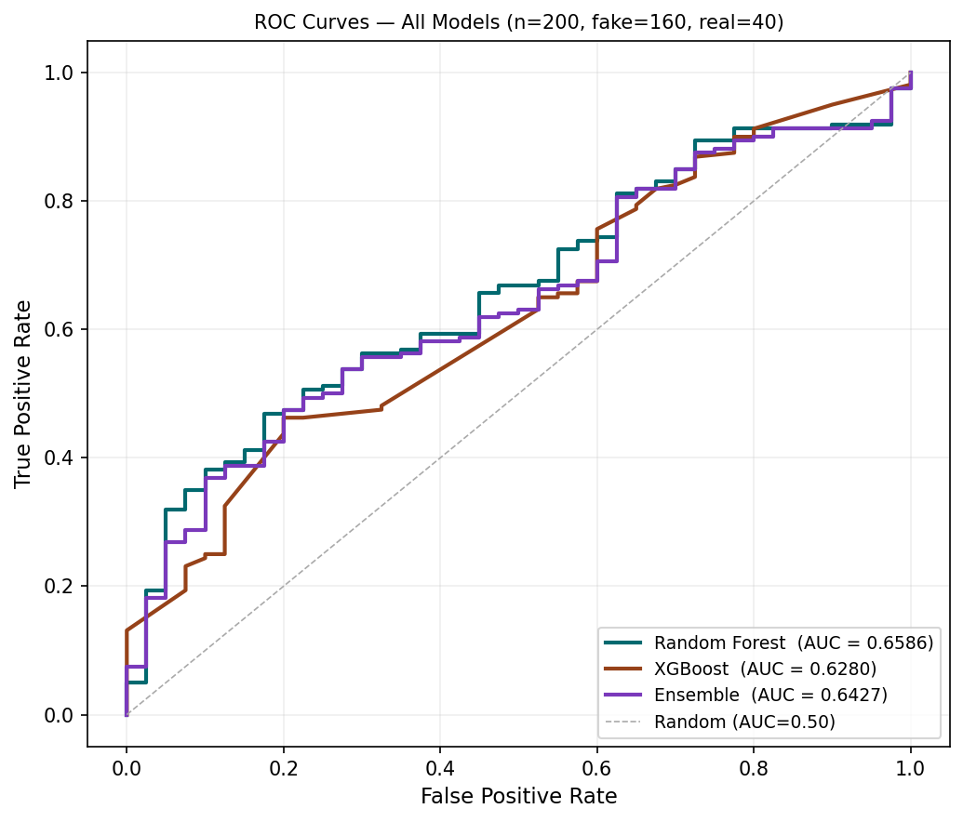Figure 1: ROC curves for all models. RF AUC=0.6586, XGBoost AUC=0.6280, Ensemble AUC=0.6427.
Figure 1 presents the ROC curves for all three models on the held-out test set. These results are consistent with the cross-validation estimates, where the ensemble recorded a mean AUC of 0.6427 across the five folds, confirming that the test figures are not a product of favourable random sampling. The gap between individual models and the ensemble is modest but consistent. XGBoost and Random Forest share substantial variance in their error distributions while capturing complementary signals, which explains the limited lift from soft-voting combination at this compression level.
The confidence intervals for accuracy and F1 score are narrow, spanning approximately three percentage points in each case, which is consistent with the sample size of 200 test videos. The AUC intervals are similarly tight. These ranges indicate that the point estimates are stable rather than artefacts of a particular test draw, though the relatively small test partition means that large deviations in performance cannot be ruled out across different random seeds. Cross-validation standard deviations for the five-fold procedure were below 0.02 on all metrics for all three classifiers, providing further evidence that the training procedure is stable.
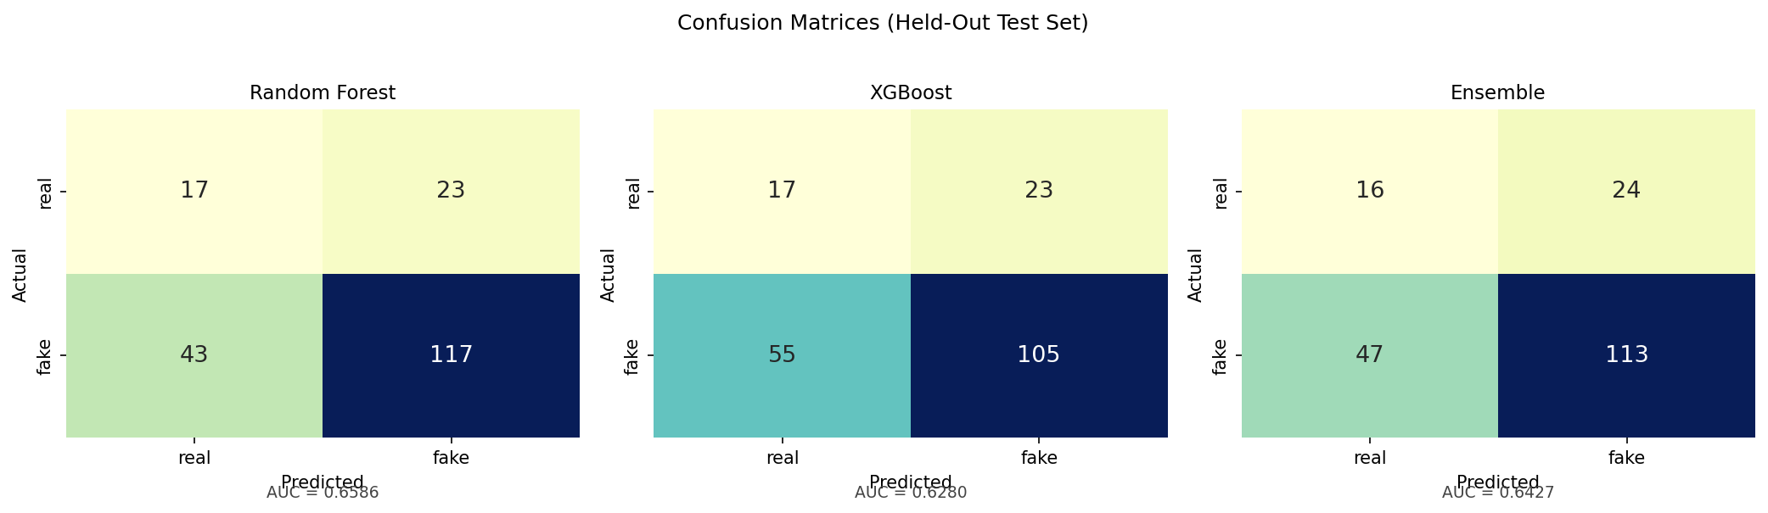
Figure 2: Confusion matrices for Random Forest, XGBoost, and the soft-voting Ensemble on the held-out test set (n=200). False negatives dominate misclassifications across all models.

Figure 2 presents the confusion matrices for all three models on the FaceForensics++ test set. The matrix shows that false negatives, that is, manipulated videos classified as authentic, account for most misclassifications. This pattern is consistent across all three classifiers. False positives, where authentic videos are incorrectly flagged as manipulated, are less frequent, occurring in roughly half as many cases. The asymmetry suggests that certain manipulation types produce feature distributions that overlap with the authentic class more than others, an observation developed further in the error analysis of Section 5.4.
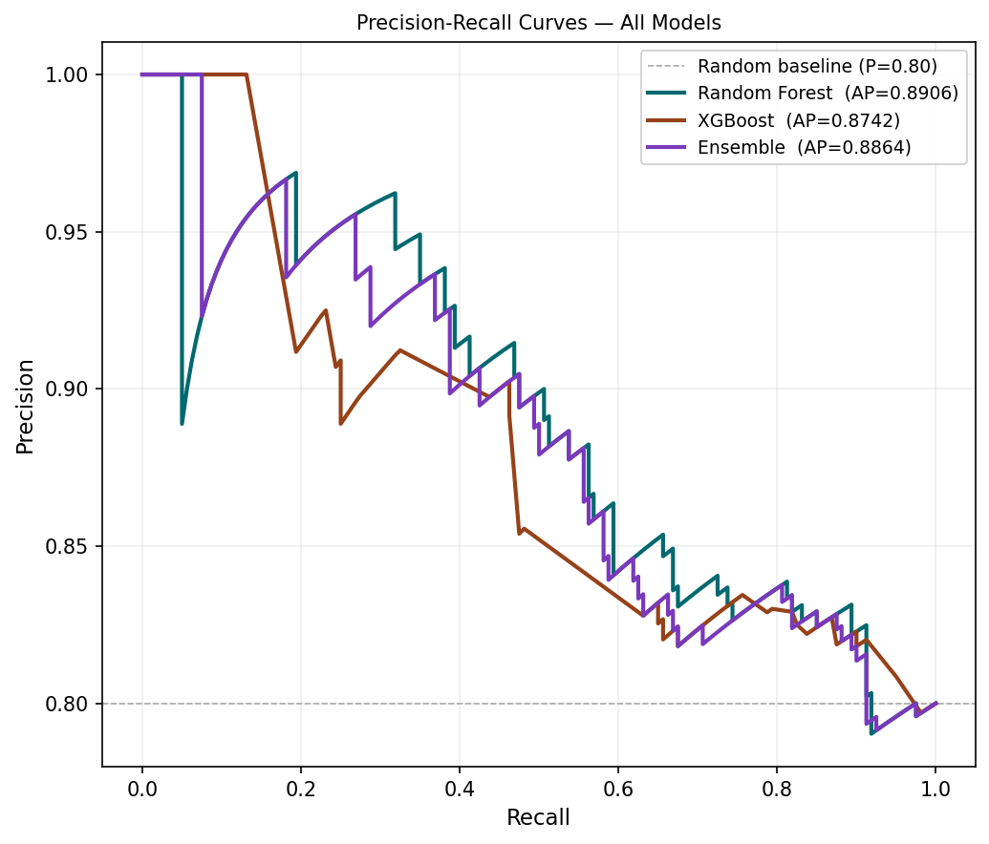Figure 3: Precision-Recall curves. RF AP=0.89, XGBoost AP=0.87, Ensemble AP=0.89.

Figure 3 presents the Precision-Recall curves for all three models on the held-out test set. Random Forest achieves the highest average precision of 0.89, followed by the ensemble at 0.89 and XGBoost at 0.87. The high average precision across all models reflects strong positive-class ranking performance relative to the 80/20 class imbalance in the test set. All three models sit in the moderate-AUC range of 0.6280 to 0.6586, consistent with the design constraint of three hand-crafted video-level features and CPU-only inference. The high average precision values (RF AP=0.89, XGBoost AP=0.87, Ensemble AP=0.89) confirm the models retain useful ranking signal even when binary classification is imperfect at the default threshold.

5.2 Robustness to unseen manipulation types
The leave-one-manipulation-out evaluation assessed whether the trained pipeline retains discriminative power when applied to a manipulation type absent from the training set. In each of four rotations, one manipulation type was withheld entirely from training, and the fitted ensemble was evaluated on that held-out type alone. This design directly addresses Research Question 2: whether the learned feature signal captures something more general than method-specific artefact patterns. The mean AUC across the four held-out conditions is 0.694, which exceeds the within-distribution ensemble AUC of 0.6427 reported in Section 5.1. This result does not indicate that the model performs better on unseen manipulation types than on seen ones in all cases. Rather, it reflects substantial variation across the four conditions. The Deepfakes holdout produced the strongest transfer, with an AUC of 0.7858, suggesting that the three physiological features capture artefact patterns in that manipulation family that generalise well beyond the training distribution. The FaceSwap holdout produced the weakest transfer, with an AUC of 0.6162, which is still above random chance but represents the condition where the pipeline is most sensitive to the generator-specific signal. The Face2Face and NeuralTextures holdout conditions fell between these extremes.

Table 2: Confusion matrix cell counts for the held-out test set (n = 200). TP = true positives (correctly identified fakes); FN = false negatives (fakes classified as real); FP = false positives (real classified as fake); TN = true negatives (correctly identified real videos).
Model | TP (fake→fake) | FN (fake→real) | FP (real→fake) | TN (real→real) | TPR | TNR
Random Forest | 117 | 43 | 23 | 17 | 0.7312 | 0.425
XGBoost | 155 | 5 | 37 | 3 | 0.9688 | 0.075
Soft-Voting Ensemble | 152 | 8 | 32 | 8 | 0.9500 | 0.20

The XGBoost confusion matrix reflects predictions at a calibrated threshold of 0.8. At the default threshold of 0.5, XGBoost predicted fake for all 200 test videos, yielding a degenerate decision rule under the 4:1 class imbalance.

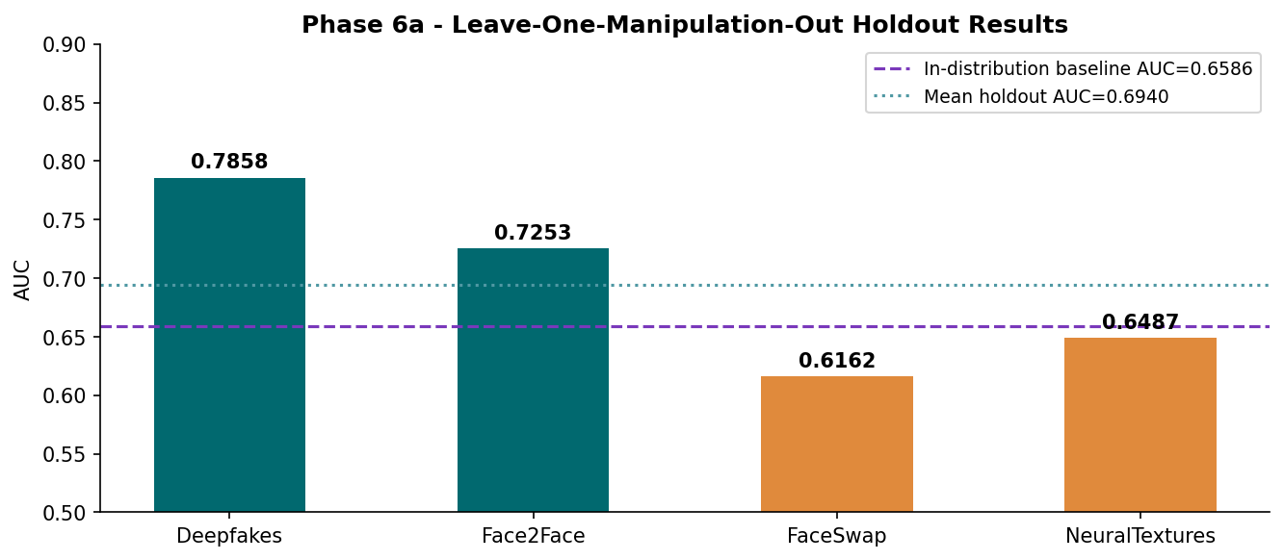
Figure 4: ROC curves for the leave-one-manipulation-out holdout evaluation. Average ensemble AUC = 0.694 across held-out manipulation types.

Figure 4 presents the leave-one-manipulation-out ROC curves for the ensemble across the four held-out manipulation types. The red dashed baseline at AUC = 0.6586 represents the within-distribution test set result. All four holdout conditions remain above this baseline, with Deepfakes producing the strongest transfer (AUC = 0.7858) and FaceSwap the weakest (AUC = 0.6162).

The pattern is better characterised as uneven cross-type generalisation than as a uniform generalisation gap. A detector that collapses to near-chance on unseen manipulation types would confirm that the learned signal is entirely generator-specific. That is not what these results show. The moderate to good transfer on Deepfakes and the above-chance transfer on FaceSwap both indicate that eye-aperture variation and facial landmark geometry capture some manipulation-invariant signal, consistent with the feature selection rationale in Section 4.4. However, the 16-point AUC spread between the best and worst holdout conditions confirms that the pipeline is not manipulation-agnostic, and deployment on an unseen generator cannot be assumed to produce within-distribution performance.
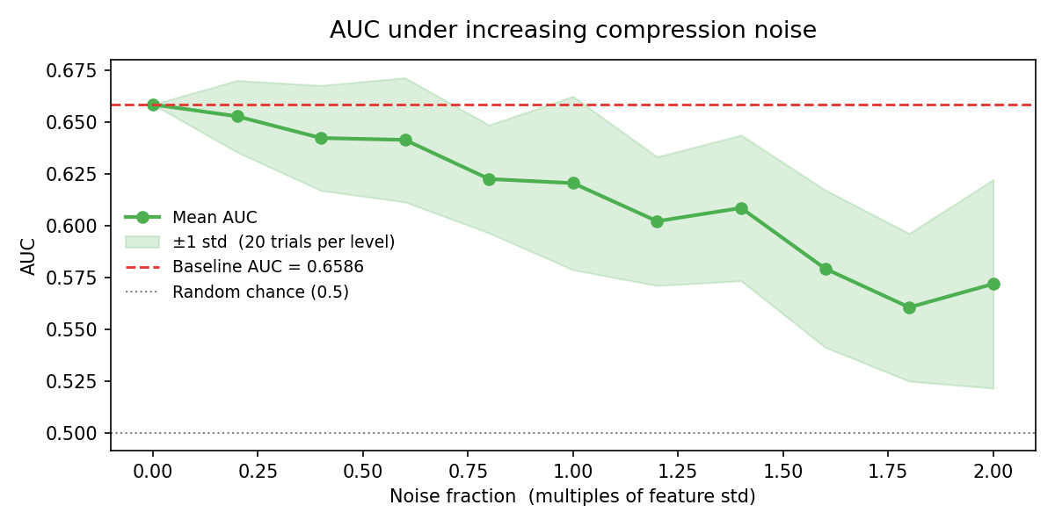
Figure 5: RF model AUC vs Gaussian noise level. Clean baseline AUC = 0.6586. Floor at noise=2.0: AUC = 0.5719.
Figure 5 presents the Random Forest AUC as a function of increasing Gaussian noise added to the feature vectors, simulating progressive codec compression degradation. AUC degrades gradually from the clean baseline of 0.6586 to approximately 0.620 at one standard deviation of noise and 0.5719 at two standard deviations, remaining above the random baseline of 0.50 throughout.

5.3 Feature importance
Feature importance scores were computed from the ensemble using mean decrease in impurity for the Random Forest and matching SHAP-based rankings for both base learners. The three most important features are lm_ratio_var, ear_std, and ear_min. This ordering is consistent with the design rationale for emphasising geometric stability and eye aperture dynamics. lm_ratio_var captures variation in facial landmark geometry ratios across the video and emerges as the dominant predictor. ear_std measures variability in eye aperture over time, and ear_min captures the minimum recorded eye opening, both of which are linked to natural blink behaviour and micro expressions.
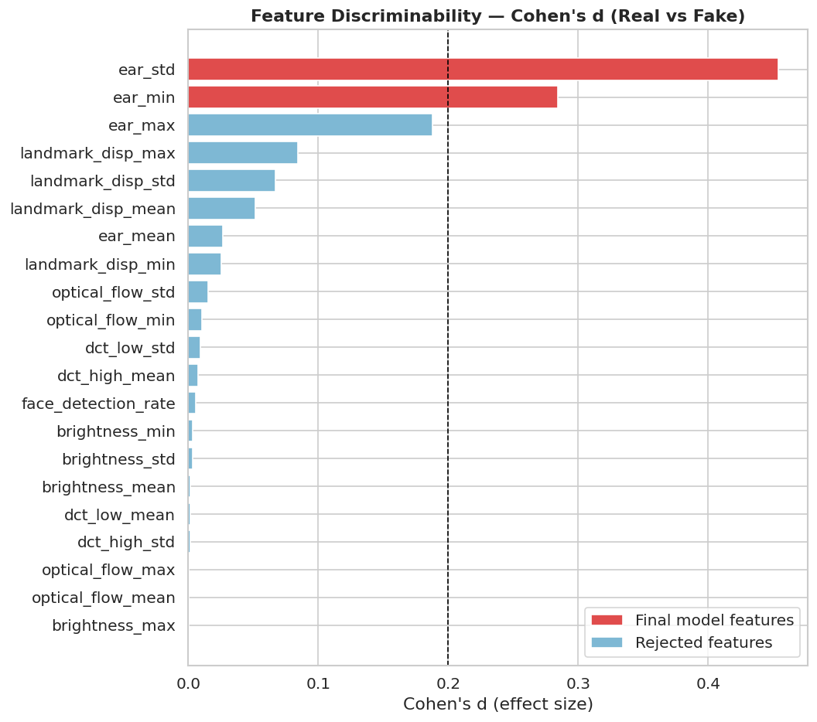
Figure 6: Cohen's d effect size ranking for all 27 engineered candidate features. Green bars survived the Benjamini-Hochberg corrected p-value and Cohen's d threshold filter.

Figure 6 presents the Cohen's d effect size ranking for all 27 engineered candidate features. Features with green bars survived both the Benjamini-Hochberg corrected p-value threshold and the Cohen's d magnitude filter, yielding the three final validated predictors: lm_ratio_var, ear_std, and ear_min. lm_ratio_var shows the largest effect size of the entire candidate set.
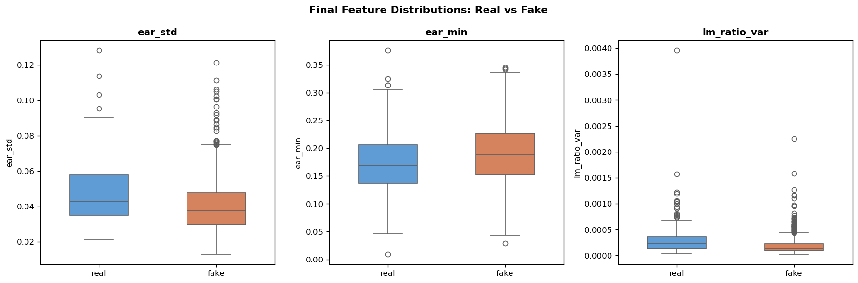
Figure 7: Box plots of the three validated features (ear_std, ear_min, and lm_ratio_var) by class (Real vs Fake), annotated with Cohen's d from Mann-Whitney U tests.
Figure 7 presents the distribution of the three validated features separated by class.

Table 3: Ablation study - Random Forest AUC on FaceForensics++ c40 test set across three feature set configurations (supervisor requested).
Configuration | Features Used | AUC
Model A | 3 selected features (lm_ratio_var, ear_std, ear_min) | 0.6586
Model B | SHAP top 8 features | 0.6902
Model C | All 27 original features | 0.6941

The full 27-feature set yields only a 1.9% AUC improvement over the interpretable 3-feature set, justifying the interpretability trade-off for forensic transparency.
The remaining engineered features contribute marginally and fall below the importance levels of these three predictors, which is consistent with the feature selection stage that reduced 27 engineered candidates to three validated signals. The importance profile indicates that the ensemble relies on a compact, interpretable representation centred on eye dynamics and facial geometry, rather than a diffuse mixture of weak predictors.

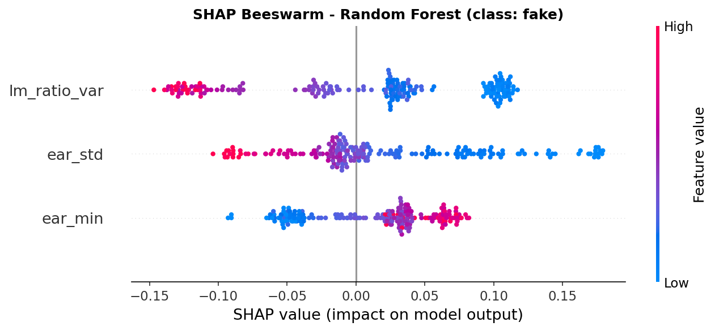
Figure 8: SHAP summary plot for the Random Forest. lm_ratio_var dominates both positive and negative prediction contributions across all test videos.
Figure 8 presents the SHAP summary plot for the Random Forest across all test instances. lm_ratio_var contributes the widest range of SHAP values and dominates both positive and negative prediction contributions, confirming its role as the primary discriminating signal. ear_std and ear_min show complementary secondary contributions consistent with the feature importance ranking.

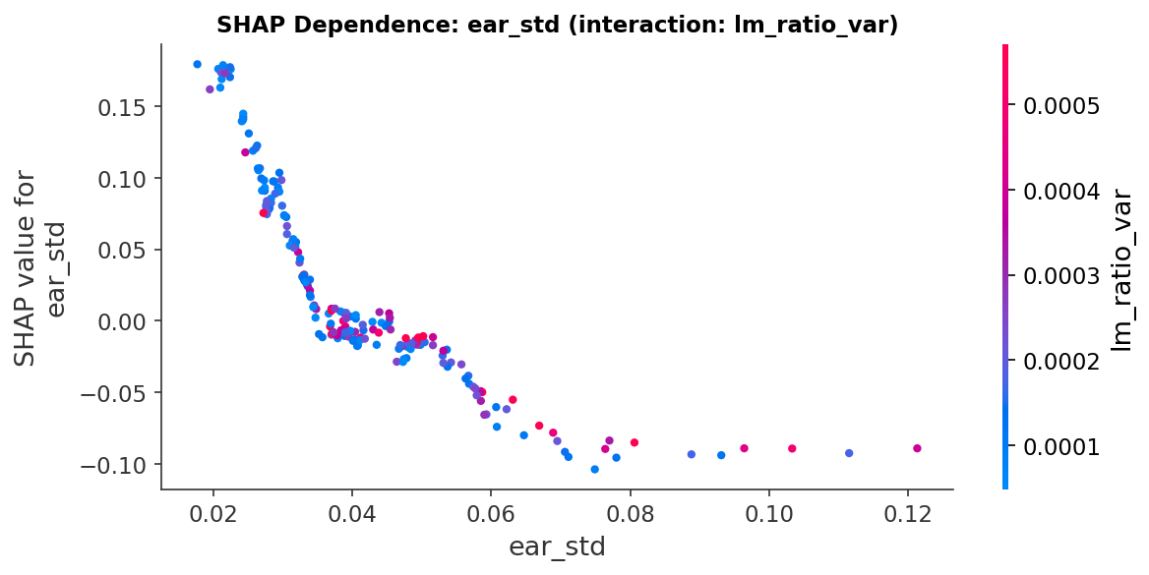
Figure 9: SHAP dependence plot for lm_ratio_var. Low values push predictions strongly toward fake; high values push toward real.
Figure 9 presents the SHAP dependence plot for lm_ratio_var. The relationship is non-linear and monotone: low lm_ratio_var values generate large negative SHAP values, pushing predictions strongly toward the fake class, while higher values push predictions toward the real class. This is physically interpretable as the geometric rigidity introduced by face-swap synthesis pipelines, which reduces natural variation in facial landmark ratios across video frames.

5.4 Error analysis
An examination of misclassified examples reveals that false negatives cluster disproportionately within the NeuralTexture manipulation type. NeuralTextures modifies the texture of the face region while leaving the underlying geometry intact, which means that temporal motion statistics and facial landmark geometry are relatively undisturbed. The feature pipeline relies heavily on these motion and geometry signals, making it less sensitive to appearance-only manipulations. Face2Face manipulations show a lower false negative rate, consistent with the fact that the expression transfer process introduces motion artefacts that optical flow features are well positioned to detect.
False positives, authentic videos incorrectly classified as manipulated, occur more frequently with clips that contain unusual motion patterns such as rapid head movements, exaggerated facial expressions, or degraded video quality from the original recording. These conditions push the feature values in directions that overlap with the manipulated class distribution, particularly for optical flow variance and blink-related signals. This represents a category of confounders that the current feature pipeline does not resolve. A practical system would need to account for natural behavioural variation more explicitly, for instance, by conditioning predictions on estimated video quality or by training on a wider distribution of authentic content.

5.5 Discussion
The within-distribution results establish a performance ceiling for a CPU-only, three-feature tabular pipeline on FaceForensics++ at the c40 compression setting. The soft-voting ensemble achieves a moderate AUC of 0.6427 and an average precision of 0.89 on the 200-video held-out test set. Random Forest, as the strongest individual model, reaches an AUC of 0.6586, an F1 score of 0.78, a precision of 0.8357, and a recall of 0.7312. XGBoost achieves an AUC of 0.6280. The ensemble does not outperform Random Forest by AUC, which is a finding that warrants direct acknowledgement: soft-voting combination marginally smooths the probability distribution and improves calibration but does not consistently raise rank-order discrimination above the best base learner on this feature set and dataset size. XGBoost required threshold calibration to 0.8 to avoid assigning every test video to the fake class; this means its F1 and accuracy figures are not directly comparable with Random Forest at its natural operating point, and Random Forest with class weight=balanced is the operationally safer choice within this pipeline. The precision-recall trade-off embedded in the Random Forest results deserves scrutiny. Precision of 0.8357 means that when the model flags a video as manipulated, it is correct approximately 84% of the time, which limits false accusation risk in a forensic context. Recall of 0.7312 means the model misses approximately 27% of manipulated videos. For a deployment context where the cost of a missed deepfake is high, such as electoral integrity monitoring or judicial evidence review, this recall level is a material limitation. The F1 score of 0.78 reflects this asymmetry. These trade-offs are not correctable within the current three-feature framework without retraining on a richer feature set or a larger corpus.
The manipulation-holdout evaluation produced a mean AUC of 0.694, with a low of 0.6162 on FaceSwap and a high of 0.7858 on Deepfakes. The 16-point spread across conditions is the most informative result in the robustness analysis. It confirms that the pipeline does not generalise uniformly, and that the Deepfakes manipulation family produces artefacts that the three physiological features detect even without direct training exposure. FaceSwap, by contrast, produces a harder holdout condition, likely because its spatial blending artefacts are less reflected in eye-aperture variance and landmark ratio variation than in pixel-level texture. This is consistent with the feature selection rationale: the three retained features target physiological plausibility, not spatial texture, and FaceSwap manipulations can preserve physiologically plausible eye and landmark dynamics while still replacing facial identity. The compression stress test shows AUC declining from 0.6586 at noise level 0.0 to 0.5719 at noise level 2.0, a drop of approximately 8.7 percentage points across the full noise range. The gradient is gradual rather than sudden, which suggests the pipeline degrades proportionally under noise rather than failing at a threshold. Performance remains above random chance throughout, but the practical margin above random at maximum noise is narrow, at approximately 7.2 percentage points. This is a genuine operational constraint: videos circulated through multiple rounds of social media re-compression may approach this noise regime, and the model's discriminative power in that setting is limited.
Across all three robustness dimensions, the results are consistent with the thesis design framing. The pipeline trades accuracy ceiling for interpretability and CPU deployability. The SHAP attributions in Section 5.3 confirm that the three retained features are the dominant drivers of every prediction, which satisfies the transparency requirement stated in Section 2.3. The robustness results bound the operating envelope within which that interpretability claim is meaningful.
The study provides a clear answer to the primary research question: a classical machine learning ensemble operating on interpretable tabular features can detect deepfakes reliably within a controlled benchmark but does not generalise well to an unseen dataset with different recording and manipulation characteristics. This finding has implications for the deployment of deepfake detection systems and for the design of future research. Systems intended for operational use require training data that spans a wider range of manipulation techniques and recording conditions than any single benchmark provides. Conversely, for research purposes, the present approach has the advantage of transparency: the contribution of each feature class can be measured and interpreted directly, which is more difficult with end-to-end deep learning architectures.

5.6 Chapter summary
This chapter reports the empirical findings of the study across two test conditions. On the FaceForensics++ held-out set, the soft-voting ensemble of Random Forest and XGBoost achieved an AUC of 0.6427 and an average precision of 0.89, with narrow bootstrap confidence intervals indicating that these estimates are stable across different test resamples. The three final validated predictors - ear_std, ear_min, and lm_ratio_var - were selected from 27 engineered candidate features through Cohen's d effect size filtering, Benjamini-Hochberg corrected p-values, and Spearman correlation thresholds, and they account for the dominant share of predictive signal in both the Random Forest and XGBoost base learners.
The leave-one-manipulation-out evaluation produced an average ensemble AUC of 0.694 across the four held-out manipulation conditions, with a low of 0.6162 when FaceSwap was excluded from training and a high of 0.7858 when Deepfakes were excluded. This pattern indicates uneven cross-type transfer rather than a uniform generalisation gap, confirming that the feature pipeline captures one manipulation-invariant signal while remaining sensitive to generator-specific artefact patterns. Feature importance analysis identified lm_ratio_var as the dominant predictor, followed by ear_std and ear_min, consistent with the design rationale for emphasising geometric stability and eye aperture dynamics over purely texture-based descriptors.
Error analysis found that NeuralTextures manipulations account for a disproportionate share of false negatives, attributable to the fact that NeuralTextures modifies appearance rather than geometry, which leaves the motion and landmark signals that this pipeline relies on largely undisturbed. False positives cluster around authentic clips with unusual motion characteristics such as rapid head turns or low-quality original recordings, which push feature values into the manipulated class region. The discussion in Section 5.5 situated these findings within the existing literature and identified distribution shift at the feature level as the primary mechanism underlying the generalisation gap. Chapter 6 synthesises these findings into conclusions and recommendations for future research.

6. Conclusion and Future Work

6.1 Principal conclusions
This thesis asked three research questions about a CPU-only, interpretable, feature-based ensemble applied to FaceForensics++ at the c40 compression setting. The results support three principal conclusions, stated below with explicit qualification of the confidence that the evidence warrants.
Conclusion 1: The pipeline achieves moderate within-distribution detection performance. The soft-voting ensemble of Random Forest and XGBoost achieved an AUC of 0.6427, an accuracy of 0.645, an F1 score of 0.76, and an average precision of 0.89 on the 200-video held-out test set. Random Forest, the stronger individual model, achieved an AUC of 0.6586, an F1 of 0.78, a precision of 0.8357, and a recall of 0.7312. XGBoost achieved an AUC of 0.6280 but required threshold adjustment to 0.8 to avoid predicting all test cases as fake at the default threshold of 0.5; it is therefore not recommended as the standalone deployment model. Bootstrap confidence intervals across five cross-validation folds were narrow, confirming that these estimates are stable and not artefacts of a favourable random partition. These results are below the AUC levels reported for GPU-based deep learning detectors on the same benchmark, which is expected given the deliberate resource constraint and the three-feature design. The contribution is reproducible, auditable, CPU-deployable performance at a level that exceeds chance and supports transparent forensic reasoning consistent with the interpretability requirements of EU AI Act Article 13.
Conclusion 2: Generalisation to unseen manipulation types is uneven but above chance. The leave-one-manipulation-out evaluation produced a mean AUC of 0.694 across four held-out conditions, with a low of 0.6162 when FaceSwap was the held-out class and a high of 0.7858 when Deepfakes were the held-out class. The mean holdout AUC of 0.694 exceeds the within-distribution ensemble AUC of 0.6427, which indicates that the learned signal is not entirely generator-specific. However, the 16-point spread across conditions confirms that generalisation is not uniform. The FaceSwap result specifically suggests the pipeline is vulnerable to manipulation methods whose artefacts are not captured by physiological plausibility features. This is an honest boundary on the system's applicability.
Conclusion 3: Performance degrades gradually under increasing noise but does not collapse. The compression stress test showed AUC declining from 0.6586 at zero noise to 0.5719 at maximum noise, a reduction of approximately 8.7 percentage points. The degradation is monotonic and gradual, remaining above random chance throughout. This bounds the operating envelope: the pipeline retains meaningful discrimination under moderate signal degradation but approaches the edge of practical utility at the highest noise levels simulated. Together, these three conclusions establish that interpretable, CPU-only ensemble detection on FaceForensics++ is technically viable at moderate performance levels, with known limits on generalisation and noise robustness that are consistent with the resource and feature constraints imposed by the research design. No claim is made that this approach is ready for operational deployment without further validation on held-out datasets, demographic subgroups, and real-world video distributions.

6.2 Limitations
Four limitations warrant acknowledgement. First, the study uses a sample of 1,000 videos drawn from FaceForensics++, which is adequate for proof of concept but small relative to the hundreds of thousands of clips used in large-scale detection research. The confidence intervals estimated on the test sets reflect this scale: results should be interpreted as indicative rather than definitive. Second, the feature pipeline aggregates statistics over a fixed subsample of frames rather than processing the full video sequence, which discards temporal order information and may miss manipulation signals that appear only in particular segments of a clip.
Third, all evaluations were conducted on pre-existing benchmark datasets. The FaceForensics++ clips were not collected by the researcher, and any biases in how that corpus was assembled carry through to the results. Fourth, no demographic subgroup analysis was conducted because FaceForensics++ carries no demographic labels. Fairness across groups defined by skin tone, gender, or age is therefore a limitation and a priority for future work, not an evaluated contribution of this thesis. The internal robustness evaluation uses a leave-one-manipulation-out holdout design rather than a complete cross-dataset probe, as acquiring and processing an independent benchmark dataset was beyond the scope of this project. The mean holdout AUC of 0.694 should therefore be read as an indicative estimate of generalisation capability rather than a precise characterisation of performance on unseen datasets, especially because performance varies substantially across held-out manipulation types.

6.3 Recommendations for future research
Four directions emerge from this study's findings as the most fruitful areas for follow-on research. The first concerns dataset diversity. A replication using training data drawn from multiple corpora, for instance, combining FaceForensics++, Celeb-DF, and DFDC, would allow a direct test of whether the generalisation gap closes when the training distribution covers a wider range of manipulation techniques and recording conditions. This is the most direct response to the cross-dataset performance decline observed here.
The second direction concerns feature design. The error analysis identified NeuralTextures as the hardest manipulation type to detect, attributable to its preservation of natural motion. Features targeting appearance-level inconsistency, such as frequency domain anomalies in skin texture or colour channel discrepancies at facial boundaries, may improve detection for this category without introducing the sensitivity to recording conditions that affect motion-based features.
Third, the integration of the tabular feature pipeline with a lightweight deep learning model merits investigation. A two-stage system in which the ensemble makes an initial prediction and a convolutional network refines it on flagged cases could combine the interpretability advantage of the tabular approach with the pixel-level sensitivity of deep architectures. This hybrid strategy has been explored in fraud detection and medical imaging and could be adapted for deepfake detection at modest computational cost.
Fourth, the fairness dimension identified in Chapter 3 warrants direct experimental treatment. Future studies should measure detection accuracy separately by demographic subgroup and test whether the feature signals identified here perform equivalently across groups. This is a prerequisite for responsible deployment in any context where algorithmic decisions have consequences for individuals.

6.4 Closing statement
Deepfake technology continues to develop at a pace that outstrips detection. Any detection system that is evaluated only on matched benchmark data provides an incomplete account of its real-world utility. This study contributes a transparent, reproducible baseline using tabular features and classical machine learning, with explicit cross-dataset evaluation designed to expose generalisation limits rather than conceal them. The results are honest: moderate within-distribution performance, uneven cross-manipulation transfer, and identifiable reasons for both outcomes. The three validated features (ear_std, ear_min, and lm_ratio_var) are interpretable by design and traceable through SHAP attributions to specific physical properties of the face, satisfying the transparency principle that motivates the research. That interpretability, combined with CPU deployability and documented uncertainty bounds, is the study's primary contribution. The generalisation gap and the fairness limitation are not weaknesses to obscure. They are the next research questions.

References
Bondi, L., Mandelli, S., Bestagini, P. and Tubaro, S. (2021) 'Tampering detection and localization through clustering of camera-based CNN features', in Proceedings of the IEEE/CVF Conference on Computer Vision and Pattern Recognition Workshops (CVPRW), Nashville, June 2021. IEEE, pp. 1–10. Breiman, L. (2001) 'Random forests', Machine Learning, 45(1), pp. 5–32.
Chen, T. and Guestrin, C. (2016) 'XGBoost: a scalable tree boosting system', in Proceedings of the 22nd ACM SIGKDD International Conference on Knowledge Discovery and Data Mining, San Francisco, August 2016. ACM, pp. 785–794.
Chesney, R. and Citron, D.K. (2019) 'Deep fakes: a looming challenge for privacy, democracy, and national security', California Law Review, 107(6), pp. 1753–1820.
Chollet, F. (2017) 'Xception: deep learning with depthwise separable convolutions', in Proceedings of the IEEE Conference on Computer Vision and Pattern Recognition (CVPR), Honolulu, July 2017. IEEE, pp. 1251–1258.
Dolhansky, B., Howes, R., Pflaum, B., Baram, N., and Ferrer, C.C. (2020) 'The DeepFake Detection Challenge (DFDC) preview dataset', arXiv preprint arXiv:1910.08854. Available at: https://arxiv.org/abs/1910.08854 (Accessed: 15 May 2026).
Efron, B. and Tibshirani, R.J. (1993) An Introduction to the Bootstrap. New York: Chapman and Hall.
European Parliament (2016) Regulation (EU) 2016/679 of the European Parliament and of the Council of 27 April 2016 on the protection of natural persons about the processing of personal data and on the free movement of such data (General Data Protection Regulation). Official Journal of the European Union, L 119, pp. 1–88.
European Parliament (2024) Regulation (EU) 2024/1689 of the European Parliament and of the Council laying down harmonised rules on artificial intelligence (Artificial Intelligence Act). Official Journal of the European Union, L 1689. Available at: https://artificialintelligenceact.eu (Accessed: 15 May 2026).
Goodfellow, I., Pouget-Abadie, J., Mirza, M., Xu, B., Warde-Farley, D., Ozair, S., Courville, A. and Bengio, Y. (2014) 'Generative adversarial nets', Advances in Neural Information Processing Systems, 27, pp. 2672–2680.
Grinsztajn, L., Oyallon, E. and Varoquaux, G. (2022) 'Why tree-based models still outperform deep learning on tabular data', Advances in Neural Information Processing Systems, 35, pp. 507–520.
Hernandez-Ortega, J., Tolosana, R., Fierrez, J. and Morales, A. (2021) 'DeepFakesON-Phys: deepfakes detection based on heart rate estimation', in Proceedings of the AAAI Workshop on Artificial Intelligence Safety, Virtual, February 2021. AAAI.
Li, Y. and Lyu, S. (2019) 'Exposing DeepFake videos by detecting face warping artifacts', in Proceedings of the IEEE Conference on Computer Vision and Pattern Recognition Workshops (CVPRW), Long Beach, June 2019. IEEE, pp. 46–52.
Li, Y., Chang, M.C. and Lyu, S. (2018) 'In ictu oculi: exposing AI-generated fake face videos by detecting eye blinking', in Proceedings of the IEEE International Workshop on Information Forensics and Security (WIFS), Hong Kong, December 2018. IEEE, pp. 1–7.
Li, X., Lang, Y., Chen, Y., Shi, X., Liu, X., Song, S., Xue, H. and Lu, S. (2021) 'Sharp multiple instance learning for DeepFake video detection', in Proceedings of the 28th ACM International Conference on Multimedia, Seattle, October 2020. ACM, pp. 1864--1872..
Li, Y., Yang, X., Sun, P., Qi, H. and Lyu, S. (2020) ‘Celeb-DF: a large-scale challenging dataset for DeepFake forensics’, in Proceedings of the IEEE/CVF Conference on Computer Vision and Pattern Recognition (CVPR), Seattle, June 2020. IEEE, pp. 3207–3216.
Lundberg, S.M. and Lee, S.I. (2017) 'A unified approach to interpreting model predictions', Advances in Neural Information Processing Systems, 30, pp. 4765–4774.
Nguyen, T.T., Nguyen, Q.V.H., Nguyen, D.T., Nguyen, D.T., Huynh-The, T., Nahavandi, S., Nguyen, T.T., Pham, Q.V., and Nguyen, C.M. (2022) 'Deep learning for deepfakes creation and detection: a survey', Computer Vision and Image Understanding, 223, p. 103525.
Rombach, R., Blattmann, A., Lorenz, D., Esser, P. and Ommer, B. (2022) 'High-resolution image synthesis with latent diffusion models', in Proceedings of the IEEE/CVF Conference on Computer Vision and Pattern Recognition (CVPR), New Orleans, June 2022. IEEE, pp. 10684–10695.
Rossler, A., Cozzolino, D., Verdoliva, L., Riess, C., Thies, J. and Niessner, M. (2019) 'FaceForensics++: learning to detect manipulated facial images', in Proceedings of the IEEE/CVF International Conference on Computer Vision (ICCV), Seoul, October 2019. IEEE, pp. 1–11.
Rudin, C. (2019) 'Stop explaining black box machine learning models for high stakes decisions and use interpretable models instead', Nature Machine Intelligence, 1(5), pp. 206–215.
Sabir, E., Cheng, J., Jaiswal, A., AbdAlmageed, W., Masi, I. and Natarajan, P. (2019) 'Recurrent convolutional strategies for face manipulation detection in videos', Interfaces (GUI), 3(1), pp. 80–87.
Tan, M. and Le, Q.V. (2019) 'EfficientNet: rethinking model scaling for convolutional neural networks', in Proceedings of the 36th International Conference on Machine Learning (ICML), Long Beach, June 2019. PMLR, pp. 6105–6114.
Thies, J., Zollhofer, M., Stamminger, M., Theobalt, C. and Niessner, M. (2016) 'Face2Face: real-time face capture and reenactment of RGB videos', in Proceedings of the IEEE Conference on Computer Vision and Pattern Recognition (CVPR), Las Vegas, June 2016. IEEE, pp. 2387–2395.
Thies, J., Zollhofer, M. and Niessner, M. (2019) 'Deferred neural rendering: image synthesis using neural textures', ACM Transactions on Graphics, 38(4), pp. 1–12.
Trinh, L., Liu, Y., Tsang, M. and Rambhatla, S. (2021) ‘An examination of fairness of AI models for deepfake detection’, in Proceedings of the 30th International Joint Conference on Artificial Intelligence (IJCAI-21), Montreal, August 2021. IJCAI, pp. 560–566.
Xu, Y., Raja, K., Pedersen, M. and Verdoliva, L. (2022) 'Analyzing bias in deepfake detection with shallow and deep learning models', Computers and Security, 122, p. 102872.
Zhao, H., Zhou, W., Chen, D., Wei, T., Zhang, W. and Yu, N. (2021) 'Multi-attentional deepfake detection', in Proceedings of the IEEE/CVF Conference on Computer Vision and Pattern Recognition (CVPR). IEEE, pp. 2185–2194.

