ELEC 374 Digital Systems Engineering

CPU Design Project: Lab Final Report
Author names and student numbers: Russell Litwin (20398808), Jake Hoffman (20398257), Josh Ossip (20398317)
Lab section: Group 26
Submission date: April 1, 2026
Course term: Winter 2026
Institution: Queen's University, Department of Electrical and Computer Engineering

Abstract
This report documents the complete design, implementation, and verification of a Mini SRC processor for the ELEC 374 CPU design project. The processor is a 32 bit single bus architecture with sixteen general purpose registers, a 512 word memory, and a control unit implemented as a finite state machine. The design was developed in four phases, progressing from a standalone datapath through control unit integration to FPGA implementation on a Cyclone V device. The final design executes all required instructions correctly, meets timing at over 250 MHz, and uses 13 percent of the available logic resources. All four phases were completed successfully and demonstrated in the lab.

Table of Contents
CPU Design Project: Lab Final Report 1
Abstract 1
Table of Contents 1
1. Project Specification 3
2. Project Design and Implementation 3
2.1 Datapath Architecture (Phase 1) 3
2.2 Select and Encode, Branches, Memory, and IO (Phase 2) 4
2.3 Control Unit (Phase 3) 5
2.4 FPGA Implementation (Phase 4) 5
3. Evaluation Results 6
3.1 Maximum Frequency of Operation 6
3.2 Average Cycles Per Instruction 6
3.3 Chip Area Utilization 7
4. Discussion 7
5. Conclusion and Future Work 8
Academic Integrity Statement 9
Appendix A: Verilog Source Code 9
A.1 Defines (defines.vh) 9
A.2 Control Unit (control_unit.v) 10
A.3 CPU Integration (cpu_phase3.v) 17
A.4 FPGA Top Level (cpu_phase4_top.v) 19
A.5 Datapath (datapath_logic.v) 20
A.6 Bus Multiplexer (bus_mux.v) 25
A.7 ALU (alu_logic.v) 26
A.8 32-bit CLA Adder (cla32.v) 27
A.9 4-bit CLA Block (cla4.v) 27
A.10 Booth Multiplier (booth_bit_pair.v) 28
A.11 Non-Restoring Divider (nonrestoring_div32.v) 29
A.12 Select and Encode (select_encode.v) 30
A.13 Sign Extension (sign_extend_c.v) 30
A.14 Condition Logic (con_ff_logic.v) 31
A.15 IO Ports (io_ports.v) 31
A.16 RAM (ram512x32.v) 31
A.17 32-bit Register (register32.v) 32
A.18 64-bit Register (register64.v) 32
A.19 Seven Segment Decoder (seven_seg_hex.v) 33
Appendix B: Testbenches and Test Programs 33
B.1 Phase 3 Testbench (tb_phase3_cpu.v) 33
B.2 Phase 4 Testbench (tb_phase4_cpu.v) 37
B.3 Phase 3 Memory Init (phase3_mem_init.hex) 39
B.4 Phase 4 Memory Init (phase4_mem_init.hex) 40
Appendix C: Functional Simulation Results 41
Appendix D: Phase 4 Waveform Screenshots 42

1. Project Specification
The Mini SRC is a 32 bit RISC processor with a single internal bus architecture. The design follows the specification provided in the course documentation, which defines the processor state, instruction set, and memory organization. The processor contains sixteen 32 bit general purpose registers R0 through R15, with R0 through R7 designated as general purpose, R8 through R11 as argument registers, R12 as the return address register, R13 and R14 as return value registers, and R15 as the stack pointer. Two additional 32 bit registers HI and LO hold the upper and lower halves of multiplication and division results.
The memory unit is 512 words of 32 bits each. Memory is accessed through the MAR and MDR registers using load and store instructions. A 32 bit input port and a 32 bit output port provide basic input and output capability.
The instruction set consists of 32 bit instructions in five formats. R format instructions encode three register operands for arithmetic and logical operations. I format instructions encode two registers and a 19 bit sign extended constant for immediate operations, loads, and stores. B format instructions encode a register, a two bit condition code, and a 19 bit offset for conditional branches. J format instructions encode a single register for jumps and input output operations. M format instructions encode only an opcode for nop and halt.
The arithmetic logic unit supports thirteen operations: add, subtract, multiply, divide, shift right, shift right arithmetic, shift left, rotate right, rotate left, logical AND, logical OR, negate, and bitwise NOT. The multiply and divide operations produce 64 bit results split across the HI and LO registers.
Four conditional branch modes are supported: branch if zero, branch if nonzero, branch if positive, and branch if negative. The branch target is computed as PC plus one plus the sign extended offset. The processor does not use a condition code register. Instead, the value in the register specified by the Ra field is tested directly against the branch condition.

2. Project Design and Implementation

2.1 Datapath Architecture (Phase 1)
The datapath was implemented as a one bus architecture. In each clock cycle, at most one source value is placed on the shared 32 bit bus, and one or more destination registers capture that value when their load enable is asserted. A 25 to 1 bus multiplexer selects the bus source based on a five bit control field. The selectable sources include the sixteen general purpose registers, the program counter, instruction register, Y register, MAR, MDR, HI, LO, and the low and high halves of the Z register.
A temporary register Y holds the first arithmetic operand because the bus can carry only one value at a time. The ALU receives Y as its A input and the current bus value as its B input and produces a 64 bit result. A 64 bit Z register captures the ALU output so that both 32 bit operations and 64 bit multiply and divide results can be stored using the same structure. For 32 bit operations the upper half of Z is zero and the result is read from the low half. For multiply and divide the low half goes to the LO register and the high half goes to the HI register.
The ALU was built using dedicated arithmetic blocks. Addition and subtraction share a 32 bit carry lookahead adder constructed from eight four bit CLA blocks. Subtraction is handled by inverting the B operand and setting the carry input to one. Multiplication uses a Booth bit pair recoding multiplier that processes two bits of the multiplier per iteration. Division uses a non restoring division algorithm that produces a 32 bit quotient and 32 bit remainder. Shifts, rotates, and logical operations are implemented using standard Verilog operators.

2.2 Select and Encode, Branches, Memory, and IO (Phase 2)
In Phase 2 the datapath was extended with several components required for full instruction execution. The select and encode logic decodes the register fields Ra, Rb, and Rc from the instruction register and generates one hot register select signals. Three control inputs Gra, Grb, and Grc choose which field to decode, and two outputs Rin decoded and Rout decoded drive the register file load enables and bus source selection respectively. This allows the control unit to reference registers by their instruction field position rather than by explicit register number.
The sign extension unit takes the 19 bit constant field from the instruction register and sign extends it to 32 bits. The sign extended value is placed on the bus when the Cout control signal is asserted, allowing immediate values to participate in ALU operations.
The CON FF logic evaluates branch conditions. It receives the bus value and the two bit condition code from the instruction register and produces a one bit condition flag. The four conditions are branch if zero, branch if nonzero, branch if positive, and branch if negative. The flag is latched on the clock edge when CONin is asserted, and it controls whether the conditional program counter write is enabled during the branch execute state.
The memory subsystem uses a 512 by 32 bit synchronous RAM block. The RAM is initialized from a hex file at elaboration time. Reads are asynchronous and writes occur on the rising clock edge when the write enable signal is asserted. The MAR provides the address and the MDR provides the write data or captures the read data. A separate debug address port allows the testbench to inspect any memory location without interfering with the program.
The input and output ports are simple registered interfaces. The output port captures the bus value when OutPortin is asserted. The input port captures an external data value when InPortLoad is asserted, and the latched value is placed on the bus when InPortout is asserted.

2.3 Control Unit (Phase 3)
The control unit was implemented as a single Mealy style finite state machine with 43 states. On each clock edge the state register advances according to the next state logic, and a combinational block drives all datapath control signals based on the current state and the opcode field of the instruction register.
Every instruction begins with a three state fetch sequence. In the first fetch state the program counter is placed on the bus and loaded into MAR while the Z register captures PC plus one through the IncPC path. In the second fetch state the incremented value is written back to PC and the MDR captures the instruction word from RAM. In the third fetch state the MDR contents are transferred into the instruction register. A decode state then examines the five bit opcode and branches to the appropriate execution state sequence.
R type ALU instructions use three execution states. The first places the Rb register on the bus and loads it into Y. The second places the Rc register on the bus, sets the ALU operation, and captures the result in Z. The third places the Z low half on the bus and writes it to the Ra register. Immediate ALU instructions follow the same pattern but use the sign extended constant in place of the Rc register.
Multiply and divide use four execution states because the 64 bit result must be split into separate writes to HI and LO. Load instructions use five states to compute the effective address, read from memory, and write the result to a register. Store instructions also use five states but latch the store data into MDR before computing the address.
Branch instructions use four states. The first latches the condition flag by placing the Ra register on the bus and asserting CONin. The remaining states compute the branch target as PC plus the sign extended offset and conditionally write it to PC based on the latched flag. Jump register and jump and link use one and two states respectively. The halt state deasserts the run signal and holds the machine in a self loop.

2.4 FPGA Implementation (Phase 4)
For the FPGA implementation a top level wrapper module was created to interface the CPU with the DE0 CV development board. The 50 MHz board clock is divided down using a three bit counter, with bit two selected as the CPU clock, producing a 6.25 MHz effective clock rate. Push buttons KEY0 and KEY1 are active low on the DE0 CV, so they are inverted to produce the active high reset and stop signals expected by the control unit.
The eight slide switches SW0 through SW7 feed into the lower eight bits of the 32 bit input port, with the upper 24 bits tied to zero. The lower byte of the output port drives two seven segment display decoders for HEX0 and HEX1, allowing the output value to be displayed in hexadecimal on the board. Displays HEX2 through HEX5 are blanked by driving all segments high. A single LED indicates the run state of the processor.
The test program for Phase 4 extends the Phase 3 program with an input output loop. The program reads the switch value through the input port, stores it to memory, and then enters a display loop that shifts the value right by one bit and outputs each intermediate result. A delay counter loaded from memory provides a visible pause between display updates. The loop repeats five times before outputting a final value and halting. On the FPGA board, the display shows a shifting pattern across the two seven segment digits before settling on the final value.
The Quartus project targets the Cyclone V 5CEBA4F23C7 device. Pin assignments follow the DE0 CV user manual. An SDC constraint file defines the 50 MHz clock on the CLOCK 50 input pin. The design compiles with zero errors and meets timing with positive slack on all paths.

3. Evaluation Results

3.1 Maximum Frequency of Operation
The Quartus Timing Analyzer reports a worst case setup slack of 16.024 nanoseconds against a 20 nanosecond clock period under the slow 1100 millivolt 85 degree Celsius model. The maximum operating frequency is therefore one divided by the critical path delay of 3.976 nanoseconds, which gives approximately 251.5 MHz. Under the fast corner model the slack increases to 17.927 nanoseconds, corresponding to a maximum frequency of approximately 482.6 MHz. In practice the design runs on the FPGA at a divided clock rate of 6.25 MHz, well within the timing margins.
Corner | Setup Slack (ns) | Fmax (MHz)
Slow 1100mV 85C | 16.024 | 251.5
Fast 1100mV 0C | 17.927 | 482.6

3.2 Average Cycles Per Instruction
The Phase 3 test program executes 44 instructions in 310 clock cycles, giving an average CPI of 7.05. This includes the four cycle fetch and decode overhead for every instruction plus the variable number of execution states per instruction type. Instructions with memory access such as load and store have the highest individual cycle counts at nine cycles each, while simple register moves through mfhi and mflo complete in five cycles. The overall average is dominated by the fixed four cycle fetch decode cost, which accounts for more than half of the total cycles.
The Phase 4 test program executes approximately 782 instructions in 5269 clock cycles, giving an average CPI of approximately 6.74. The lower average compared to Phase 3 is due to the inner delay loop, which consists of short instructions that execute in fewer cycles per instruction.
Test Program | Instructions | Cycles | Avg CPI
Phase 3 | 44 | 310 | 7.05
Phase 4 | ~782 | 5269 | ~6.74

3.3 Chip Area Utilization
The design uses 2344 of 18480 available adaptive logic modules on the Cyclone V device, which corresponds to 13 percent utilization. The register count is 937. The RAM block usage is two blocks out of 308 available, consuming 16384 of over three million available block memory bits. No DSP blocks or PLLs are used. The low utilization indicates substantial headroom for additional features such as a wider bus architecture or more complex control logic.
Resource | Used / Available | Utilization
Logic (ALMs) | 2,344 / 18,480 | 13%
Registers | 937 | -
Block Memory Bits | 16,384 / 3,153,920 | <1%
RAM Blocks | 2 / 308 | <1%

4. Discussion
The single bus architecture was straightforward to implement and debug because each clock cycle involves exactly one bus transfer. The main disadvantage is performance. Every instruction requires at least four cycles for fetch and decode before any execution states begin. A multi bus architecture could overlap operand reads and reduce the cycle count for most instructions, but at the cost of a more complex bus arbitration scheme and wider multiplexers.
The non restoring division algorithm was the most challenging component to implement. Early versions produced incorrect quotients for certain sign combinations because the correction step was not handling the remainder sign properly. The issue was resolved by testing all four sign combinations in the Phase 1 testbench and comparing against hand calculated expected values.
The Booth bit pair multiplier was chosen over a simple shift and add multiplier because it reduces the number of partial product rows by half. This did not significantly affect the synthesis area because the multiplier is purely combinational and Quartus optimizes it aggressively, but it simplified the verification since each partial product step could be checked against the recoding table.
One challenge during Phase 3 was ensuring that the control unit and datapath agreed on timing. The control unit drives its signals combinationally based on the current state, and the datapath latches values on the next clock edge. Off by one errors in the state sequencing caused several instructions to read stale register values during initial testing. These were caught by the automated testbench, which checks not just final values but also intermediate control flow properties like whether specific instructions were observed in the IR during execution.
The Phase 4 FPGA implementation required a clock divider because the test program runs too quickly at 50 MHz for the display pattern to be visible. A three bit counter with bit two as the CPU clock was sufficient to slow the display updates to a rate where the shifting pattern could be observed by eye.
All four phases were completed and demonstrated successfully. There are no known outstanding issues. The design passes all testbench verification checks for both Phase 3 and Phase 4 test programs.

5. Conclusion and Future Work
The Mini SRC processor was designed, simulated, and implemented on the DE0 CV FPGA board across four project phases. The final design correctly executes all required instructions including arithmetic and logical operations, load and store with multiple addressing modes, conditional branches, jump and link, multiply and divide with HI LO register writeback, and input output operations. The control unit finite state machine generates the correct control sequence for each instruction, and the automated testbenches confirm correct behavior for both the Phase 3 and Phase 4 test programs.
The design meets timing with a maximum operating frequency of approximately 251 MHz under worst case conditions and uses 13 percent of the available logic on the Cyclone V device. The average cycles per instruction is approximately seven, which is expected for a single bus architecture where every instruction requires a four cycle fetch and decode sequence.
Several directions for future work could improve the design. A three bus architecture would allow simultaneous reads of two source operands and a write to the destination in a single cycle, potentially reducing the CPI by half or more. Pipelining the fetch decode execute stages would allow the next instruction to begin fetching while the current one is still executing. Branch prediction could reduce the penalty of taken branches in a pipelined design. Hardware interrupt support would allow the processor to respond to external events without polling. A cache memory system would be necessary if the address space were expanded beyond the current 512 words.

Academic Integrity Statement
"We do hereby verify that this written lab report is our own work and contains our own original ideas, concepts, and designs. No portion of this report has been copied in whole or in part from another source, with the possible exception of properly referenced material".

Appendix A: Verilog Source Code
The following listings contain the complete Verilog source code for the Mini SRC processor design.

A.1 Defines (defines.vh)
`ifndef DEFINES_VH
`define DEFINES_VH
`define ANDop 4'd1
`define ORop 4'd2
`define SHLop 4'd3
`define SHRop 4'd4
`define SHRAop 4'd5
`define ROLop 4'd6
`define RORop 4'd7
`define ADDop 4'd8
`define SUBop 4'd9
`define MULop 4'd10
`define DIVop 4'd11
`define NEGop 4'd12
`define NOTop 4'd13
`define OP_ADD 5'd0
`define OP_SUB 5'd1
`define OP_AND 5'd2
`define OP_OR 5'd3
`define OP_SHR 5'd4
`define OP_SHRA 5'd5
`define OP_SHL 5'd6
`define OP_ROR 5'd7
`define OP_ROL 5'd8
`define OP_ADDI 5'd9
`define OP_ANDI 5'd10
`define OP_ORI 5'd11
`define OP_DIV 5'd12
`define OP_MUL 5'd13
`define OP_NEG 5'd14
`define OP_NOT 5'd15
`define OP_LD 5'd16
`define OP_LDI 5'd17
`define OP_ST 5'd18
`define OP_JAL 5'd19
`define OP_JR 5'd20
`define OP_BR 5'd21
`define OP_IN 5'd22
`define OP_OUT 5'd23
`define OP_MFHI 5'd24
`define OP_MFLO 5'd25
`define OP_NOP 5'd26
`define OP_HALT 5'd27
`endif

A.2 Control Unit (control_unit.v)
`include "defines.vh"
module control_unit (
input wire clk,
input wire reset,
input wire stop,
input wire [31:0] IR,
input wire CON_q,
output wire Run,
output reg [4:0] bus_sel,
output reg [15:0] Rin,
output reg Yin,
output reg Zin,
output reg PCin,
output reg IRin,
output reg MARin,
output reg MDRin,
output reg HIin,
output reg LOin,
output reg IncPC,
output reg Read,
output reg Write,
output reg Gra,
output reg Grb,
output reg Grc,
output reg Rin_dec,
output reg Rout_dec,
output reg BAout,
output reg Cout,
output reg CONin,
output reg CON_to_PCin,
output reg OutPortin,
output reg InPortout,
output reg InPortLoad,
output reg [3:0] op
);
localparam [4:0] SEL_PC = 5'd16;
localparam [4:0] SEL_MDR = 5'd20;
localparam [4:0] SEL_HI = 5'd21;
localparam [4:0] SEL_LO = 5'd22;
localparam [4:0] SEL_ZLOW = 5'd23;
localparam [4:0] SEL_ZHIGH = 5'd24;
localparam [5:0]
S_RESET = 6'd0,
S_FETCH0 = 6'd1,
S_FETCH1 = 6'd2,
S_FETCH2 = 6'd3,
S_DECODE = 6'd42,
S_ALU_T3 = 6'd4,
S_ALU_T4 = 6'd5,
S_ALU_T5 = 6'd6,
S_UNARY_T3 = 6'd7,
S_UNARY_T4 = 6'd8,
S_MD_T3 = 6'd9,
S_MD_T4 = 6'd10,
S_MD_T5 = 6'd11,
S_MD_T6 = 6'd12,
S_LD_T3 = 6'd13,
S_LD_T4 = 6'd14,
S_LD_T5 = 6'd15,
S_LD_T6 = 6'd16,
S_LD_T7 = 6'd17,
S_LDI_T3 = 6'd18,
S_LDI_T4 = 6'd19,
S_LDI_T5 = 6'd20,
S_ST_T3 = 6'd21,
S_ST_T4 = 6'd22,
S_ST_T5 = 6'd23,
S_ST_T6 = 6'd24,
S_ST_T7 = 6'd25,
S_IMM_T3 = 6'd26,
S_IMM_T4 = 6'd27,
S_IMM_T5 = 6'd28,
S_BR_T3 = 6'd29,
S_BR_T4 = 6'd30,
S_BR_T5 = 6'd31,
S_BR_T6 = 6'd32,
S_JR_T3 = 6'd33,
S_JAL_T3 = 6'd34,
S_JAL_T4 = 6'd35,
S_MFHILO_T3 = 6'd36,
S_OUT_T3 = 6'd37,
S_IN_T3 = 6'd38,
S_IN_T4 = 6'd39,
S_NOP_T3 = 6'd40,
S_HALT = 6'd41;
reg [5:0] state;
reg [5:0] next_state;
reg run_q;
reg next_run;
wire [4:0] opcode = IR[31:27];
assign Run = run_q;
function [3:0] alu_from_opcode;
input [4:0] opcode_f;
begin
case (opcode_f)
`OP_ADD: alu_from_opcode = `ADDop;
`OP_SUB: alu_from_opcode = `SUBop;
`OP_AND: alu_from_opcode = `ANDop;
`OP_OR: alu_from_opcode = `ORop;
`OP_SHR: alu_from_opcode = `SHRop;
`OP_SHRA: alu_from_opcode = `SHRAop;
`OP_SHL: alu_from_opcode = `SHLop;
`OP_ROR: alu_from_opcode = `RORop;
`OP_ROL: alu_from_opcode = `ROLop;
`OP_ADDI: alu_from_opcode = `ADDop;
`OP_ANDI: alu_from_opcode = `ANDop;
`OP_ORI: alu_from_opcode = `ORop;
`OP_MUL: alu_from_opcode = `MULop;
`OP_DIV: alu_from_opcode = `DIVop;
`OP_NEG: alu_from_opcode = `NEGop;
`OP_NOT: alu_from_opcode = `NOTop;
default: alu_from_opcode = 4'd0;
endcase
end
endfunction
always @(posedge clk) begin
if (reset) begin
state <= S_RESET;
run_q <= 1'b1;
end else begin
state <= next_state;
run_q <= next_run;
end
end
always @(*) begin
next_state = state;
next_run = run_q;
bus_sel = 5'd0;
Rin = 16'd0;
Yin = 1'b0;
Zin = 1'b0;
PCin = 1'b0;
IRin = 1'b0;
MARin = 1'b0;
MDRin = 1'b0;
HIin = 1'b0;
LOin = 1'b0;
IncPC = 1'b0;
Read = 1'b0;
Write = 1'b0;
Gra = 1'b0;
Grb = 1'b0;
Grc = 1'b0;
Rin_dec = 1'b0;
Rout_dec = 1'b0;
BAout = 1'b0;
Cout = 1'b0;
CONin = 1'b0;
CON_to_PCin = 1'b0;
OutPortin = 1'b0;
InPortout = 1'b0;
InPortLoad = 1'b0;
op = 4'd0;
if (stop) begin
next_state = S_HALT;
next_run = 1'b0;
end else begin
case (state)
S_RESET: begin
next_state = S_FETCH0;
next_run = 1'b1;
end
S_FETCH0: begin
bus_sel = SEL_PC;
MARin = 1'b1;
IncPC = 1'b1;
Zin = 1'b1;
next_state = S_FETCH1;
end
S_FETCH1: begin
bus_sel = SEL_ZLOW;
PCin = 1'b1;
Read = 1'b1;
MDRin = 1'b1;
next_state = S_FETCH2;
end
S_FETCH2: begin
bus_sel = SEL_MDR;
IRin = 1'b1;
next_state = S_DECODE;
end
S_DECODE: begin
case (opcode)
`OP_ADD,
`OP_SUB,
`OP_AND,
`OP_OR,
`OP_SHR,
`OP_SHRA,
`OP_SHL,
`OP_ROR,
`OP_ROL: next_state = S_ALU_T3;
`OP_NEG,
`OP_NOT: next_state = S_UNARY_T3;
`OP_MUL,
`OP_DIV: next_state = S_MD_T3;
`OP_LD: next_state = S_LD_T3;
`OP_LDI: next_state = S_LDI_T3;
`OP_ST: next_state = S_ST_T3;
`OP_ADDI,
`OP_ANDI,
`OP_ORI: next_state = S_IMM_T3;
`OP_BR: next_state = S_BR_T3;
`OP_JR: next_state = S_JR_T3;
`OP_JAL: next_state = S_JAL_T3;
`OP_MFHI,
`OP_MFLO: next_state = S_MFHILO_T3;
`OP_OUT: next_state = S_OUT_T3;
`OP_IN: next_state = S_IN_T3;
`OP_NOP: next_state = S_NOP_T3;
`OP_HALT: begin
next_state = S_HALT;
next_run = 1'b0;
end
default: begin
next_state = S_HALT;
next_run = 1'b0;
end
endcase
end
S_ALU_T3: begin
Grb = 1'b1;
Rout_dec = 1'b1;
Yin = 1'b1;
next_state = S_ALU_T4;
end
S_ALU_T4: begin
Grc = 1'b1;
Rout_dec = 1'b1;
op = alu_from_opcode(opcode);
Zin = 1'b1;
next_state = S_ALU_T5;
end
S_ALU_T5: begin
bus_sel = SEL_ZLOW;
Gra = 1'b1;
Rin_dec = 1'b1;
next_state = S_FETCH0;
end
S_UNARY_T3: begin
Grb = 1'b1;
Rout_dec = 1'b1;
op = alu_from_opcode(opcode);
Zin = 1'b1;
next_state = S_UNARY_T4;
end
S_UNARY_T4: begin
bus_sel = SEL_ZLOW;
Gra = 1'b1;
Rin_dec = 1'b1;
next_state = S_FETCH0;
end
S_MD_T3: begin
Gra = 1'b1;
Rout_dec = 1'b1;
Yin = 1'b1;
next_state = S_MD_T4;
end
S_MD_T4: begin
Grb = 1'b1;
Rout_dec = 1'b1;
op = alu_from_opcode(opcode);
Zin = 1'b1;
next_state = S_MD_T5;
end
S_MD_T5: begin
bus_sel = SEL_ZLOW;
LOin = 1'b1;
next_state = S_MD_T6;
end
S_MD_T6: begin
bus_sel = SEL_ZHIGH;
HIin = 1'b1;
next_state = S_FETCH0;
end
S_LD_T3: begin
Grb = 1'b1;
Rout_dec = 1'b1;
BAout = 1'b1;
Yin = 1'b1;
next_state = S_LD_T4;
end
S_LD_T4: begin
Cout = 1'b1;
op = `ADDop;
Zin = 1'b1;
next_state = S_LD_T5;
end
S_LD_T5: begin
bus_sel = SEL_ZLOW;
MARin = 1'b1;
next_state = S_LD_T6;
end
S_LD_T6: begin
Read = 1'b1;
MDRin = 1'b1;
next_state = S_LD_T7;
end
S_LD_T7: begin
bus_sel = SEL_MDR;
Gra = 1'b1;
Rin_dec = 1'b1;
next_state = S_FETCH0;
end
S_LDI_T3: begin
Grb = 1'b1;
Rout_dec = 1'b1;
BAout = 1'b1;
Yin = 1'b1;
next_state = S_LDI_T4;
end
S_LDI_T4: begin
Cout = 1'b1;
op = `ADDop;
Zin = 1'b1;
next_state = S_LDI_T5;
end
S_LDI_T5: begin
bus_sel = SEL_ZLOW;
Gra = 1'b1;
Rin_dec = 1'b1;
next_state = S_FETCH0;
end
S_ST_T3: begin
Gra = 1'b1;
Rout_dec = 1'b1;
MDRin = 1'b1;
next_state = S_ST_T4;
end
S_ST_T4: begin
Grb = 1'b1;
Rout_dec = 1'b1;
BAout = 1'b1;
Yin = 1'b1;
next_state = S_ST_T5;
end
S_ST_T5: begin
Cout = 1'b1;
op = `ADDop;
Zin = 1'b1;
next_state = S_ST_T6;
end
S_ST_T6: begin
bus_sel = SEL_ZLOW;
MARin = 1'b1;
next_state = S_ST_T7;
end
S_ST_T7: begin
Write = 1'b1;
next_state = S_FETCH0;
end
S_IMM_T3: begin
Grb = 1'b1;
Rout_dec = 1'b1;
Yin = 1'b1;
next_state = S_IMM_T4;
end
S_IMM_T4: begin
Cout = 1'b1;
op = alu_from_opcode(opcode);
Zin = 1'b1;
next_state = S_IMM_T5;
end
S_IMM_T5: begin
bus_sel = SEL_ZLOW;
Gra = 1'b1;
Rin_dec = 1'b1;
next_state = S_FETCH0;
end
S_BR_T3: begin
Gra = 1'b1;
Rout_dec = 1'b1;
CONin = 1'b1;
next_state = S_BR_T4;
end
S_BR_T4: begin
bus_sel = SEL_PC;
Yin = 1'b1;
next_state = S_BR_T5;
end
S_BR_T5: begin
Cout = 1'b1;
op = `ADDop;
Zin = 1'b1;
next_state = S_BR_T6;
end
S_BR_T6: begin
bus_sel = SEL_ZLOW;
CON_to_PCin = 1'b1;
next_state = S_FETCH0;
end
S_JR_T3: begin
Gra = 1'b1;
Rout_dec = 1'b1;
PCin = 1'b1;
next_state = S_FETCH0;
end
S_JAL_T3: begin
bus_sel = SEL_PC;
Rin[12] = 1'b1;
next_state = S_JAL_T4;
end
S_JAL_T4: begin
Gra = 1'b1;
Rout_dec = 1'b1;
PCin = 1'b1;
next_state = S_FETCH0;
end
S_MFHILO_T3: begin
bus_sel = (opcode == `OP_MFHI) ? SEL_HI : SEL_LO;
Gra = 1'b1;
Rin_dec = 1'b1;
next_state = S_FETCH0;
end
S_OUT_T3: begin
Gra = 1'b1;
Rout_dec = 1'b1;
OutPortin = 1'b1;
next_state = S_FETCH0;
end
S_IN_T3: begin
InPortLoad = 1'b1;
next_state = S_IN_T4;
end
S_IN_T4: begin
InPortout = 1'b1;
Gra = 1'b1;
Rin_dec = 1'b1;
next_state = S_FETCH0;
end
S_NOP_T3: begin
next_state = S_FETCH0;
end
S_HALT: begin
next_state = S_HALT;
next_run = 1'b0;
end
default: begin
next_state = S_HALT;
next_run = 1'b0;
end
endcase
end
end
endmodule

A.3 CPU Integration (cpu_phase3.v)
module cpu_phase3 #(
parameter MEM_INIT_FILE = ""
) (
input wire clk,
input wire reset,
input wire stop,
input wire [31:0] in_port_data,
input wire [8:0] mem_dbg_addr,
output wire run,
output wire [31:0] bus_dbg,
output wire [31:0] ir_dbg,
output wire [31:0] pc_dbg,
output wire [31:0] mar_dbg,
output wire [31:0] mdr_dbg,
output wire [31:0] hi_dbg,
output wire [31:0] lo_dbg,
output wire [31:0] y_dbg,
output wire [63:0] z_dbg,
output wire con_dbg,
output wire [31:0] out_port_dbg,
output wire [31:0] in_port_dbg,
output wire [31:0] ram_read_data_dbg,
output wire [31:0] ram_dbg_data,
output wire [31:0] r0_dbg,
output wire [31:0] r1_dbg,
output wire [31:0] r2_dbg,
output wire [31:0] r3_dbg,
output wire [31:0] r4_dbg,
output wire [31:0] r5_dbg,
output wire [31:0] r6_dbg,
output wire [31:0] r7_dbg,
output wire [31:0] r8_dbg,
output wire [31:0] r9_dbg,
output wire [31:0] r10_dbg,
output wire [31:0] r11_dbg,
output wire [31:0] r12_dbg,
output wire [31:0] r13_dbg,
output wire [31:0] r14_dbg,
output wire [31:0] r15_dbg
);
wire [4:0] bus_sel;
wire [15:0] Rin;
wire Yin;
wire Zin;
wire PCin;
wire IRin;
wire MARin;
wire MDRin;
wire HIin;
wire LOin;
wire IncPC;
wire Read;
wire Write;
wire Gra;
wire Grb;
wire Grc;
wire Rin_dec;
wire Rout_dec;
wire BAout;
wire Cout;
wire CONin;
wire CON_to_PCin;
wire OutPortin;
wire InPortout;
wire InPortLoad;
wire [3:0] op;
control_unit UCTRL (
.clk(clk),
.reset(reset),
.stop(stop),
.IR(ir_dbg),
.CON_q(con_dbg),
.Run(run),
.bus_sel(bus_sel),
.Rin(Rin),
.Yin(Yin),
.Zin(Zin),
.PCin(PCin),
.IRin(IRin),
.MARin(MARin),
.MDRin(MDRin),
.HIin(HIin),
.LOin(LOin),
.IncPC(IncPC),
.Read(Read),
.Write(Write),
.Gra(Gra),
.Grb(Grb),
.Grc(Grc),
.Rin_dec(Rin_dec),
.Rout_dec(Rout_dec),
.BAout(BAout),
.Cout(Cout),
.CONin(CONin),
.CON_to_PCin(CON_to_PCin),
.OutPortin(OutPortin),
.InPortout(InPortout),
.InPortLoad(InPortLoad),
.op(op)
);
datapath_logic #(
.MEM_INIT_FILE(MEM_INIT_FILE)
) UDATAPATH (
.clk(clk),
.reset(reset),
.bus_sel(bus_sel),
.Rin(Rin),
.Yin(Yin),
.Zin(Zin),
.PCin(PCin),
.IRin(IRin),
.MARin(MARin),
.MDRin(MDRin),
.HIin(HIin),
.LOin(LOin),
.IncPC(IncPC),
.Read(Read),
.Write(Write),
.Mdatain(32'b0),
.Gra(Gra),
.Grb(Grb),
.Grc(Grc),
.Rin_dec(Rin_dec),
.Rout_dec(Rout_dec),
.BAout(BAout),
.Cout(Cout),
.CONin(CONin),
.CON_to_PCin(CON_to_PCin),
.OutPortin(OutPortin),
.InPortout(InPortout),
.InPortLoad(InPortLoad),
.InPort_data(in_port_data),
.UseRAM(1'b1),
.MemDbgAddr(mem_dbg_addr),
.PC(32'b0),
.IR(32'b0),
.HI(32'b0),
.LO(32'b0),
.MAR(32'b0),
.MDR(32'b0),
.op(op),
.BUS(bus_dbg),
.R0_q(r0_dbg),
.R1_q(r1_dbg),
.R2_q(r2_dbg),
.R3_q(r3_dbg),
.R4_q(r4_dbg),
.R5_q(r5_dbg),
.R6_q(r6_dbg),
.R7_q(r7_dbg),
.R8_q(r8_dbg),
.R9_q(r9_dbg),
.R10_q(r10_dbg),
.R11_q(r11_dbg),
.R12_q(r12_dbg),
.R13_q(r13_dbg),
.R14_q(r14_dbg),
.R15_q(r15_dbg),
.HI_q_dbg(hi_dbg),
.LO_q_dbg(lo_dbg),
.IR_q_dbg(ir_dbg),
.PC_q_dbg(pc_dbg),
.MAR_q_dbg(mar_dbg),
.MDR_q_dbg(mdr_dbg),
.Y_q(y_dbg),
.Z_q(z_dbg),
.CON_q_dbg(con_dbg),
.OutPort_q_dbg(out_port_dbg),
.InPort_q_dbg(in_port_dbg),
.RAM_read_data_dbg(ram_read_data_dbg),
.RAM_dbg_data(ram_dbg_data)
);
endmodule

A.4 FPGA Top Level (cpu_phase4_top.v)
module cpu_phase4_top (
input wire CLOCK_50,
input wire [1:0] KEY,
input wire [7:0] SW,
output wire RUN_LED,
output wire [6:0] HEX0,
output wire [6:0] HEX1,
output wire [6:0] HEX2,
output wire [6:0] HEX3,
output wire [6:0] HEX4,
output wire [6:0] HEX5
);
localparam USE_RAW_CLOCK = 1'b0;
localparam integer CLOCK_DIVIDER_BIT = 2; // 50 MHz / 2^(2+1) = 6.25 MHz
reg [31:0] clock_divider = 32'b0;
wire cpu_clk;
wire reset;
wire stop;
wire run;
wire [31:0] out_port_dbg;
always @(posedge CLOCK_50) begin
clock_divider <= clock_divider + 32'd1;
end
assign cpu_clk = USE_RAW_CLOCK ? CLOCK_50 : clock_divider[CLOCK_DIVIDER_BIT];
assign reset = ~KEY[0];
assign stop = ~KEY[1];
assign RUN_LED = run;
seven_seg_hex u_hex0 (
.hex(out_port_dbg[3:0]),
.seg_n(HEX0)
);
seven_seg_hex u_hex1 (
.hex(out_port_dbg[7:4]),
.seg_n(HEX1)
);
assign HEX2 = 7'b1111111;
assign HEX3 = 7'b1111111;
assign HEX4 = 7'b1111111;
assign HEX5 = 7'b1111111;
cpu_phase3 #(
.MEM_INIT_FILE("tb/phase4_mem_init.hex")
) dut (
.clk(cpu_clk),
.reset(reset),
.stop(stop),
.in_port_data({24'b0, SW}),
.mem_dbg_addr(9'd0),
.run(run),
.bus_dbg(),
.ir_dbg(),
.pc_dbg(),
.mar_dbg(),
.mdr_dbg(),
.hi_dbg(),
.lo_dbg(),
.y_dbg(),
.z_dbg(),
.con_dbg(),
.out_port_dbg(out_port_dbg),
.in_port_dbg(),
.ram_read_data_dbg(),
.ram_dbg_data(),
.r0_dbg(),
.r1_dbg(),
.r2_dbg(),
.r3_dbg(),
.r4_dbg(),
.r5_dbg(),
.r6_dbg(),
.r7_dbg(),
.r8_dbg(),
.r9_dbg(),
.r10_dbg(),
.r11_dbg(),
.r12_dbg(),
.r13_dbg(),
.r14_dbg(),
.r15_dbg()
);
endmodule

A.5 Datapath (datapath_logic.v)
module datapath_logic #(
parameter MEM_INIT_FILE = ""
) (
input wire clk,
input wire reset,
// bus control
input wire [4:0] bus_sel,
input wire [15:0] Rin,
input wire Yin,
input wire Zin,
// control of internal special registers
input wire PCin,
input wire IRin,
input wire MARin,
input wire MDRin,
input wire HIin,
input wire LOin,
input wire IncPC,
input wire Read,
input wire Write,
input wire [31:0] Mdatain,
// phase 2 controls
input wire Gra,
input wire Grb,
input wire Grc,
input wire Rin_dec,
input wire Rout_dec,
input wire BAout,
input wire Cout,
input wire CONin,
input wire CON_to_PCin,
input wire OutPortin,
input wire InPortout,
input wire InPortLoad,
input wire [31:0] InPort_data,
input wire UseRAM,
input wire [8:0] MemDbgAddr,
// reset-time seed values for internal special registers
input wire [31:0] PC,
input wire [31:0] IR,
input wire [31:0] HI,
input wire [31:0] LO,
input wire [31:0] MAR,
input wire [31:0] MDR,
// ALU logic controls
input wire [3:0] op,
// debug/visibility
output wire [31:0] BUS,
output wire [31:0] R5_q,
output wire [31:0] R6_q,
output wire [31:0] R3_q,
output wire [31:0] R2_q,
output wire [31:0] R0_q,
output wire [31:0] R1_q,
output wire [31:0] R4_q,
output wire [31:0] R12_q,
output wire [31:0] R7_q,
output wire [31:0] R8_q,
output wire [31:0] R9_q,
output wire [31:0] R10_q,
output wire [31:0] R11_q,
output wire [31:0] R13_q,
output wire [31:0] R14_q,
output wire [31:0] R15_q,
output wire [31:0] HI_q_dbg,
output wire [31:0] LO_q_dbg,
output wire [31:0] IR_q_dbg,
output wire [31:0] PC_q_dbg,
output wire [31:0] MAR_q_dbg,
output wire [31:0] MDR_q_dbg,
output wire [31:0] Y_q,
output wire [63:0] Z_q,
// phase 2 debug
output wire CON_q_dbg,
output wire [31:0] OutPort_q_dbg,
output wire [31:0] InPort_q_dbg,
output wire [31:0] RAM_read_data_dbg,
output wire [31:0] RAM_dbg_data
);
// -------- Registers R0..R15 --------
wire [31:0] R [0:15];
wire [15:0] Rin_decoded;
wire [15:0] Rout_decoded;
wire [3:0] decoded_reg_idx;
wire [15:0] Rin_effective;
assign Rin_effective = Rin | Rin_decoded;
genvar i;
generate
for (i = 0; i < 16; i = i + 1) begin : GEN_REGS
register32 Ri (
.clk(clk), .reset(reset),
.en(Rin_effective[i]),
.d(BUS),
.q(R[i])
);
end
endgenerate
assign R5_q = R[5];
assign R6_q = R[6];
assign R2_q = R[2];
assign R3_q = R[3];
assign R0_q = R[0];
assign R1_q = R[1];
assign R4_q = R[4];
assign R12_q = R[12];
assign R7_q = R[7];
assign R8_q = R[8];
assign R9_q = R[9];
assign R10_q = R[10];
assign R11_q = R[11];
assign R13_q = R[13];
assign R14_q = R[14];
assign R15_q = R[15];
// -------- Internal special registers --------
reg [31:0] PC_q;
reg [31:0] IR_q;
reg [31:0] MAR_q;
reg [31:0] MDR_q;
reg [31:0] HI_q;
reg [31:0] LO_q;
reg [31:0] decoded_rout_data;
wire [31:0] C_sign_extended;
wire CON_q;
wire [31:0] out_port_q;
wire [31:0] in_port_q;
wire [31:0] ram_read_data;
wire [31:0] bus_mux_out;
wire decoded_rout_active = |Rout_decoded;
wire use_ram_data = (UseRAM === 1'b1);
wire write_mem = (Write === 1'b1);
wire cout_en = (Cout === 1'b1);
wire inportout_en = (InPortout === 1'b1);
// -------- Y register (operand A latch) --------
register32 Yreg (
.clk(clk), .reset(reset),
.en(Yin),
.d(BUS),
.q(Y_q)
);
// -------- ALU logic (A=Y, B=BUS) --------
wire [63:0] ALU_C;
alu_logic ULOGIC (
.A(Y_q),
.B(BUS),
.op(op),
.overflow(),
.C(ALU_C)
);
// IncPC path for T0: Z <- PC + 1 when IncPC is asserted.
wire [63:0] Z_d = IncPC ? {32'b0, (BUS + 32'd1)} : ALU_C;
// -------- Z register --------
register64 Zreg (
.clk(clk), .reset(reset),
.en(Zin),
.d(Z_d),
.q(Z_q)
);
wire [31:0] Zlow = Z_q[31:0];
wire [31:0] Zhigh = Z_q[63:32];
assign HI_q_dbg = HI_q;
assign LO_q_dbg = LO_q;
assign IR_q_dbg = IR_q;
assign PC_q_dbg = PC_q;
assign MAR_q_dbg = MAR_q;
assign MDR_q_dbg = MDR_q;
assign CON_q_dbg = CON_q;
assign OutPort_q_dbg = out_port_q;
assign InPort_q_dbg = in_port_q;
assign RAM_read_data_dbg = ram_read_data;
select_encode USELECT (
.IR(IR_q),
.Gra(Gra),
.Grb(Grb),
.Grc(Grc),
.Rin_sel(Rin_dec),
.Rout_sel(Rout_dec),
.Rin_decoded(Rin_decoded),
.Rout_decoded(Rout_decoded),
.selected_reg(decoded_reg_idx)
);
sign_extend_c USEXT (
.IR(IR_q),
.Cout(Cout),
.C_sign_extended(C_sign_extended)
);
con_ff_logic UCON (
.clk(clk),
.reset(reset),
.CONin(CONin),
.bus_value(BUS),
.c2(IR_q[20:19]),
.CON_q(CON_q)
);
io_ports UIO (
.clk(clk),
.reset(reset),
.OutPortin(OutPortin),
.bus_in(BUS),
.InPortLoad(InPortLoad),
.InPort_data(InPort_data),
.OutPort_q(out_port_q),
.InPort_q(in_port_q)
);
ram512x32 #(
.MEM_INIT_FILE(MEM_INIT_FILE)
) URAM (
.clk(clk),
.write_en(write_mem),
.addr(MAR_q[8:0]),
.write_data(MDR_q),
.read_data(ram_read_data),
.dbg_addr(MemDbgAddr),
.dbg_data(RAM_dbg_data)
);
always @(*) begin
case (decoded_reg_idx)
4'd0: decoded_rout_data = R[0];
4'd1: decoded_rout_data = R[1];
4'd2: decoded_rout_data = R[2];
4'd3: decoded_rout_data = R[3];
4'd4: decoded_rout_data = R[4];
4'd5: decoded_rout_data = R[5];
4'd6: decoded_rout_data = R[6];
4'd7: decoded_rout_data = R[7];
4'd8: decoded_rout_data = R[8];
4'd9: decoded_rout_data = R[9];
4'd10: decoded_rout_data = R[10];
4'd11: decoded_rout_data = R[11];
4'd12: decoded_rout_data = R[12];
4'd13: decoded_rout_data = R[13];
4'd14: decoded_rout_data = R[14];
4'd15: decoded_rout_data = R[15];
default: decoded_rout_data = 32'b0;
endcase
end
wire [31:0] decoded_bus_value = (BAout && (decoded_reg_idx == 4'd0)) ? 32'b0 : decoded_rout_data;
assign BUS = decoded_rout_active ? decoded_bus_value :
(cout_en ? C_sign_extended :
(inportout_en ? in_port_q : bus_mux_out));
// Special registers load from control signals.
always @(posedge clk) begin
if (reset) begin
PC_q <= PC;
IR_q <= IR;
MAR_q <= MAR;
MDR_q <= MDR;
HI_q <= HI;
LO_q <= LO;
end else begin
if (MARin) begin
MAR_q <= BUS;
end
if (MDRin) begin
MDR_q <= Read ? (use_ram_data ? ram_read_data : Mdatain) : BUS;
end
if (IRin) begin
IR_q <= BUS;
end
if (PCin || ((CON_to_PCin === 1'b1) && CON_q)) begin
PC_q <= BUS;
end
if (HIin) begin
HI_q <= BUS;
end
if (LOin) begin
LO_q <= BUS;
end
end
end
bus_mux UBUS (
.sel(bus_sel),
.R0(R[0]), .R1(R[1]), .R2(R[2]), .R3(R[3]),
.R4(R[4]), .R5(R[5]), .R6(R[6]), .R7(R[7]),
.R8(R[8]), .R9(R[9]), .R10(R[10]), .R11(R[11]),
.R12(R[12]), .R13(R[13]), .R14(R[14]), .R15(R[15]),
.PC(PC_q),
.IR(IR_q),
.Y(Y_q),
.MAR(MAR_q),
.MDR(MDR_q),
.HI(HI_q),
.LO(LO_q),
.Zlow(Zlow),
.Zhigh(Zhigh),
.bus(bus_mux_out)
);
endmodule

A.6 Bus Multiplexer (bus_mux.v)
module bus_mux (
input wire [4:0] sel,
input wire [31:0] R0, R1, R2, R3, R4, R5, R6, R7, R8, R9, R10, R11, R12, R13, R14, R15,
input wire [31:0] PC, IR, Y, MAR, MDR, HI, LO,
input wire [31:0] Zlow, Zhigh,
output reg [31:0] bus
);
//Register numbers may need changing
always @(*) begin
case (sel)
5'd0: bus = R0;
5'd1: bus = R1;
5'd2: bus = R2;
5'd3: bus = R3;
5'd4: bus = R4;
5'd5: bus = R5;
5'd6: bus = R6;
5'd7: bus = R7;
5'd8: bus = R8;
5'd9: bus = R9;
5'd10: bus = R10;
5'd11: bus = R11;
5'd12: bus = R12;
5'd13: bus = R13;
5'd14: bus = R14;
5'd15: bus = R15;
5'd16: bus = PC;
5'd17: bus = IR;
5'd18: bus = Y;
5'd19: bus = MAR;
5'd20: bus = MDR;
5'd21: bus = HI;
5'd22: bus = LO;
5'd23: bus = Zlow;
5'd24: bus = Zhigh;
default: bus = 32'b0;
endcase
end
endmodule

A.7 ALU (alu_logic.v)
`include "defines.vh"
module alu_logic (
input wire [31:0] A,
input wire [31:0] B,
input wire [3:0] op,
output reg overflow,
output reg [63:0] C
//Implemented - And(1), Or(2), Addition (CLA)(8), Multiplication(10), Shift Left(3)
//Rotate Left(6), Rotate Right(7), Shift Right(4), Shift Right (Signed)(5), negate, not, Subtraction(9), Division(11),
);
// Add/Sub wiring
wire [31:0] B_eff = (op == `SUBop) ? ~B : B;
wire cin_eff = (op == `SUBop) ? 1'b1 : 1'b0;
wire [31:0] add_sum;
wire add_cout;
wire [63:0] md_sum;
// Division wiring
wire [31:0] div_q;
wire [31:0] div_r;
wire [4:0] sh = B[4:0];
wire add_overflow = (~(A[31] ^ B[31])) & (add_sum[31] ^ A[31]);
wire sub_overflow = (A[31] ^ B[31]) & (add_sum[31] ^ A[31]);
cla32 inst_cla32 (
.a (A),
.b (B_eff),
.cin (cin_eff),
.sum (add_sum),
.cout (add_cout)
);
booth_bit_pair inst_bbp (
.M(A),
.Q(B),
.P(md_sum)
);
nonrestoring_div32 u_div (
.numerator (A),
.denominator (B),
.remainder (div_r),
.quotient (div_q)
);
always @(*) begin
C = 64'b0;
overflow = 1'b0;
case (op)
`ANDop: C = {32'b0, (A & B)};
`ORop: C = {32'b0, (A | B)};
`SHLop: C = {32'b0, A << sh};
`SHRop: C = {32'b0, A >> sh};
`SHRAop: C = {32'b0, $signed(A) >>> sh};
`ROLop: C = {32'b0, (sh == 0) ? A : ((A << sh) | (A >> (6'd32 - sh)))};
`RORop: C = {32'b0, (sh == 0) ? A : ((A >> sh) | (A << (6'd32 - sh)))};
`ADDop: begin
C = {32'b0, add_sum};
overflow = add_overflow;
end
`MULop: C = {md_sum};
`NEGop: C = {32'b0, ~B+1'b1};
`NOTop: C = {32'b0, ~B};
`SUBop: begin
C = {32'b0, add_sum};
overflow = sub_overflow;
end
`DIVop: C = {div_r, div_q};
default: begin
C = 64'b0;
overflow = 1'b0;
end
endcase
end
endmodule

A.8 32-bit CLA Adder (cla32.v)
module cla32(
input wire [31:0] a,
input wire [31:0] b,
input wire cin,
output wire [31:0] sum,
output wire cout
);
wire [7:0] P, G; // group propagate/generate from each 4-bit block
wire [8:0] C; // carry into each block (C[0]=cin), C[8]=final cout
assign C[0] = cin;
genvar k;
generate
for (k=0; k<8; k=k+1) begin : BLK
cla4 inst_cla4 (
.a (a[4*k+3 : 4*k]),
.b (b[4*k+3 : 4*k]),
.cin (C[k]),
.sum (sum[4*k+3 : 4*k]),
.cout(), // not needed since we use group P/G + C[k] to form C[k+1] below
.P (P[k]), //2 Gate Delays
.G (G[k]) //3 Gate Delays
);
end
endgenerate
// Carry from block to block (hierarchical CLA)
assign C[1] = G[0] | (P[0] & C[0]); //4 gate delays
assign C[2] = G[1] | (P[1] & C[1]); //6 gate delays
assign C[3] = G[2] | (P[2] & C[2]); //8 gate delays
assign C[4] = G[3] | (P[3] & C[3]); //10 gate delays
assign C[5] = G[4] | (P[4] & C[4]); //12 gate delays
assign C[6] = G[5] | (P[5] & C[5]); //14 gate delays
assign C[7] = G[6] | (P[6] & C[6]); //16 gate delays
assign C[8] = G[7] | (P[7] & C[7]); //18 gate delays
assign cout = C[8];
endmodule

A.9 4-bit CLA Block (cla4.v)
module cla4(
input wire [3:0] a,
input wire [3:0] b,
input wire cin,
output wire [3:0] sum,
output wire cout,
output wire P, // group propagate
output wire G // group generate
);
wire [3:0] p, g;
wire c1, c2, c3, c4;
//First Gate Delay
assign p = a ^ b; //XOR
assign g = a & b;
//Second(&) and Third(|) Gate Delay
assign c1 = g[0] | (p[0] & cin);
assign c2 = g[1] | (p[1] & g[0]) | (p[1] & p[0] & cin);
assign c3 = g[2] | (p[2] & g[1]) | (p[2] & p[1] & g[0]) | (p[2] & p[1] & p[0] & cin);
assign c4 = g[3] | (p[3] & g[2]) | (p[3] & p[2] & g[1])
| (p[3] & p[2] & p[1] & g[0])
| (p[3] & p[2] & p[1] & p[0] & cin);
//Fourth Gate Delay
assign sum[0] = p[0] ^ cin;
assign sum[1] = p[1] ^ c1;
assign sum[2] = p[2] ^ c2;
assign sum[3] = p[3] ^ c3;
assign cout = c4;
// Group P/G for building 32-bit hierarchy
assign P = p[3] & p[2] & p[1] & p[0]; //2 Delays
assign G = g[3] | (p[3] & g[2]) | (p[3] & p[2] & g[1]) | (p[3] & p[2] & p[1] & g[0]); //3 Delays
endmodule

A.10 Booth Multiplier (booth_bit_pair.v)
module booth_bit_pair #(
parameter N = 32
)(
input wire signed [N-1:0] M, // multiplicand
input wire signed [N-1:0] Q, // multiplier
output reg signed [2*N-1:0] P // product
);
integer i;
reg signed [2*N-1:0] M_ext;
reg signed [2*N-1:0] pp; // current partial product (unshifted)
reg [2:0] booth_bits;
always @(*) begin
M_ext = {{N{M[N-1]}}, M}; // sign-extend M to 2N
P = {2*N{1'b0}};
//Bit Pair: (q[2i+1], q[2i], q[2i-1]) with q[-1] = 0
for (i = 0; i < N/2; i = i + 1) begin
booth_bits[0] = (i == 0) ? 1'b0 : Q[2*i - 1];
booth_bits[1] = Q[2*i];
booth_bits[2] = ((2*i + 1) < N) ? Q[2*i + 1] : Q[N-1];
// Decode to pp in {-2M, -M, 0, +M, +2M}
if ((booth_bits == 3'b000) || (booth_bits == 3'b111)) begin
pp = {2*N{1'b0}};
end else if ((booth_bits == 3'b001) || (booth_bits == 3'b010)) begin
pp = M_ext;
end else if (booth_bits == 3'b011) begin
pp = M_ext <<< 1;
end else if (booth_bits == 3'b100) begin
pp = -(M_ext <<< 1);
end else if ((booth_bits == 3'b101) || (booth_bits == 3'b110)) begin
pp = -M_ext;
end else begin
pp = {2*N{1'b0}};
end
// Shift by 2i (shifted for the )
P = P + (pp <<< (2*i));
end
end
endmodule

A.11 Non-Restoring Divider (nonrestoring_div32.v)
module nonrestoring_div32(
input wire [31:0] numerator,
input wire [31:0] denominator,
output reg [31:0] remainder,
output reg [31:0] quotient
);
reg signed [32:0] a;
reg [31:0] q;
reg signed [32:0] m;
reg num_neg, den_neg;
integer i;
reg [31:0] num_mag, den_mag;
always @(*) begin
// Defaults prevent inferred latches in combinational implementation.
quotient = 32'b0;
remainder = 32'b0;
a = 33'sd0;
q = 32'b0;
m = 33'sd0;
num_mag = 32'b0;
den_mag = 32'b0;
i = 0;
num_neg = ($signed(numerator) < 0);
den_neg = ($signed(denominator) < 0);
if (denominator == 32'b0) begin
quotient = 32'hFFFF_FFFF;
remainder = numerator;
end else begin
num_mag = num_neg ? (~numerator + 1'b1) : numerator;
den_mag = den_neg ? (~denominator + 1'b1) : denominator;
a = 33'sd0;
q = num_mag;
m = {1'b0, den_mag};
for (i = 0; i < 32; i = i + 1) begin
a = {a[31:0], q[31]};
q = q << 1;
if (a >= 0)
a = a - m;
else
a = a + m;
q[0] = (a >= 0);
end
if (a < 0) begin
a = a + m;
end
if (num_neg ^ den_neg) begin
quotient = ~q + 1'b1;
end else begin
quotient = q;
end
if (num_neg) begin
remainder = ~a[31:0] + 1'b1;
end else begin
remainder = a[31:0];
end
end
end
endmodule

A.12 Select and Encode (select_encode.v)
module select_encode (
input wire [31:0] IR,
input wire Gra,
input wire Grb,
input wire Grc,
input wire Rin_sel,
input wire Rout_sel,
output reg [15:0] Rin_decoded,
output reg [15:0] Rout_decoded,
output reg [3:0] selected_reg
);
reg [15:0] onehot;
always @(*) begin
if (Gra) begin
selected_reg = IR[26:23];
end else if (Grb) begin
selected_reg = IR[22:19];
end else if (Grc) begin
selected_reg = IR[18:15];
end else begin
selected_reg = 4'd0;
end
onehot = 16'b0;
onehot[selected_reg] = 1'b1;
if (Rin_sel === 1'b1) begin
Rin_decoded = onehot;
end else begin
Rin_decoded = 16'b0;
end
if (Rout_sel === 1'b1) begin
Rout_decoded = onehot;
end else begin
Rout_decoded = 16'b0;
end
end
endmodule

A.13 Sign Extension (sign_extend_c.v)
module sign_extend_c (
input wire [31:0] IR,
input wire Cout,
output wire [31:0] C_sign_extended
);
wire [31:0] sext_c = {{13{IR[18]}}, IR[18:0]};
assign C_sign_extended = Cout ? sext_c : 32'b0;
endmodule

A.14 Condition Logic (con_ff_logic.v)
module con_ff_logic (
input wire clk,
input wire reset,
input wire CONin,
input wire [31:0] bus_value,
input wire [1:0] c2,
output reg CON_q
);
reg cond_eval;
always @(*) begin
case (c2)
2'b00: cond_eval = (bus_value == 32'b0); // brzr
2'b01: cond_eval = (bus_value != 32'b0); // brnz
2'b10: cond_eval = (~bus_value[31]) & (bus_value != 32'b0); // brpl
2'b11: cond_eval = bus_value[31]; // brmi
default: cond_eval = 1'b0;
endcase
end
always @(posedge clk) begin
if (reset) begin
CON_q <= 1'b0;
end else if (CONin) begin
CON_q <= cond_eval;
end
end
endmodule

A.15 IO Ports (io_ports.v)
module io_ports (
input wire clk,
input wire reset,
input wire OutPortin,
input wire [31:0] bus_in,
input wire InPortLoad,
input wire [31:0] InPort_data,
output reg [31:0] OutPort_q,
output reg [31:0] InPort_q
);
always @(posedge clk) begin
if (reset) begin
OutPort_q <= 32'b0;
InPort_q <= 32'b0;
end else begin
if (OutPortin) begin
OutPort_q <= bus_in;
end
if (InPortLoad) begin
InPort_q <= InPort_data;
end
end
end
endmodule

A.16 RAM (ram512x32.v)
module ram512x32 #(
parameter MEM_INIT_FILE = ""
) (
input wire clk,
input wire write_en,
input wire [8:0] addr,
input wire [31:0] write_data,
output wire [31:0] read_data,
input wire [8:0] dbg_addr,
output wire [31:0] dbg_data
);
reg [31:0] mem [0:511];
integer i;
initial begin
for (i = 0; i < 512; i = i + 1) begin
mem[i] = 32'b0;
end
if (MEM_INIT_FILE != "") begin
$readmemh(MEM_INIT_FILE, mem);
end
end
always @(posedge clk) begin
if (write_en) begin
mem[addr] <= write_data;
end
end
assign read_data = mem[addr];
assign dbg_data = mem[dbg_addr];
endmodule

A.17 32-bit Register (register32.v)
// register32.v
module register32 (
input wire clk,
input wire reset, // set to 0 on reset
input wire en, // load enable
input wire [31:0] d,
output reg [31:0] q
);
// Synchronous reset
always @(posedge clk) begin
if (reset) begin
q <= 32'b0;
end else if (en) begin
q <= d;
end
end
endmodule

A.18 64-bit Register (register64.v)
// register64.v
module register64 (
input wire clk,
input wire reset,
input wire en,
input wire [63:0] d,
output reg [63:0] q
);
always @(posedge clk) begin
if (reset) begin
q <= 64'b0;
end else if (en) begin
q <= d;
end
end
endmodule

A.19 Seven Segment Decoder (seven_seg_hex.v)
module seven_seg_hex (
input wire [3:0] hex,
output reg [6:0] seg_n
);
always @(*) begin
case (hex)
4'h0: seg_n = 7'b1000000;
4'h1: seg_n = 7'b1111001;
4'h2: seg_n = 7'b0100100;
4'h3: seg_n = 7'b0110000;
4'h4: seg_n = 7'b0011001;
4'h5: seg_n = 7'b0010010;
4'h6: seg_n = 7'b0000010;
4'h7: seg_n = 7'b1111000;
4'h8: seg_n = 7'b0000000;
4'h9: seg_n = 7'b0010000;
4'hA: seg_n = 7'b0001000;
4'hB: seg_n = 7'b0000011;
4'hC: seg_n = 7'b1000110;
4'hD: seg_n = 7'b0100001;
4'hE: seg_n = 7'b0000110;
4'hF: seg_n = 7'b0001110;
default: seg_n = 7'b1111111;
endcase
end
endmodule

Appendix B: Testbenches and Test Programs

B.1 Phase 3 Testbench (tb_phase3_cpu.v)
`timescale 1ns/1ps
module tb_phase3_cpu;
reg clk = 1'b0;
always #5 clk = ~clk;
reg reset;
reg stop;
reg [31:0] in_port_data;
reg [8:0] mem_dbg_addr;
wire run;
wire [31:0] bus_dbg;
wire [31:0] ir_dbg;
wire [31:0] pc_dbg;
wire [31:0] mar_dbg;
wire [31:0] mdr_dbg;
wire [31:0] hi_dbg;
wire [31:0] lo_dbg;
wire [31:0] y_dbg;
wire [63:0] z_dbg;
wire con_dbg;
wire [31:0] out_port_dbg;
wire [31:0] in_port_dbg;
wire [31:0] ram_read_data_dbg;
wire [31:0] ram_dbg_data;
wire [31:0] r0_dbg;
wire [31:0] r1_dbg;
wire [31:0] r2_dbg;
wire [31:0] r3_dbg;
wire [31:0] r4_dbg;
wire [31:0] r5_dbg;
wire [31:0] r6_dbg;
wire [31:0] r7_dbg;
wire [31:0] r8_dbg;
wire [31:0] r9_dbg;
wire [31:0] r10_dbg;
wire [31:0] r11_dbg;
wire [31:0] r12_dbg;
wire [31:0] r13_dbg;
wire [31:0] r14_dbg;
wire [31:0] r15_dbg;
localparam [31:0] IR_BRMI = 32'hAA980003;
localparam [31:0] IR_BRPL = 32'hA8900002;
localparam [31:0] IR_LDI_AFTER_BRMI = 32'h8AA80005;
localparam [31:0] IR_SKIP_12 = 32'h89A80007;
localparam [31:0] IR_SKIP_13 = 32'h8B9FFFFC;
localparam [31:0] IR_JAL = 32'h9D000000;
localparam [31:0] IR_JR = 32'hA6000000;
localparam [31:0] IR_HALT = 32'hD8000000;
integer failures;
integer cycles;
reg seen_brmi;
reg seen_brpl;
reg seen_after_brmi;
reg seen_skip_12;
reg seen_skip_13;
reg seen_jal;
reg seen_jr;
reg seen_jal_effect;
cpu_phase3 #(
.MEM_INIT_FILE("tb/phase3_mem_init.hex")
) dut (
.clk(clk),
.reset(reset),
.stop(stop),
.in_port_data(in_port_data),
.mem_dbg_addr(mem_dbg_addr),
.run(run),
.bus_dbg(bus_dbg),
.ir_dbg(ir_dbg),
.pc_dbg(pc_dbg),
.mar_dbg(mar_dbg),
.mdr_dbg(mdr_dbg),
.hi_dbg(hi_dbg),
.lo_dbg(lo_dbg),
.y_dbg(y_dbg),
.z_dbg(z_dbg),
.con_dbg(con_dbg),
.out_port_dbg(out_port_dbg),
.in_port_dbg(in_port_dbg),
.ram_read_data_dbg(ram_read_data_dbg),
.ram_dbg_data(ram_dbg_data),
.r0_dbg(r0_dbg),
.r1_dbg(r1_dbg),
.r2_dbg(r2_dbg),
.r3_dbg(r3_dbg),
.r4_dbg(r4_dbg),
.r5_dbg(r5_dbg),
.r6_dbg(r6_dbg),
.r7_dbg(r7_dbg),
.r8_dbg(r8_dbg),
.r9_dbg(r9_dbg),
.r10_dbg(r10_dbg),
.r11_dbg(r11_dbg),
.r12_dbg(r12_dbg),
.r13_dbg(r13_dbg),
.r14_dbg(r14_dbg),
.r15_dbg(r15_dbg)
);
task check_eq;
input [31:0] got;
input [31:0] exp;
input [255:0] msg;
begin
if (got !== exp) begin
failures = failures + 1;
$display("FAIL: %0s got=%h exp=%h", msg, got, exp);
end else begin
$display("PASS: %0s value=%h", msg, got);
end
end
endtask
task check_mem;
input [8:0] addr;
input [31:0] exp;
input [255:0] msg;
begin
mem_dbg_addr = addr;
#1;
check_eq(ram_dbg_data, exp, msg);
end
endtask
always @(posedge clk) begin
if (!reset) begin
if (ir_dbg == IR_BRMI) begin
seen_brmi <= 1'b1;
end
if (ir_dbg == IR_BRPL) begin
seen_brpl <= 1'b1;
end
if (ir_dbg == IR_LDI_AFTER_BRMI) begin
seen_after_brmi <= 1'b1;
end
if (ir_dbg == IR_SKIP_12) begin
seen_skip_12 <= 1'b1;
end
if (ir_dbg == IR_SKIP_13) begin
seen_skip_13 <= 1'b1;
end
if (ir_dbg == IR_JAL) begin
seen_jal <= 1'b1;
end
if (ir_dbg == IR_JR) begin
seen_jr <= 1'b1;
end
if ((r12_dbg == 32'h00000029) && (pc_dbg == 32'h000000B2)) begin
seen_jal_effect <= 1'b1;
end
end
end
initial begin
$dumpfile("phase3_cpu.vcd");
$dumpvars(0, tb_phase3_cpu);
failures = 0;
cycles = 0;
seen_brmi = 1'b0;
seen_brpl = 1'b0;
seen_after_brmi = 1'b0;
seen_skip_12 = 1'b0;
seen_skip_13 = 1'b0;
seen_jal = 1'b0;
seen_jr = 1'b0;
seen_jal_effect = 1'b0;
stop = 1'b0;
in_port_data = 32'b0;
mem_dbg_addr = 9'd0;
reset = 1'b1;
@(posedge clk);
@(posedge clk);
reset = 1'b0;
while (run && (cycles < 5000)) begin
@(posedge clk);
cycles = cycles + 1;
end
if (run) begin
failures = failures + 1;
$display("FAIL: timeout waiting for halt");
end else begin
$display("PASS: halted in %0d cycles", cycles);
end
// Final architectural state checks.
check_eq(ir_dbg, IR_HALT, "halt IR latched");
check_eq(r0_dbg, 32'h00000614, "R0 final");
check_eq(r1_dbg, 32'h00000000, "R1 final");
check_eq(r2_dbg, 32'h00000004, "R2 final");
check_eq(r3_dbg, 32'h00000019, "R3 final");
check_eq(r4_dbg, 32'h00006800, "R4 final");
check_eq(r5_dbg, 32'h00000680, "R5 final");
check_eq(r6_dbg, 32'h000000AF, "R6 final");
check_eq(r7_dbg, 32'h00000007, "R7 final");
check_eq(r8_dbg, 32'h00000009, "R8 final");
check_eq(r9_dbg, 32'h00000015, "R9 final");
check_eq(r10_dbg, 32'h000000B2, "R10 final");
check_eq(r11_dbg, 32'h00000005, "R11 final");
check_eq(r12_dbg, 32'h00000029, "R12 return address");
check_eq(r13_dbg, 32'h00000010, "R13 final");
check_eq(r14_dbg, 32'h000000AB, "R14 final");
check_eq(r15_dbg, 32'h00000000, "R15 final");
check_eq(hi_dbg, 32'h00000004, "HI final");
check_eq(lo_dbg, 32'h00000003, "LO final");
check_mem(9'h0A3, 32'h00000008, "mem[0xA3] final");
check_mem(9'h089, 32'h0000006C, "mem[0x89] final");
// Control-flow evidence checks.
if (!seen_brmi) begin
failures = failures + 1;
$display("FAIL: brmi instruction was not observed");
end else begin
$display("PASS: brmi observed");
end
if (!seen_after_brmi) begin
failures = failures + 1;
$display("FAIL: brmi not-taken path evidence missing (next instruction not observed)");
end else begin
$display("PASS: brmi not-taken path observed");
end
if (!seen_brpl) begin
failures = failures + 1;
$display("FAIL: brpl instruction was not observed");
end else begin
$display("PASS: brpl observed");
end
if (seen_skip_12 || seen_skip_13) begin
failures = failures + 1;
$display("FAIL: brpl-taken path violated (skipped instructions executed)");
end else begin
$display("PASS: brpl taken path observed (skipped instructions not executed)");
end
if (!seen_jal || !seen_jal_effect || !seen_jr) begin
failures = failures + 1;
$display("FAIL: jal/jr control-flow evidence missing jal=%0d jal_effect=%0d jr=%0d",
seen_jal, seen_jal_effect, seen_jr);
end else begin
$display("PASS: jal/jr control-flow observed");
end
if (failures == 0) begin
$display("PASS PHASE3 CPU SUITE");
end else begin
$display("FAIL PHASE3 CPU SUITE: failures=%0d", failures);
$fatal;
end
$finish;
end
endmodule

B.2 Phase 4 Testbench (tb_phase4_cpu.v)
`timescale 1ns/1ps
module tb_phase4_cpu;
reg clk = 1'b0;
always #5 clk = ~clk;
reg reset;
reg stop;
reg [31:0] in_port_data;
reg [8:0] mem_dbg_addr;
wire run;
wire [31:0] ir_dbg;
wire [31:0] hi_dbg;
wire [31:0] lo_dbg;
wire [31:0] out_port_dbg;
wire [31:0] ram_dbg_data;
wire [31:0] r2_dbg;
wire [31:0] r3_dbg;
wire [31:0] r5_dbg;
wire [31:0] r6_dbg;
wire [31:0] r7_dbg;
wire [31:0] r12_dbg;
integer failures;
integer cycles;
integer out_count;
integer i;
reg [31:0] last_out;
reg [31:0] expected_out [0:40];
cpu_phase3 #(
.MEM_INIT_FILE("tb/phase4_mem_init.hex")
) dut (
.clk(clk),
.reset(reset),
.stop(stop),
.in_port_data(in_port_data),
.mem_dbg_addr(mem_dbg_addr),
.run(run),
.bus_dbg(),
.ir_dbg(ir_dbg),
.pc_dbg(),
.mar_dbg(),
.mdr_dbg(),
.hi_dbg(hi_dbg),
.lo_dbg(lo_dbg),
.y_dbg(),
.z_dbg(),
.con_dbg(),
.out_port_dbg(out_port_dbg),
.in_port_dbg(),
.ram_read_data_dbg(),
.ram_dbg_data(ram_dbg_data),
.r0_dbg(),
.r1_dbg(),
.r2_dbg(r2_dbg),
.r3_dbg(r3_dbg),
.r4_dbg(),
.r5_dbg(r5_dbg),
.r6_dbg(r6_dbg),
.r7_dbg(r7_dbg),
.r8_dbg(),
.r9_dbg(),
.r10_dbg(),
.r11_dbg(),
.r12_dbg(r12_dbg),
.r13_dbg(),
.r14_dbg(),
.r15_dbg()
);
task check_eq;
input [31:0] got;
input [31:0] exp;
input [255:0] msg;
begin
if (got !== exp) begin
failures = failures + 1;
$display("FAIL: %0s got=%h exp=%h", msg, got, exp);
end else begin
$display("PASS: %0s value=%h", msg, got);
end
end
endtask
task check_mem;
input [8:0] addr;
input [31:0] exp;
input [255:0] msg;
begin
mem_dbg_addr = addr;
#1;
check_eq(ram_dbg_data, exp, msg);
end
endtask
initial begin
for (i = 0; i < 5; i = i + 1) begin
expected_out[(i * 8) + 0] = 32'h000000E0;
expected_out[(i * 8) + 1] = 32'h00000070;
expected_out[(i * 8) + 2] = 32'h00000038;
expected_out[(i * 8) + 3] = 32'h0000001C;
expected_out[(i * 8) + 4] = 32'h0000000E;
expected_out[(i * 8) + 5] = 32'h00000007;
expected_out[(i * 8) + 6] = 32'h00000003;
expected_out[(i * 8) + 7] = 32'h00000001;
end
expected_out[40] = 32'h00000063;
failures = 0;
cycles = 0;
out_count = 0;
last_out = 32'b0;
stop = 1'b0;
in_port_data = 32'h000000E0;
mem_dbg_addr = 9'd0;
reset = 1'b1;
@(posedge clk);
@(posedge clk);
reset = 1'b0;
// Keep the board image exact, but shrink the delay loop for regression speed.
dut.UDATAPATH.URAM.mem[9'h088] = 32'h00000004;
while (run && (cycles < 50000)) begin
@(posedge clk);
#1;
cycles = cycles + 1;
if (out_port_dbg !== last_out) begin
if (out_count > 40) begin
failures = failures + 1;
$display("FAIL: unexpected extra output value=%h at index=%0d", out_port_dbg, out_count);
end else if (out_port_dbg !== expected_out[out_count]) begin
failures = failures + 1;
$display("FAIL: output[%0d] got=%h exp=%h", out_count, out_port_dbg, expected_out[out_count]);
end else begin
$display("PASS: output[%0d] value=%h", out_count, out_port_dbg);
end
last_out = out_port_dbg;
out_count = out_count + 1;
end
end
if (run) begin
failures = failures + 1;
$display("FAIL: timeout waiting for halt");
end else begin
$display("PASS: halted in %0d cycles", cycles);
end
if (out_count !== 41) begin
failures = failures + 1;
$display("FAIL: expected 41 output updates, observed %0d", out_count);
end else begin
$display("PASS: observed all 41 output updates");
end
check_eq(ir_dbg, 32'hD8000000, "halt IR latched");
check_eq(r2_dbg, 32'h00000000, "R2 loop counter exhausted");
check_eq(r3_dbg, 32'h0000002E, "R3 loop address");
check_eq(r5_dbg, 32'h00000001, "R5 shift amount");
check_eq(r6_dbg, 32'h00000063, "R6 final display value");
check_eq(r7_dbg, 32'h00000000, "R7 delay counter drained");
check_eq(r12_dbg, 32'h00000029, "R12 preserved return address");
check_eq(hi_dbg, 32'h00000004, "HI final");
check_eq(lo_dbg, 32'h00000003, "LO final");
check_eq(out_port_dbg, 32'h00000063, "output port final");
check_mem(9'h077, 32'h000000E0, "mem[0x77] saved input");
check_mem(9'h089, 32'h0000006C, "mem[0x89] final");
check_mem(9'h0A3, 32'h00000008, "mem[0xA3] final");
if (failures == 0) begin
$display("PASS PHASE4 CPU SUITE");
end else begin
$display("FAIL PHASE4 CPU SUITE: failures=%0d", failures);
$fatal;
end
$finish;
end
endmodule

B.3 Phase 3 Memory Init (phase3_mem_init.hex)
@000
8A800043
8AA80006
82000089
8A200004
8027FFF8
89000004
8A800087
AA980003
8AA80005
80AFFFFD
D0000000
A8900002
89A80007
8B9FFFFC
03A90000
48880003
70880000
78880000
5088000F
3A010000
58A00005
2A090000
22A90000
928000A3
42810000
1B900000
12280000
93A00089
082B8000
32290000
8B800007
89800019
69B80000
C0800000
CB000000
61B80000
8C380002
8C9FFFFC
8D300003
8D880005
9D000000
D8000000
@089
000000A7
@0A3
00000068
@0B2
07450000
0ECD8000
0F768000
A6000000

B.4 Phase 4 Memory Init (phase4_mem_init.hex)
@000
8A800043
8AA80006
82000089
8A200004
8027FFF8
89000004
8A800087
AA980003
8AA80005
80AFFFFD
D0000000
A8900002
89A80007
8B9FFFFC
03A90000
48880003
70880000
78880000
5088000F
3A010000
58A00005
2A090000
22A90000
928000A3
42810000
1B900000
12280000
93A00089
082B8000
32290000
8B800007
89800019
69B80000
C0800000
CB000000
61B80000
8C380002
8C9FFFFC
8D300003
8D880005
9D000000
B3000000
93000077
8980002E
8A800001
89000028
BB000000
8917FFFF
A9000008
83800088
8BBFFFFF
D0000000
AB8FFFFD
23328000
AB0FFFF7
83000077
A1800000
8B000063
BB000000
D8000000
@077
00000000
@088
0000FFFF
000000A7
@0A3
00000068
@0B2
07450000
0ECD8000
0F768000
A6000000

Appendix C: Functional Simulation Results
The Phase 3 simulation completes in 310 cycles with all 27 verification checks passing. The Phase 4 simulation completes in 5269 cycles with all 55 verification checks passing. The transcript output for the Phase 3 test program is shown below.
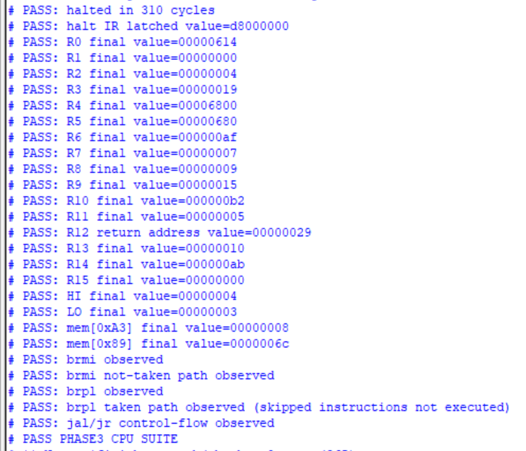
Phase 3 simulation transcript: all 27 PASS checks.
The following table summarizes the memory contents before and after execution for both Phase 3 and Phase 4 test programs.
Address | Phase 3 Before | Phase 3 After | Phase 4 After
0x77 | - | - | 0x000000E0
0x89 | 0x000000A7 | 0x0000006C | 0x0000006C
0xA3 | 0x00000068 | 0x00000008 | 0x00000008
0x88 | - | - | 0x0000FFFF

Appendix D: Phase 4 Waveform Screenshots
The following screenshots show the Phase 3 simulation waveforms. The Phase 4 simulation uses the same waveform structure with an extended test program.
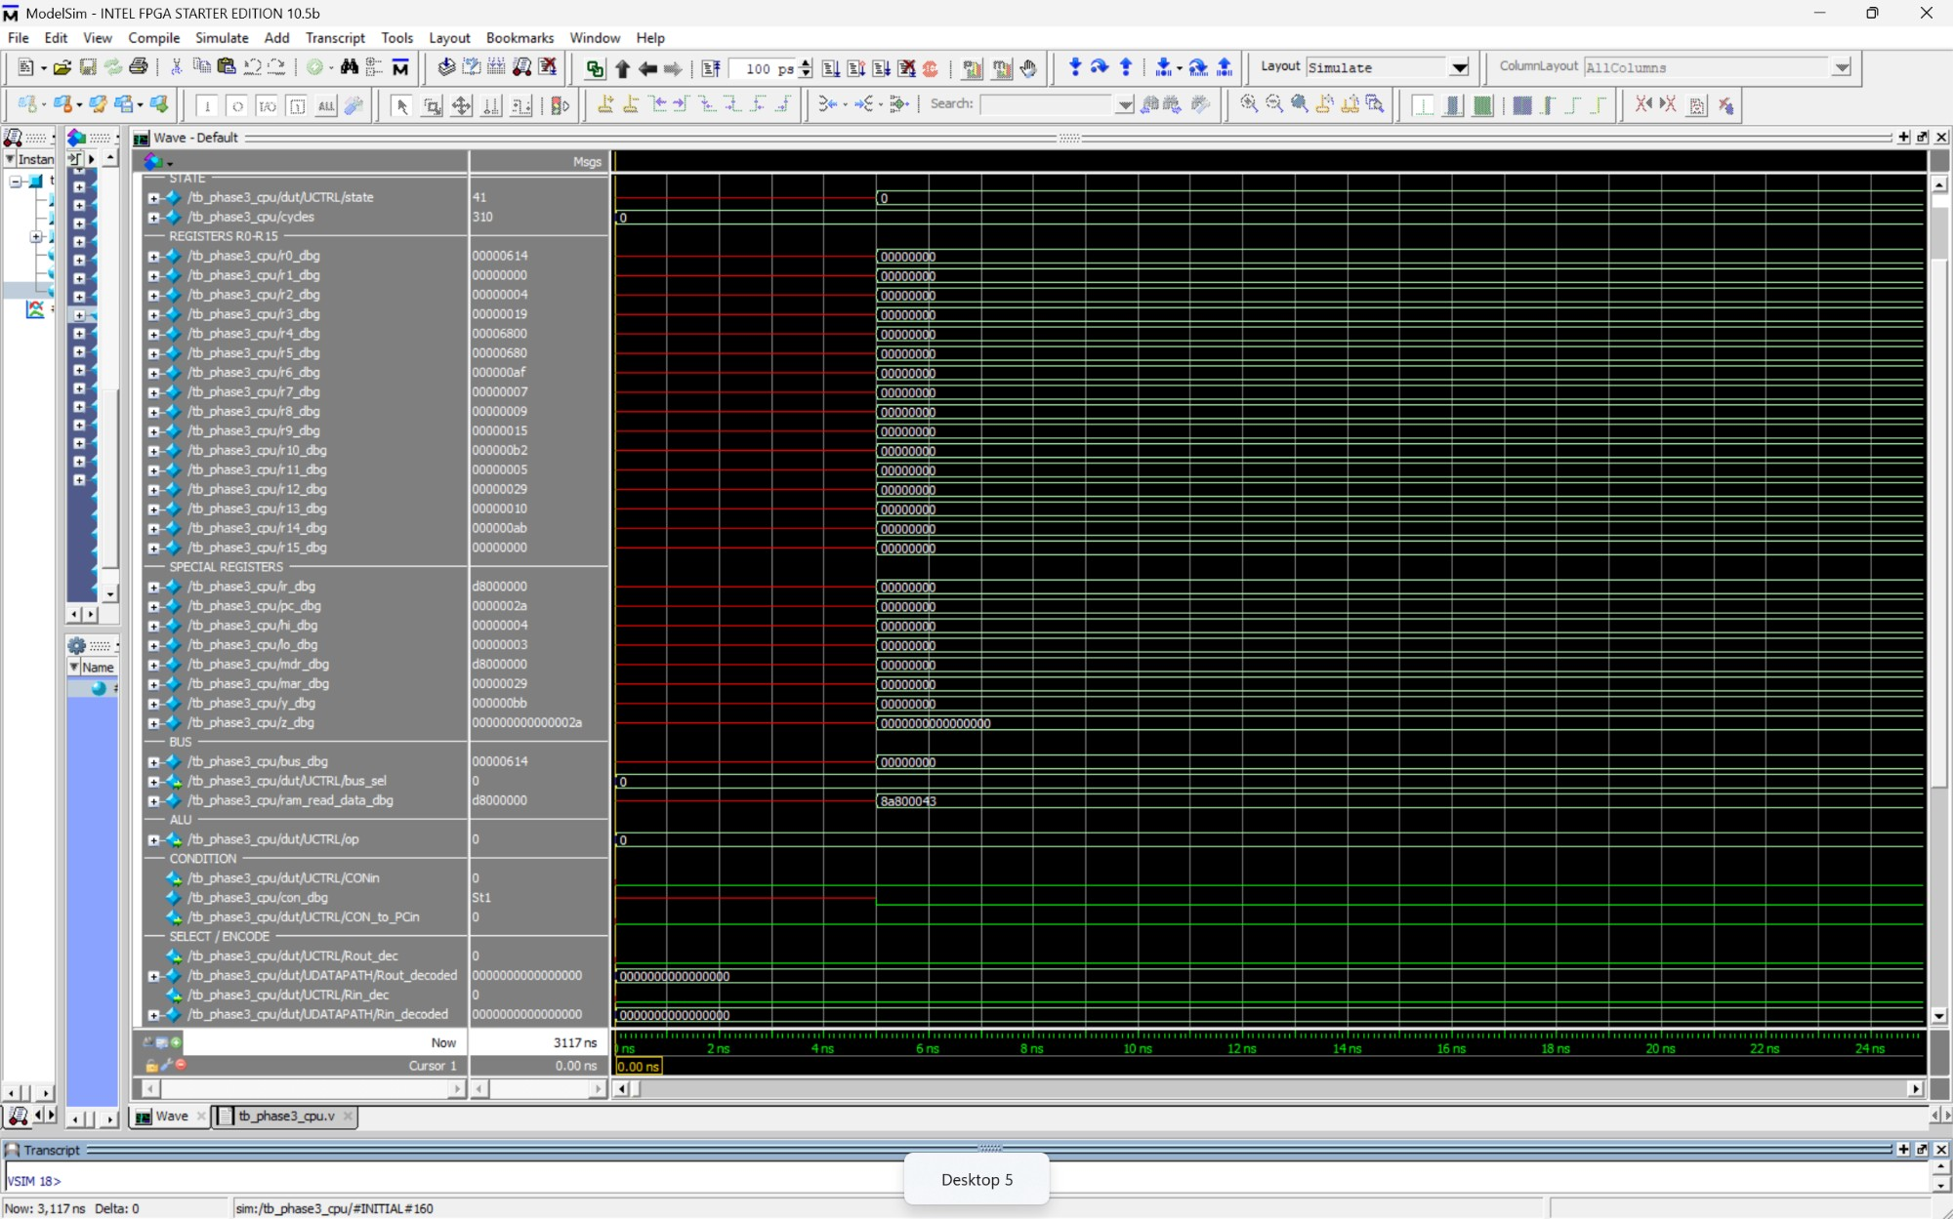
D.1 Initial register state at t=0. All registers are zero.
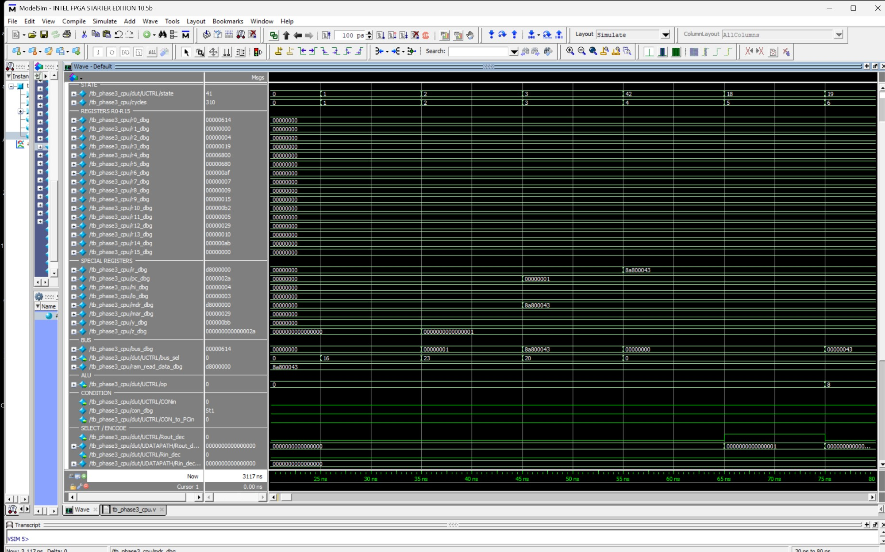
D.2 Fetch cycle: state 1, 2, 3, 42. PC increments, IR loads first instruction.
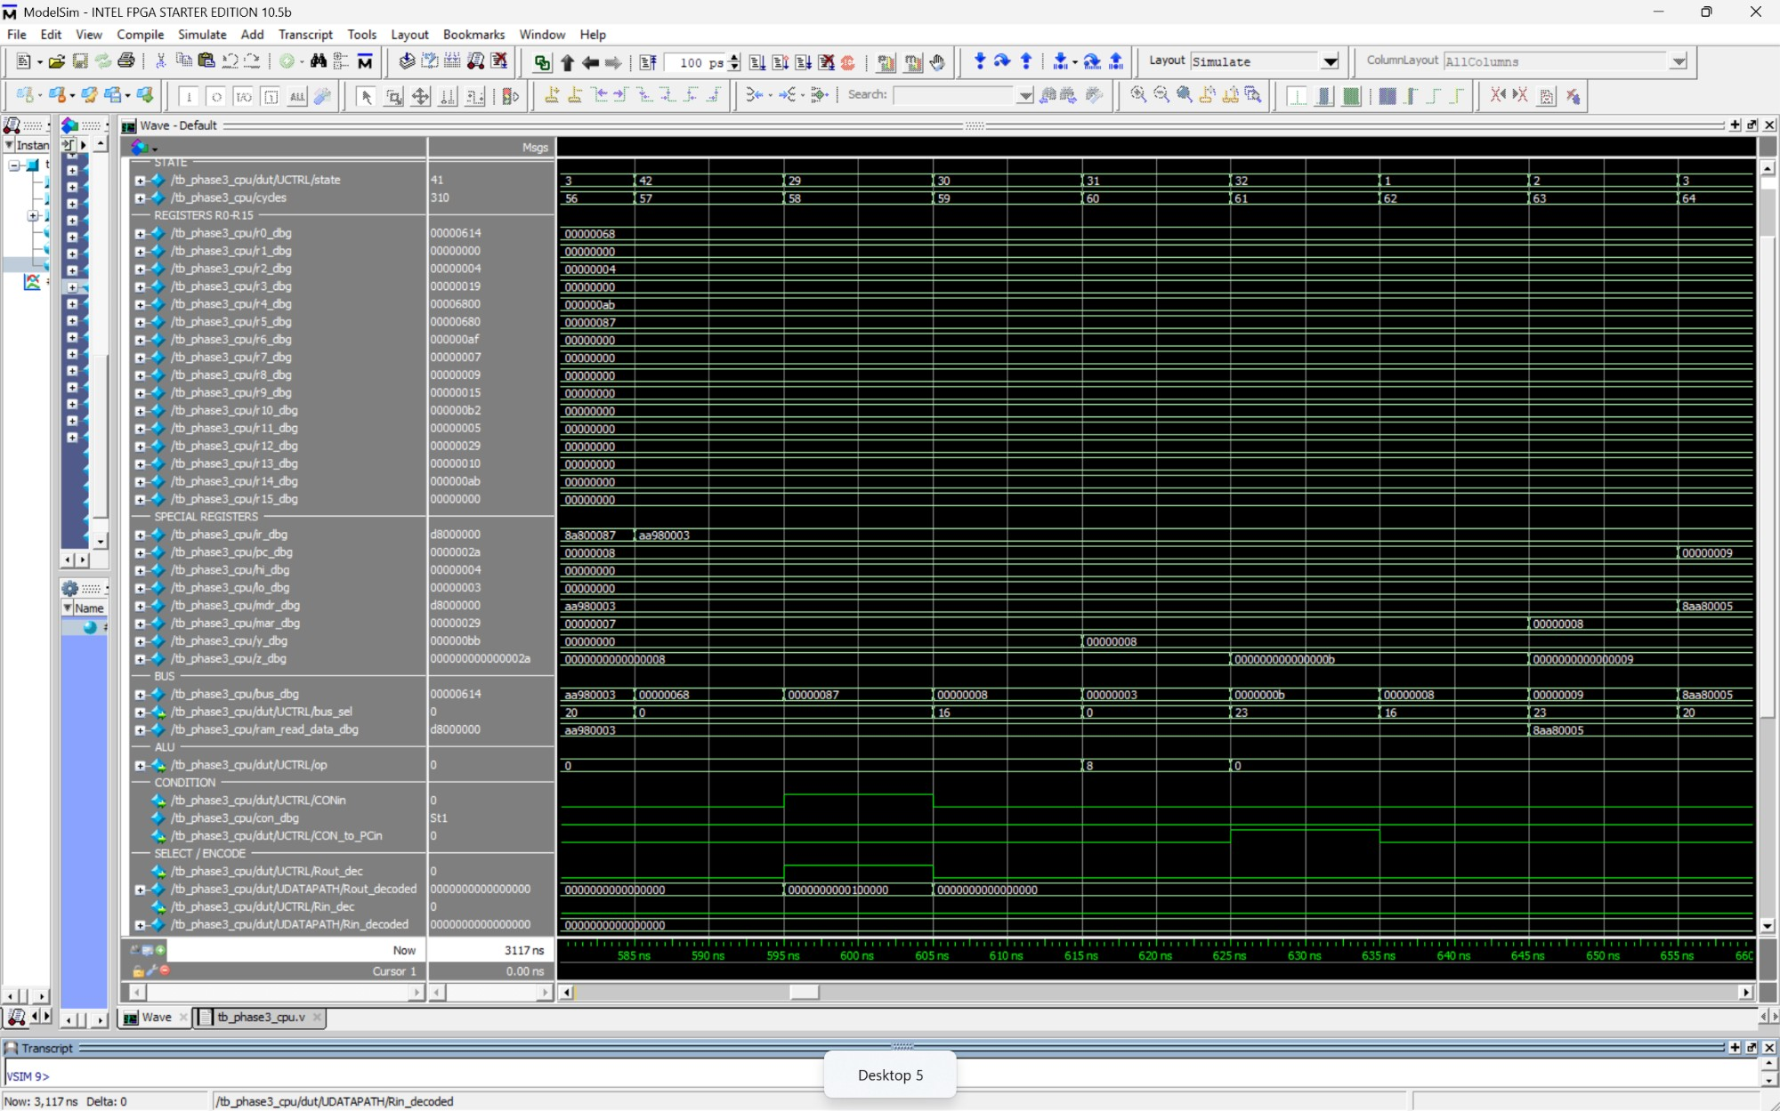
D.3 brmi not taken: IR=AA980003, CON=0, PC unchanged.
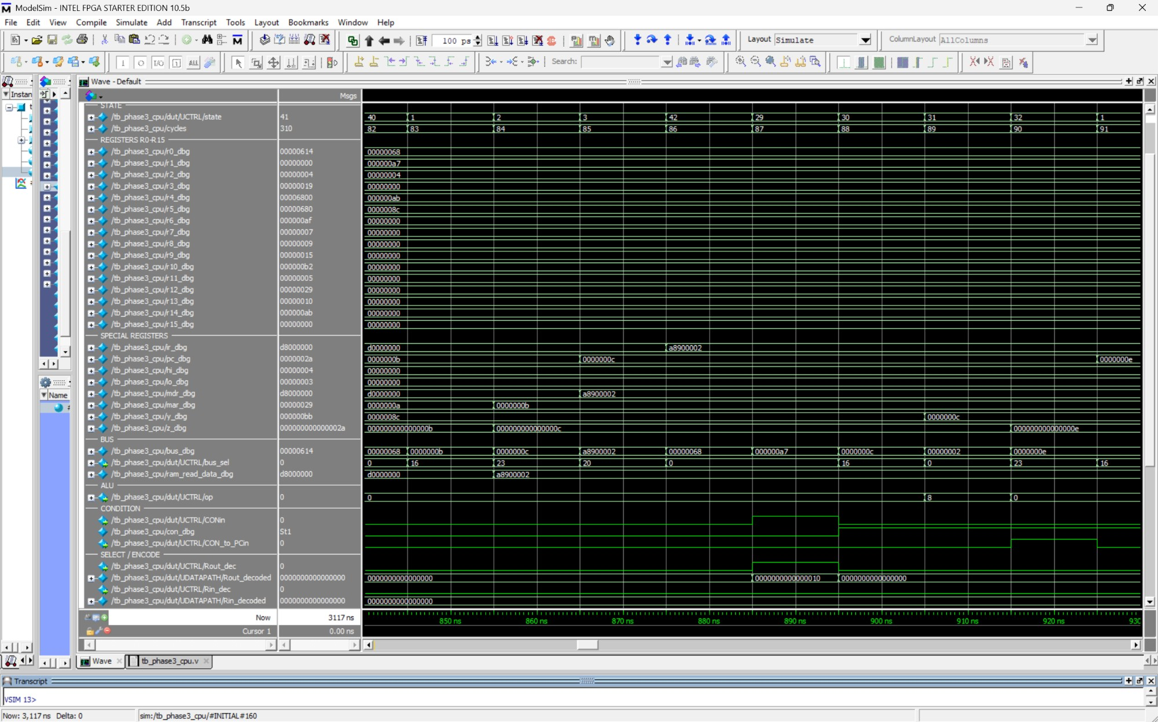
D.4 brpl taken: IR=A8900002, CON=1, PC jumps to 0x0E.
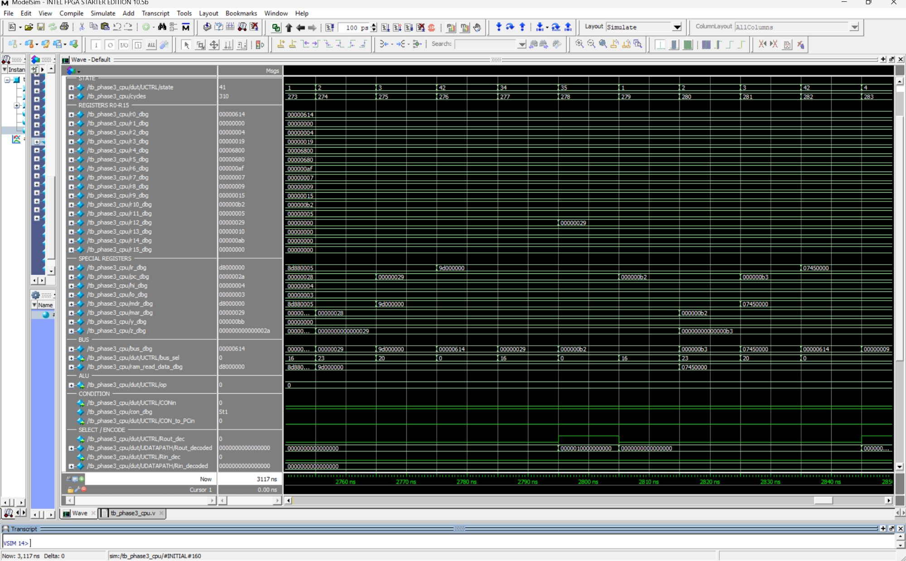
D.5 jal: R12 saves return address 0x29, PC jumps to subroutine at 0xB2.
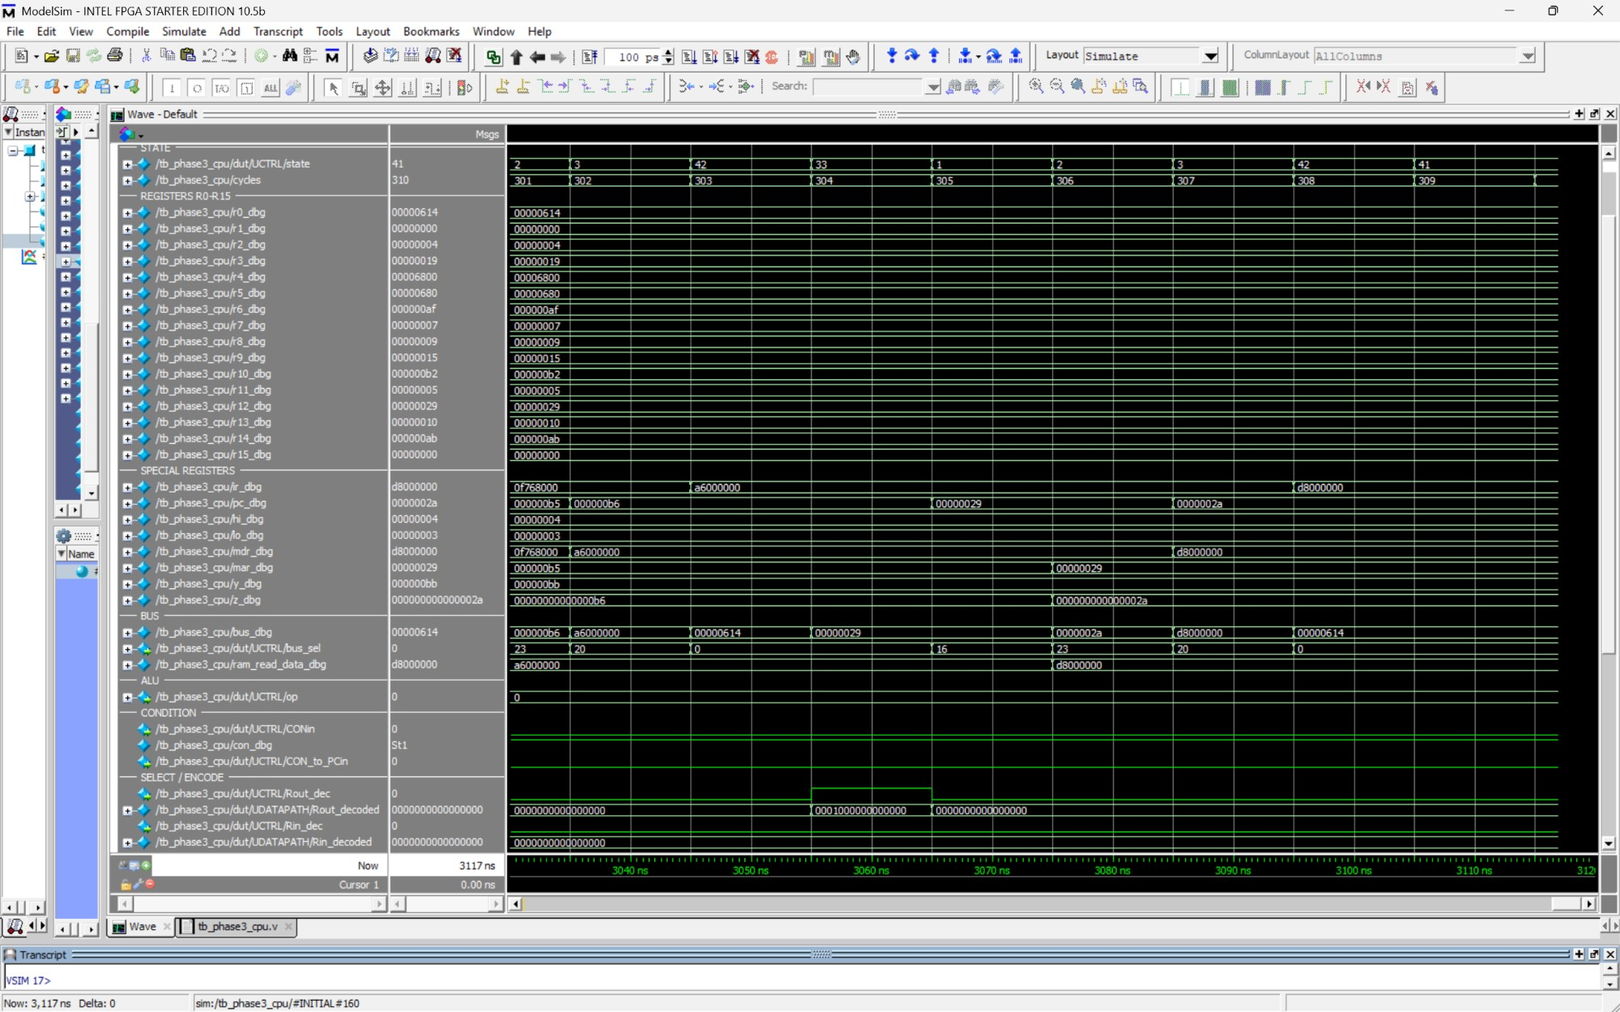
D.6 jr: PC returns to 0x29, halt instruction executes.
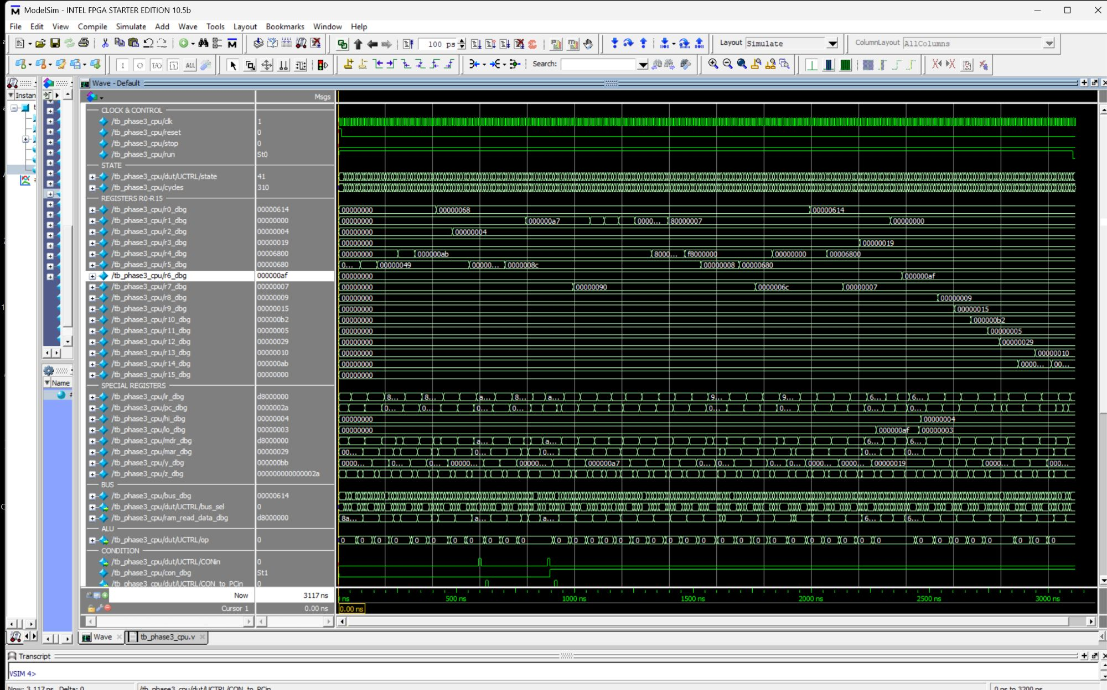
D.7 Full simulation waveform with final register values.
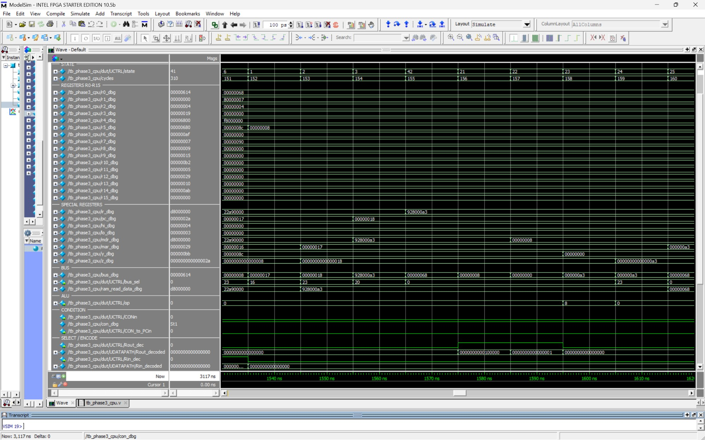
D.8 Store instruction: MAR and MDR values during write to memory.
Appendix D.9: FPGA Board Photo
[INSERT PHOTO: Take a photo of the DE0-CV board showing HEX0/HEX1 displaying 63, SW7-SW5 up, LEDR5 off]

