Code Review Report

Project: Metamorph – Horror Game (RussellChr/horrorgame)

Language: C | Framework: SDL3 | Build: CMake

Review Date: April 2026

1. Project Overview
Metamorph (internally referred to as Project Yozora) is a 2-D visual-novel horror game written in C using the SDL3 graphics library. The game presents a top-down perspective of a mysterious research facility. Players explore rooms connected by a tile-map collision system, collect items, and interact with NPCs and environmental objects through a branching-dialogue engine.
The project is structured as a classic C application: a flat src/ directory with one .c file per subsystem, a matching include/ directory with header files, an assets/ folder for art and text data, and a maps/ folder containing CSV tile maps. CMake (minimum 3.10) is used for cross-platform building.

Repository Structure
horrorgame/
├── CMakeLists.txt (build configuration)
├── mingw.cmake (MinGW cross-compilation toolchain)
├── README.md (project overview & build instructions)
├── docs/DESIGN.md (game design document)
├── include/ (14 header files)
├── src/ (14 source files)
├── assets/ (PNG textures + text data files)
└── maps/ (CSV tile maps for 6 rooms)

2. Code Correctness – Does the Program Compile and Run?
The project includes a GitHub Actions CI workflow (.github/workflows/build.yml) that builds on both Windows (MSVC 2022 + vcpkg) and macOS (Homebrew SDL3). The workflow runs on every push and pull-request to main, providing confidence that the code compiles across platforms.

Build System
CMakeLists.txt is well-formed and handles three important scenarios cleanly:
- Optional SDL3_image – detected with find_package; HAVE_SDL3_IMAGE define is injected only when the library is present.
- MinGW cross-compilation – handled by the mingw.cmake toolchain file; static libgcc/libstdc++ flags prevent missing DLL issues.
- Automatic asset copying – POST_BUILD commands copy assets/ and maps/ next to the executable, so relative paths work at runtime.

Runtime Correctness
The code demonstrates a number of good correctness practices:
- NULL-guard at every public function entry point (e.g., if (!player) return;).
- All strncpy / snprintf calls include explicit length limits.
- Delta-time is capped at 100 ms (dt > 0.1f) to prevent physics tunnelling on frame-rate spikes.
- Memory is allocated with calloc (zeroed), reducing use-before-init bugs.
- Resource cleanup is consistent: game_cleanup() destroys all subsystems in order.

Identified Correctness Issues
Issue 1 – npc.c not linked in CMakeLists.txt. npc.c is implemented but is not listed in the add_executable() call in CMakeLists.txt. NPC rendering/update calls are therefore unresolved at link time if any translation unit references them. The npc_manager is created in game.h but the corresponding .c file is excluded.
Issue 2 – Unused variable warning in npc_render(). Line 153 in npc.c declares int color; but never assigns or uses it – this will generate a compiler warning with -Wall.
Issue 3 – Incomplete NPC visual indicator block in game_render_playing(). Lines 819-825 of game.c open a block that computes the screen position of the Stranger NPC exclamation mark but the render call is missing (empty block body). The indicator is never drawn.
Issue 4 – Debug text and mouse coordinates visible on the main menu. game_render_menu() prints mouse: x, y coordinates (lines 793-795) and coordinate debug text appears during gameplay (lines 838-843). These are left-over development aids that should be removed or gated behind a compile-time DEBUG flag before release.
Issue 5 – Incomplete render_load_texture() fallback. When HAVE_SDL3_IMAGE is not defined, render_load_texture() returns NULL silently. All background textures therefore fail to load, but the game attempts to render them anyway; SDL_RenderTexture with a NULL texture causes SDL to log an error every frame.
// render.c – lines 247-250
#else
(void)r; (void)path;
return NULL; // no error logged; callers get NULL silently
#endif

3. Coding Effectiveness – Does the Code Do What It Should?
The game successfully implements its stated scope: a main-menu, a walking player character with directional sprite animation, tile-map collision, room transitions, an inventory grid, a branching dialogue/monologue system, a pause menu, and a settings screen with volume/brightness sliders.

What Works Well
- Player movement with WASD/arrow keys and correct direction-selection logic (dominant axis wins on diagonals).
- AABB collision correctly resolves the axis of smallest penetration (minimum-separation vector).
- Camera smooth-follow with clamping to world boundaries.
- Dialogue typewriter effect (40 chars/sec) with ENTER-to-complete skip.
- Power-cell puzzle: placing the power cell removes door colliders and converts interactive triggers to room-exit triggers at runtime.
- Item pickup notification with a three-stage fade (in / full / out).
- Story flags (bitmask) correctly gate item collection so items can only be picked up once.
- Monologue sentences are split at punctuation boundaries and chained into dialogue trees automatically.

Gaps Between Stated Goals and Implementation
- Save/load system: story_load() is a stub that always returns 0; save/load is completely absent.
- Audio system: volume slider updates game->volume but there is no audio subsystem to consume it – the slider has no effect.
- Advanced NPC behaviour: npc_set_patrol() and NPC_STATE_FOLLOWING are defined but never called; only NPC_STATE_IDLE is exercised in practice.
- Additional endings: story.c contains only CHAPTER_PROLOGUE and no ending-determination logic; the story_determine_ending() function documented in the README table does not exist in the code.
- Settings brightness: the overlay correctly dims the screen, but there is no equivalent brightness-boost implementation for values above 100%.

4. Coding Efficiency

Positive Efficiency Practices
- Run-length encoding in map_build_colliders(): consecutive wall tiles on the same row are merged into a single Rect, keeping the collider count low.
- Static bitmap font table in render.c: the 95-character 8×8 font is a compile-time constant array (no heap allocation, no file I/O at startup).
- Camera clamping is split into a private camera_clamp() helper called from both camera_follow() and camera_snap() – no duplication.
- dialogue_tree_create() / dialogue_tree_destroy() are thin calloc/free wrappers; the tree lives entirely on the heap, making it easy to swap trees at dialogue start/end.

Efficiency Concerns
Concern 1 – Whole-world linear scan for location lookup (O(n)). world_get_location() iterates every location on every call. With MAX_LOCATIONS = 16 this is negligible, but the pattern would not scale. Since IDs are small integers, a direct-index array would be cleaner.
Concern 2 – dialogue_get_node() is O(n) and called inside the render loop. dialogue_render() calls dialogue_get_node() which iterates all nodes every frame. With MAX_DIALOGUE_NODES = 128 this is fine in practice, but IDs are already sequential integers so direct indexing by id would be trivially correct.
Concern 3 – SDL_Delay(16) is not frame-rate agnostic. The main loop in main.c uses SDL_Delay(16) for a ≈60 FPS cap but this does not account for how long update/render took. On a slow machine a 5 ms frame would still wait 16 ms (actual ≈35 FPS). SDL_GetTicks()-based frame pacing or SDL_SetRenderVSync(1) would be more robust.
Concern 4 – Per-pixel bitmap font rendering. render_text() draws each pixel of each character as an individual SDL_FRect fill call. For the short strings used (HUD, prompts) this is fine, but long dialogue text at 40 chars could be refactored to use a texture atlas for better performance on lower-end hardware.
Concern 5 – world.c world_setup_rooms() is a monolithic 450+ line function. Each room's setup (texture load, CSV parse, spawn detection, trigger registration) could be extracted into a per-room helper. This would make the function easier to maintain as more rooms are added.

5. Naming of Variables, Functions, and Files

Positive Naming Practices
- Module-prefix convention is followed consistently: player_*, world_*, dialogue_*, camera_*, npc_*, render_*, ui_*, story_*, animation_*, utils_*, monologue_*, map_*.
- Function names are verb-noun (e.g., player_add_item, camera_follow, dialogue_state_advance), clearly expressing intent.
- Boolean-style integers use named constants: facing_right, is_moving, is_terminal, text_complete are self-documenting.
- File names match their module name exactly (player.c / player.h, camera.c / camera.h, etc.).
- Constants are upper-case with context prefixes: PLAYER_SPEED, INVENTORY_CAPACITY, MAX_DIALOGUE_NODES, FLAG_ENTERED_LAB.

Naming Issues
Issue 1 – Magic numbers without names. Several literal integers are used without named constants. Examples: trigger IDs 60, 71-75, 80-82 in game.c and world.c are bare integers; they have inline comments but no #define names, making cross-file tracing harder.
// game.c line 246 – trigger 60 is a magic number
if (tid == 60 && loc_id == 2) {
game->state = GAME_STATE_LOCKER;
Issue 2 – Direction constants should be an enum. DIRECTION_NORTH/SOUTH/EAST/WEST are defined as preprocessor macros (0–3) in player.h. Using an enum would provide type safety and better IDE support (switch exhaustiveness warnings).
Issue 3 – Inconsistent naming for 'screen' versus 'world' coordinate variables. In game.c, sx/sy are used for screen coordinates in some places and local helpers hw5x/hw5y name hallway spawn coordinates. While understandable in context, using consistent descriptive names (hallway_spawn_x, etc.) would improve readability.
Issue 4 – Monologue text quality (minor). Some strings in monologues.txt are lowercase where proper capitalisation is expected: 'GasMask found.' and 'flashlight found.' These are player-facing strings that should be written as complete, capitalised sentences.

6. Indentation and Formatting

Positive Formatting Practices
- 4-space indentation is used throughout all source files.
- Opening braces on the same line as control structures; consistent K&R brace style.
- Alignment of struct member declarations (padding with spaces for column alignment), e.g. player.h fields.
- Long argument lists are broken across lines and aligned, e.g. make_button() calls in game_init().
- Header comment banners (/* ── Section name ── */) are used consistently throughout to visually separate logical sections within each file.

Formatting Issues
Issue 1 – Mixed comment styles. The codebase uses // C99 line comments and /* */ block comments interchangeably. Some files (game_render_menu) even mix both within a single short function.
// game_render_menu() – mixed styles
if (game->title_screen_texture) {
// Draw full-screen PNG ← C99 line comment
render_texture(r, ...);
} else {
// Fallback to colored background ← same
}
// Then draw your menu buttons on top
// ... existing menu button code ... ← stale placeholder comment
Issue 2 – Stale placeholder / TODO comments left in game code. game_render_menu() contains '// ... existing menu button code ...' (line 778) – a leftover placeholder from an earlier draft. Such comments are confusing in production code.
Issue 3 – Inconsistent blank lines inside player_create(). player_create() assigns p->x = 0.0f then p->y = 0.0f, followed by a blank line and collider setup, then assigns p->x and p->y again (different values) several lines later. The double assignment is harmless but confusing and inconsistent.
// player.c – double assignment of x and y
p->x = 0.0f; // line 19 – immediately overwritten
p->y = 0.0f;
...
p->x = 400.0f; // line 29 – actual intended value
p->y = (float)FLOOR_Y;
Issue 4 – INV_NAV_COLS defined and undef'd inside a function body. game_handle_event() defines #define INV_NAV_COLS 4 inside the switch case and then #undef's it (lines 492-510). This is legal C but non-idiomatic; a file-scope or header constant would be cleaner.

7. Comments

Positive Comment Practices
- Every public function in each header file has a brief doc comment or at least a section banner.
- Non-obvious algorithmic decisions are explained inline, e.g. the minimum-separation vector in collision.c, the dt capping logic, and the door-collider truncation trick.
- Section banners (/* ── Name ── */) make navigating large files (game.c = 1000+ lines) straightforward.
- map.c provides clear inline documentation of the spawn-search algorithm (spiral outward from hint).
- The world_setup_rooms() function has pixel-precise tile-coordinate comments (e.g. 'rows 19-21, cols 45-47') linking code constants to the CSV data.

Comment Issues
Issue 1 – Inline CHANGED notes not removed. game.c lines 628 and 631 contain '// CHANGED: Remove the * 0.3f' – a developer note that should have been removed after the edit was made.
p->vy = -PLAYER_SPEED; // CHANGED: Remove the * 0.3f
...
p->vy = +PLAYER_SPEED; // CHANGED: Remove the * 0.3f
Issue 2 – Some header files lack function-level doc comments. utils.h lists function declarations without any description. render.h has better inline comments but camera.h and collision.h have no per-function documentation.
Issue 3 – story_load() stub is undocumented at the call site. story_load() returns 0 unconditionally with only a one-line comment inside. Callers in higher-level code have no indication of this limitation unless they read the implementation.

8. Readability

What Aids Readability
- Short, single-responsibility files: animation.c (48 lines), collision.c (49 lines), camera.c (73 lines) are each immediately comprehensible.
- Consistent structure: every source file opens with includes → section banner → lifecycle → core logic → helpers.
- The static make_button() helper in game.c eliminates six repetitive field assignments, improving readability of game_init().
- The helper macros ADD_COLLIDER, ADD_TRIGGER, ADD_EXIT_TRIGGER, ADD_DECOR in world.c reduce boilerplate in room-setup code significantly.
- Enums are used for GameState and NPC states, making switch statements self-documenting.

Readability Concerns
Concern 1 – game.c is 1050+ lines. The file contains the state machine, all per-state event handlers, all per-state update logic, all per-state render helpers, and the interaction handler. Separating event handling, update, and render into their own translation units would considerably reduce cognitive load.
Concern 2 – world_setup_rooms() is 450+ lines. The function uses a large switch statement with deeply nested case blocks. Extracting each room into a static setup_room_N() helper function would dramatically improve readability.
Concern 3 – Dialogue hard-coding in dialogue.c. dialogue_build_for_location() (250+ lines) constructs dialogue trees from hard-coded C strings. Expanding the game's narrative will require modifying this function. Moving all dialogue to the monologues.txt or a separate script file would be far more maintainable.
Concern 4 – Raw RGB colour literals throughout. Colours such as (10, 8, 15), (80, 60, 100), (30, 20, 50) appear dozens of times in ui.c, dialogue.c, and game.c with no symbolic names. Defining a small palette of named constants would make the visual theme easier to adjust.

9. Programming Style and Modularization

Module Separation
The project achieves reasonable separation of concerns through its 14-module architecture. Each header file declares a clean public API and each source file provides exactly one module's implementation. There is no bidirectional dependency (e.g. render.c does not include game.h).
The dependency graph flows logically downward:
game.h ──► player.h, world.h, dialogue.h, story.h, camera.h, ui.h, npc.h, monologue.h
world.h ──► collision.h, camera.h
story.h ──► player.h, world.h, dialogue.h
ui.h ──► render.h
npc.h ──► animation.h, collision.h, render.h

Header Files
- All headers use include guards (#ifndef / #define / #endif) with the file-name-derived guard name.
- Forward declarations are not used; each header includes its dependencies directly.
- MAX_ constants live in the header of their owner module (e.g. MAX_DIALOGUE_NODES in dialogue.h), not in a monolithic config header.

Style Issues
Issue 1 – Game context struct mixes concerns. The Game struct in game.h has grown to 30+ fields spanning SDL handles, state machine, all subsystems, UI widgets, settings, inventory selection, camera, timing, and notification data. A 'God struct' risks tight coupling; grouping related fields into sub-structs (e.g. UIState, GameSettings) would help.
Issue 2 – printf / console I/O left in library modules. world_move(), dialogue_run(), dialogue_print_node(), player_show_inventory(), and player_print_info() write directly to stdout/stderr. In a graphical game these should either be removed, or replaced with a logging abstraction, rather than mixing console and SDL output.
Issue 3 – story.c is thin and its responsibilities are unclear. story.c currently only wraps world_load_locations() and story_get_objective(). The story module is documented in the README as handling chapters, endings, and story event triggering, but almost none of that exists yet. This creates a misleading public API.
Issue 4 – utils_clear_screen() and utils_press_enter() use system(). Calling system('cls') / system('clear') is a known security risk in library code. These functions belong to the legacy text-game era of the codebase and should be removed from the graphical game.
Issue 5 – npc_render() declares an unused variable. int color; is declared at line 153 of npc.c but never used. The rendering logic below it uses if/else branches. The stray declaration should be removed.

10. Identification of Bugs and Design Issues

Bug 1 – Double Player Position Assignment in player_create()
player_create() sets p->x = 0.0f and p->y = 0.0f on lines 19-20, then immediately overwrites both with p->x = 400.0f and p->y = FLOOR_Y on lines 29-30. The first two assignments are dead code and should be removed.
// player.c – dead code
p->x = 0.0f; // ← overwritten 10 lines later
p->y = 0.0f; // ← overwritten 10 lines later
...
p->x = 400.0f; // ← actual value
p->y = (float)FLOOR_Y; // ← actual value

Bug 2 – Unused int color Declaration in npc_render()
npc.c line 153 declares int color; but the variable is never used. Most compilers will produce an 'unused variable' warning. The variable should be deleted.
void npc_render(NPC *npc, SDL_Renderer *renderer) {
...
int color; // ← declared but never used
if (npc->npc_type == NPC_TYPE_FRIENDLY)
render_filled_rect(renderer, ...);

Bug 3 – Empty Exclamation-Mark Render Block in game_render_playing()
Lines 819-825 of game.c compute the screen position of the Stranger NPC exclamation mark indicator, then the block ends without any draw call. The visual indicator never appears in-game.
if (game->player->current_location_id == 0) {
int npc_sx = camera_to_screen_x(...);
int npc_sy = camera_to_screen_y(...);
/* Bright yellow "!" above the NPC head */
// ← draw call is missing here!
}

Bug 4 – npc.c Not Included in CMakeLists.txt
The CMakeLists.txt add_executable() block does not include src/npc.c. If any code calls npc_ functions, the linker will fail. The file should be added to the sources list.
# CMakeLists.txt – npc.c is missing
add_executable(horrorgame
src/main.c src/game.c src/ui.c src/player.c
src/world.c src/map.c src/dialogue.c src/monologue.c
src/story.c src/utils.c src/render.c src/animation.c
src/camera.c src/collision.c
# ← src/npc.c is NOT listed here
)

Design Issue 1 – No Input Debouncing for Interaction Key
The E key handler in game_handle_event() calls handle_interaction() directly on every SDL_EVENT_KEY_DOWN. If the key is held down, SDL may fire repeated key-down events, potentially triggering the same interaction multiple times before the dialogue box opens. Adding a guard (e.g. checking game->state == PLAYING) or a cooldown timer would make this more robust.

Design Issue 2 – Static blink_tick in dialogue_render()
dialogue_render() uses a static local variable blink_tick for the 'ENTER' prompt blinking. Because static locals are process-global, the blink timer never resets between separate dialogue trees. After a long play session the blinking phase can be out of sync. Moving blink_tick into DialogueState would be the correct fix.
// dialogue.c line 347 – static local is process-global
static Uint64 blink_tick = 0;
Uint64 now = SDL_GetTicks();
if (!blink_tick) blink_tick = now; // only initialises once per process

Design Issue 3 – Room Dimensions Derived From Texture, Not Tile Map
world_setup_rooms() sets room_width/room_height from the background texture size, then passes those dimensions to map_build_colliders(). If the texture resolution changes or a room uses texture_scale (the field exists in Location but is never set), the tile-pixel mapping breaks and all colliders shift. Tile size should be derived from explicit game-design constants rather than image dimensions.

Design Issue 4 – Hardcoded Spawn Coordinates
Several spawn positions in game.c are hardcoded with magic numbers:
game->player->x = 725.0f; /* Your X coordinate */
game->player->y = 390.0f; /* Your Y coordinate */
The comments 'Your X/Y coordinate' suggest copy-paste from a debug session. Spawn coordinates should come from Location.spawn_x/spawn_y (already populated by map_find_spawn) to keep data-driven behaviour consistent.

11. Evaluation of the README File

Strengths
- Comprehensive length: the README is 280+ lines covering overview, implemented features, missing features, planned work, compilation, controls, and project structure.
- Clear build instructions for all three target platforms (Linux/macOS native, Windows MinGW cross-compilation, Debug build) with exact commands.
- Controls table is well-formatted and covers every action including dialogue navigation, inventory grid movement, and mouse interaction.
- The folder structure section includes a detailed file-by-file description and a module responsibility table – unusually helpful for a project of this size.
- Known issues are honestly listed (no save system, movement inconsistency, dialogue overflow, no audio).
- A 'What is Planned Next' section sets clear goals with numbered items.

Weaknesses
- Project name inconsistency: the README title says 'Metamorph', the DESIGN.md says 'Project Yozora', and the window title is 'Project Yozora – A Horror Story'. These should be aligned.
- The README folder structure lists 'assets/story.txt' and 'scripts/dialogue.txt' but neither of these files exists in the repository. These are artefacts of an earlier design.
- The module responsibility table refers to functions such as story_advance_chapter(), story_determine_ending(), and story_trigger_event() that do not exist in the current source code.
- The section 'Story Progression: None' under 'Core Systems Completed' is contradictory – it appears in a 'Completed' list but acknowledges nothing is done. It should move to 'What is Incomplete'.
- No screenshots or GIFs in the README. Even a single screenshot of gameplay would greatly improve the document for new readers.
- README is in the root of the repository while DESIGN.md is in docs/. There is some content duplication (build commands, controls) that could be consolidated.

12. Concrete Examples and Improvement Suggestions

12.1 Asset Screenshots
The following screenshots show the actual game art assets included in the repository.
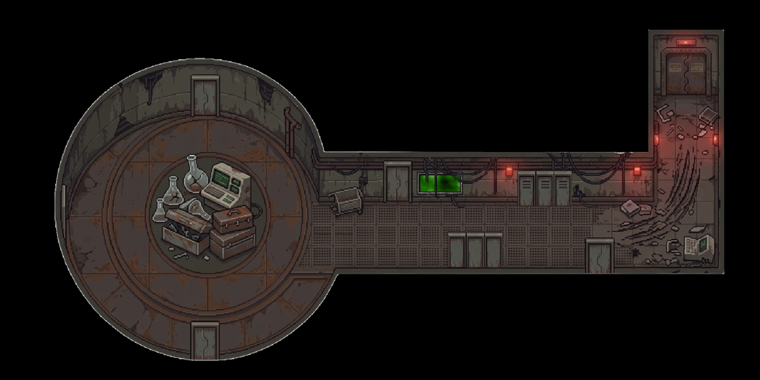
Figure 1 – Hallway room background (maps to Location ID 2)

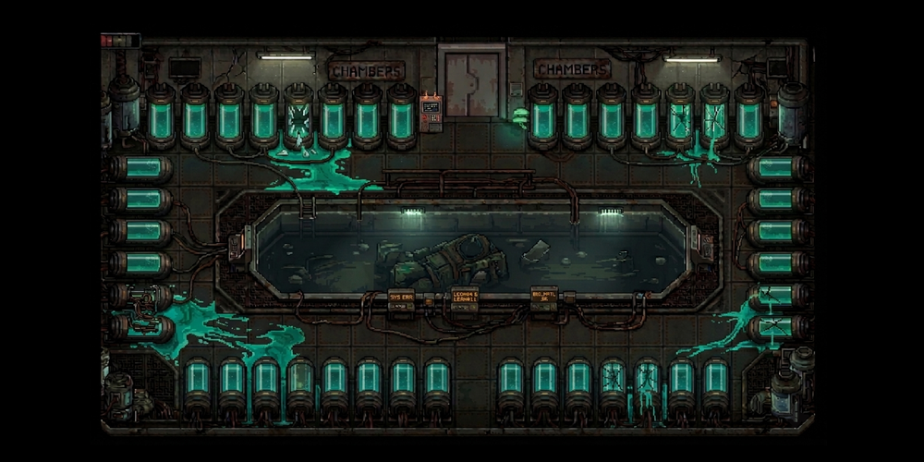
Figure 2 – Hibernation chamber background (Location ID 3)

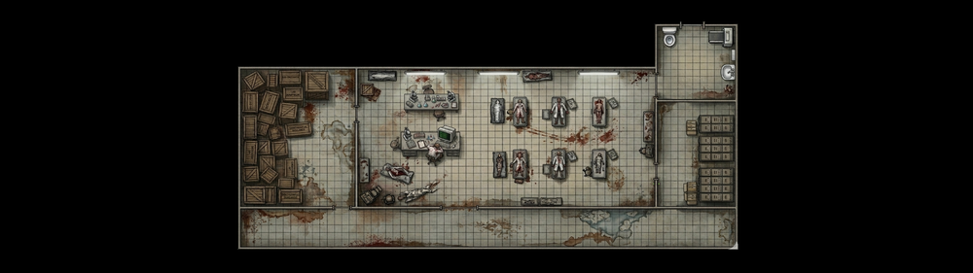
Figure 3 – Archive / Entrance Hall background (Location ID 0)

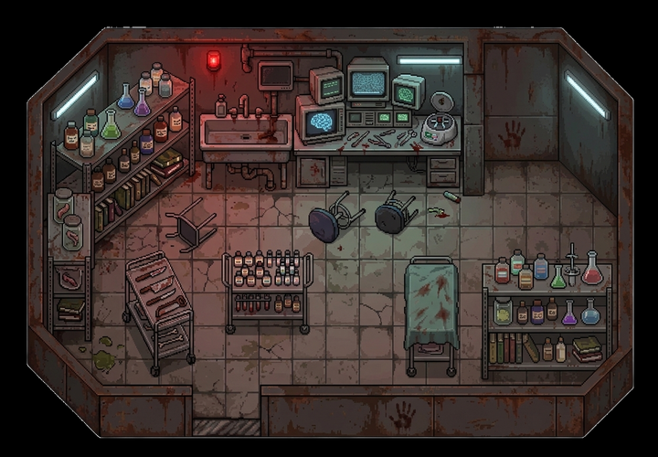
Figure 4 – Chemistry Lab background (Location ID 1)

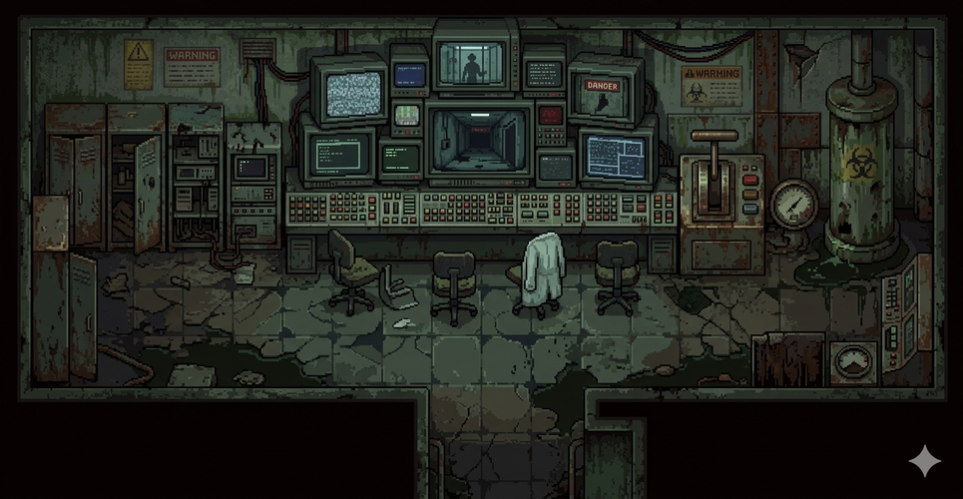
Figure 5 – Security/Monitoring room background (Location ID 5)


Figure 6 – Dialogue box background texture

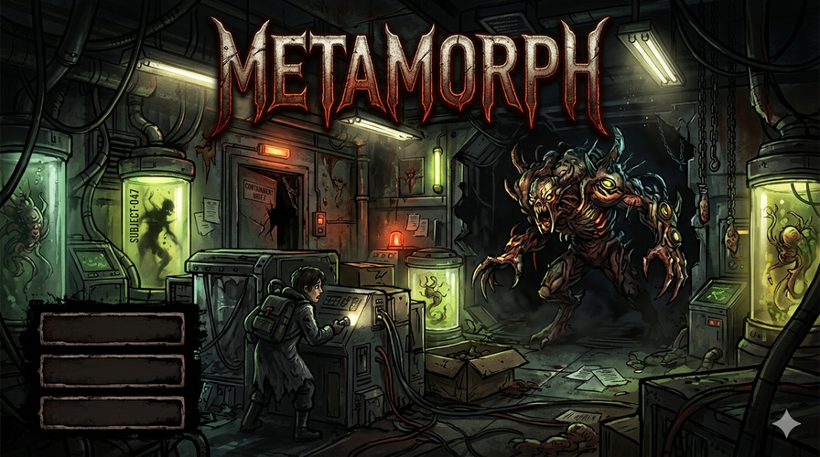
Figure 7 – Title screen PNG

Item sprites used in the inventory system:

Figure 8 – Flashlight item sprite

Figure 9 – Gas Mask item sprite

12.2 Player Sprite Sheets
The player character has four directional idle poses and two-frame walk animations in each direction (16 textures total). The sprites are small (32×64 px) and scaled up in-engine:

Figure 10 – Player idle (south/facing camera)

Figure 11 – Player idle (east)

Figure 12 – Player walk frame 0 (south)

Figure 13 – Player walk frame 1 (south)

12.3 Suggested Improvements with Code Examples

Improvement A – Replace Magic Trigger IDs with Named Constants
Currently game.c and world.c reference trigger IDs as raw integers. Define them once in a shared header:
/* In include/triggers.h (new file) */
#define TRIGGER_LOCKER 60
#define TRIGGER_HIBERN_ZONK 71
#define TRIGGER_HIBERN_POWERCELL 72
#define TRIGGER_HIBERN_SLOT 73
#define TRIGGER_HIBERN_PODS 74
#define TRIGGER_HIBERN_DOOR 75
#define TRIGGER_HALLWAY_NOTHING 80
#define TRIGGER_HALLWAY_GASMASK 81
#define TRIGGER_HALLWAY_FLASHLIGHT 82
/* Then in game.c */
if (tid == TRIGGER_LOCKER && loc_id == LOCATION_HALLWAY) {
game->state = GAME_STATE_LOCKER;
}

Improvement B – Replace Direction Macros with an Enum
/* Replace in player.h */
typedef enum {
DIRECTION_NORTH = 0,
DIRECTION_SOUTH = 1,
DIRECTION_EAST = 2,
DIRECTION_WEST = 3
} PlayerDirection;
/* Player struct then uses: */
PlayerDirection current_direction;
The enum allows the compiler to warn if a switch statement does not handle all directions, catching future bugs when new directions are added.

Improvement C – Fix Frame-Rate Cap with Proper Timing
/* Replace in main.c */
const Uint64 TARGET_FRAME_MS = 16; /* ~60 FPS */
while (game->running && game->state != GAME_STATE_QUIT) {
Uint64 frame_start = SDL_GetTicks();
/* ... handle events, update, render ... */
SDL_RenderPresent(renderer);
Uint64 elapsed = SDL_GetTicks() - frame_start;
if (elapsed < TARGET_FRAME_MS)
SDL_Delay((Uint32)(TARGET_FRAME_MS - elapsed));
}

Improvement D – Move blink_tick into DialogueState
/* In dialogue.h – add field to DialogueState */
typedef struct {
...
Uint64 blink_start; /* tick when this dialogue state started */
} DialogueState;
/* In dialogue.c – dialogue_state_init() */
ds->blink_start = SDL_GetTicks();
/* In dialogue_render() – use instance field instead of static */
int blink_on = ((SDL_GetTicks() - ds->blink_start) / 500) % 2 == 0;

Improvement E – Add src/npc.c to CMakeLists.txt
add_executable(horrorgame
src/main.c src/game.c src/ui.c
src/player.c src/world.c src/map.c
src/dialogue.c src/monologue.c src/story.c
src/utils.c src/render.c src/animation.c
src/camera.c src/collision.c
src/npc.c # ← add this line
)

Improvement F – Remove Debug Coordinates from Menu and Gameplay Screens
/* game_render_menu() – remove or guard with DEBUG flag */
#ifdef DEBUG
char buf[64];
snprintf(buf, sizeof(buf), "mouse: %d, %d",
(int)game->mouse_x, (int)game->mouse_y);
render_text(r, buf, 10, 10, 2, 255, 255, 255);
#endif
/* game_render_playing() – same guard for player coordinates */
#ifdef DEBUG
char coord_buf[32];
snprintf(coord_buf, sizeof(coord_buf),
"X:%.0f Y:%.0f", game->player->x, game->player->y);
render_text(game->renderer, coord_buf, 14, 26, 1, 110, 70, 70);
#endif

Improvement G – Data-Drive Dialogue via monologues.txt
The 250-line dialogue_build_for_location() function in dialogue.c hard-codes dialogue trees. As the game grows, this will become unmaintainable. All dialogue content should live in the monologues.txt (or a separate dialogue script), and dialogue_build_for_location() should fall back to looking up the monologue by a conventional ID such as 'location_0_default'.

13. Summary Assessment
Category | Rating | Key Finding
Code Correctness | ⭐⭐⭐⭐ (4/5) | Compiles on CI; minor issue: npc.c missing from CMakeLists.
Coding Effectiveness | ⭐⭐⭐ (3/5) | Core loop, collision, dialogue, inventory work; save/load, audio absent.
Coding Efficiency | ⭐⭐⭐ (3/5) | Good merge of wall tiles; per-pixel font rendering; SDL_Delay fixed-16ms.
Naming | ⭐⭐⭐⭐ (4/5) | Consistent module prefix; magic trigger IDs weaken otherwise good naming.
Indentation & Formatting | ⭐⭐⭐⭐ (4/5) | 4-space, K&R consistent; stale placeholder comments and mixed // / /* */ style.
Comments | ⭐⭐⭐⭐ (4/5) | Section banners and inline reasoning are strong; CHANGED notes not removed.
Readability | ⭐⭐⭐ (3/5) | Small modules very clear; game.c and world_setup_rooms() too long.
Modularization | ⭐⭐⭐⭐ (4/5) | 14 focused modules; God struct Game and console I/O in library code weaken it.
Bug / Design Issues | ⭐⭐⭐ (3/5) | Dead code, unused variable, empty render block, static blink timer.
README | ⭐⭐⭐⭐ (4/5) | Thorough; name inconsistency, phantom files, missing screenshots.

Overall, the codebase demonstrates solid foundational C practices: clean header/source separation, consistent naming conventions, careful null-guarding, and a well-structured build system. The primary areas for improvement are (1) completing the features listed in the README, (2) reducing the size of game.c and world.c through further modularisation, (3) removing debug artefacts, and (4) data-driving more content to reduce hard-coded string literals.

