Test # | Input Values (Values as Input) |  | Expected Output | Actual Output |  | Pass or Fail
Test 1 | 1: Order a Snack  2: Exit program  Enter your selection: 2 |  | Thank you for using the program. Goodbye! | Thank you for using the program. Goodbye! |  | Pass
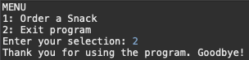
Test # |  | Input Values (Values as Input) | Expected Output |  | Actual Output | Pass or Fail
Test 2 |  | 1: Order a Snack  2: Exit program  Enter your selection: 1  Do you want a Fruit Snack (1) or Salty Snack(2): 1  What size do you want: S, M, or L: s  Do you want citrus fruit included? true/false: true | You have chosen snack type = Fruit Snack, of type = S, id = 1ST, price = $25.98 |  | You have chosen snack type = Fruit Snack, of type = S, id = 1ST, price = $25.98 | Pass
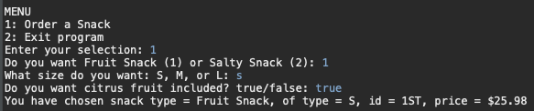

Test # | Input Values (Values as Input) | Expected Output | Actual Output | Pass or Fail
Test 3 | 1: Order a Snack  2: Exit program  Enter your selection: 1  Do you want a Fruit Snack (1) or Salty Snack(2): 1  What size do you want: S, M, or L: m  Do you want citrus fruit included? true/false: false | You have chosen snack type = Fruit Snack, of type = M, id = 1MF, price = $29.99 | You have chosen snack type = Fruit Snack, of type = M, id = 1MF, price = $29.99 | Pass
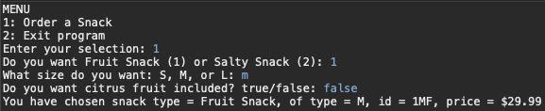
Test 4 | 1: Order a Snack  2: Exit program  Enter your selection: 1  Do you want a Fruit Snack (1) or Salty Snack(2): 1  What size do you want: S, M, or L: L  Do you want citrus fruit included? true/false: false | You have chosen snack type = Fruit Snack, of type = L, id = 1LF, price = $39.99 | You have chosen snack type = Fruit Snack, of type = L, id = 1LF, price = $39.99 | Pass
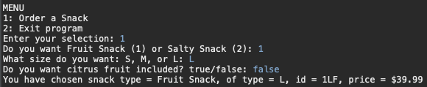

Test # | Input Values (Values as Input) | Expected Output | Actual Output | Pass or Fail
Test 5 | 1: Order a Snack  2: Exit program  Enter your selection: 1  Do you want a Fruit Snack (1) or Salty Snack(2): 2  What size do you want: S, M, or L: S  Do you want citrus fruit included? true/false: true | You have chosen snack type = Salty Snack, of type = S, id = 2ST, price = $24.49 | You have chosen snack type = Salty Snack, of type = S, id = 2ST, price = $24.49 | Pass
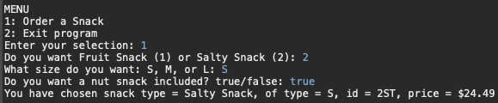
Test 6 | 1: Order a Snack  2: Exit program  Enter your selection: 1  Do you want a Fruit Snack (1) or Salty Snack(2): 2  What size do you want: S, M, or L: M  Do you want citrus fruit included? true/false: false | You have chosen snack type = Salty Snack, of type = M, id = 1SF, price = $29.99 | You have chosen snack type = Salty Snack, of type = M, id = 1SF, price = $29.99 | Pass
