Test # | Input Values |  | Expected Output | Actual Output |  | Pass or Fail
Test 1 | Run GUITest.java |  | “Welcome to Converter” window pops up with three buttons. | “Welcome to Converter” window pops up with three buttons. |  | Pass
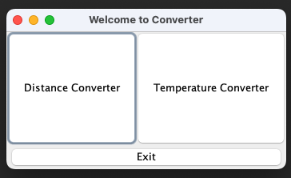

Test 2 |  | Click “Distance Converter” button. | Input dialog pops up where user can type value and click “OK” |  | Input dialog pops up where user can type value and click “OK” | Pass
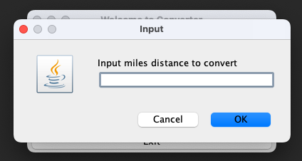

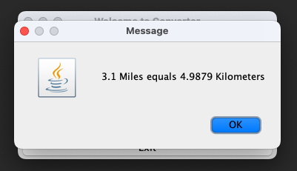

Test 3 | Click “Temperature Converter” button. | Input dialog pops up where user can type value and click “OK” | Input dialog pops up where user can type value and click “OK” | Pass
