3 Steps to get ready.
When it comes to extreme weather events, it’s not a matter of ‘if’ but ‘when’. Storms, floods, cyclones and bushfires can hit at any time and anywhere.
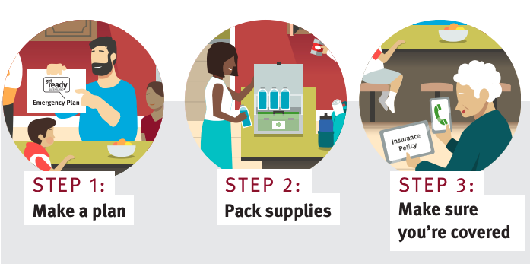

Step 1: Make a plan
The first step in being prepared is to have a Client emergency and evacuation plan.Complete the following emergency and evacuation plan so that everyone in the Client’s support network knows exactly what to do if the worst happens.

The plan includes measures for each of the following:
- preparing for, and responding to, the emergency or disaster;
- making changes to participant supports;
- adapting, and rapidly responding, to changes to participant supports and to other interruptions;
- communicating changes to participant support to workers, participants and their support networks.

Client’s family members/support network contact details
Name |  | Name
Mobile |  | Mobile
Email |  | Email
Name |  | Name
Mobile |  | Mobile
Email |  | Email

Client’s that require special assistance
Assistance required
Aids required (if applicable)

Pets
Name |  | Name
Type |  | Type
Breed |  | Breed
Vet Name |  | Vet Name
Vet Number |  | Vet Number
Vet Email |  | Vet Email
Medications/dosage |  | Medications/dosage

Vehicle/s make and registration
Vehicle make |  | Vehicle make
Registration |  | Registration

Emergency contacts (local) |  | Emergency Contacts (out of town)
Name |  | Name
Phone |  | Phone
Email |  | Email

Local council contact details
Name |  | Phone
Email

Utility companies contact details
Type |  | Type
Provider |  | Provider
Phone |  | Phone
Email |  | Email
Type |  | Type
Provider |  | Provider
Phone |  | Phone
Email |  | Email

GP/RN/Health Practitioners contact details
Name |  | Phone
Email

Client’s Insurance company
Type
Name
Phone
Email
Website

Client household safe meeting point
Address
Description

Electricity supply at Client home
Location
How to turn off

Gas supply Client home
Location
How to turn off

Water supply Client home
Location
How to turn off

Emergency and evacuation kit location
Location

Medications Schedule
Medication name and strength | When does the Client take this? | How much do they take each time? | Last updated

Checklist if required to evacuate the Client Home
⃞ | Has official advice been given to evacuate? | ⃞ | Is there an evacuation kit?
⃞ | Do we know where to evacuate to? | ⃞ | Final kit check: Has all essential medications for the Client been packed?
⃞ | Do we know the preferred route for evacuation? | ⃞ | Has all important documentation been packed or accessible via cloud storage?
⃞ | Is there a vehicle that has enough fuel to get to the evacuation point? Is it full? | ⃞ | Final kit check: Has enough water supplies been packed?
⃞ | Has the power, gas and water mains been turned off at the house? | ⃞ | Has the Client’s home house been locked and secured?
⃞ | Are any pets safe and secure?

Step 2: Pack Supplies
The second step is to pack emergency and evacuation kits. If, as a result of a natural disaster, the Worker or the client are unable to leave the Client’s home for an extended period, the emergency kit should be equipped for up to three days of isolation.

  - Essential Emergency Kit
    - An Emergency kit should be kept in a sturdy waterproof storage container and stored in a safe place in your home. Make sure it is easily accessible (except young children – make it childproof if necessary). Make a note of the emergency kit’s location on the Client’s household emergency and evacuation plan.

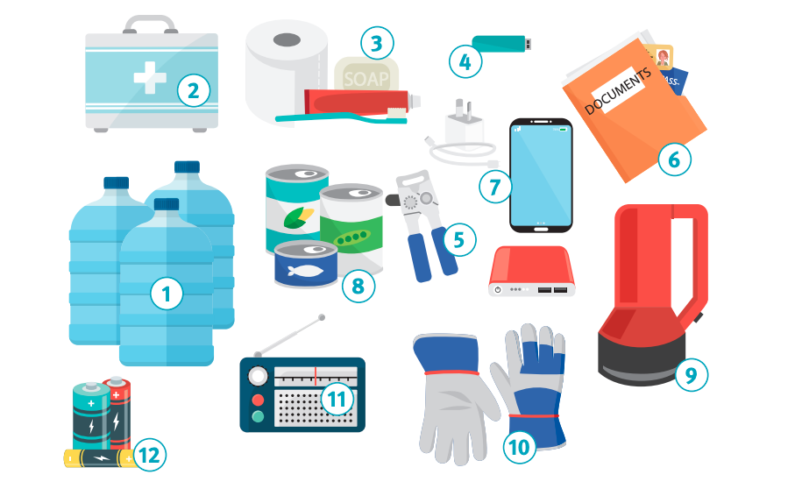
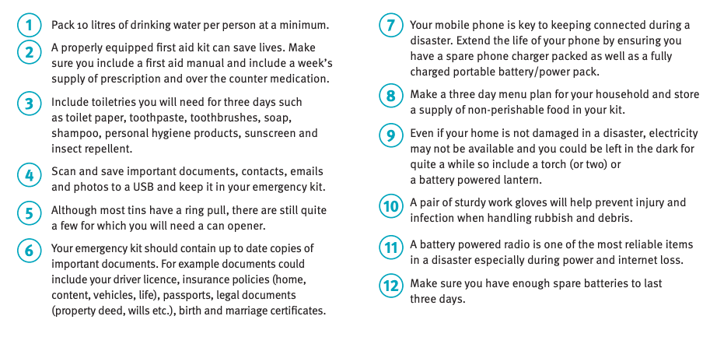
  - Comprehensive emergency kit
    - For those that would like to take further steps to cover a wider range of scenarios for a longer period, additional supplies to the emergency kit can be added to ensure everything is extensively covered.

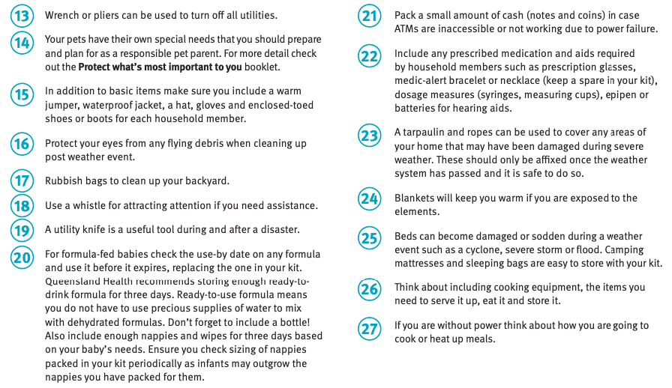

  - Evacuation kit
    - There may be times during an emergency where it becomes unsafe for the Client to stay at home and may need to evacuate. In addition to the emergency kit, an evacuation kit needs to be prepared. The evacuation kit is designed to contain only essential items that can easily and quickly ‘grab and go’.
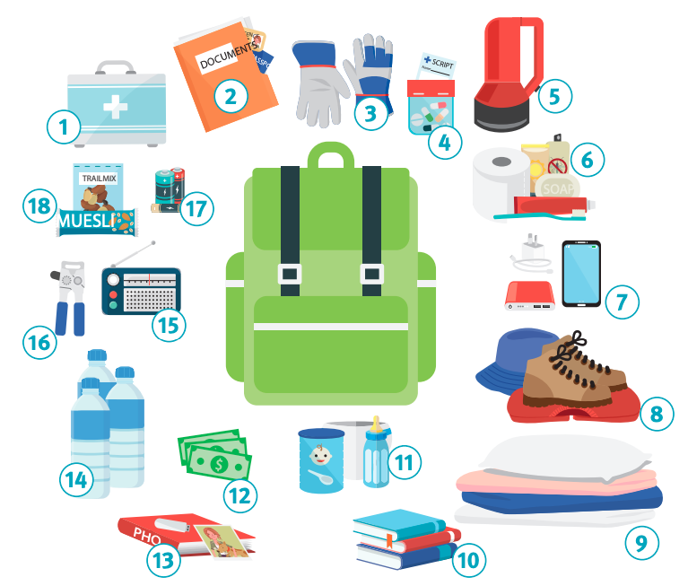
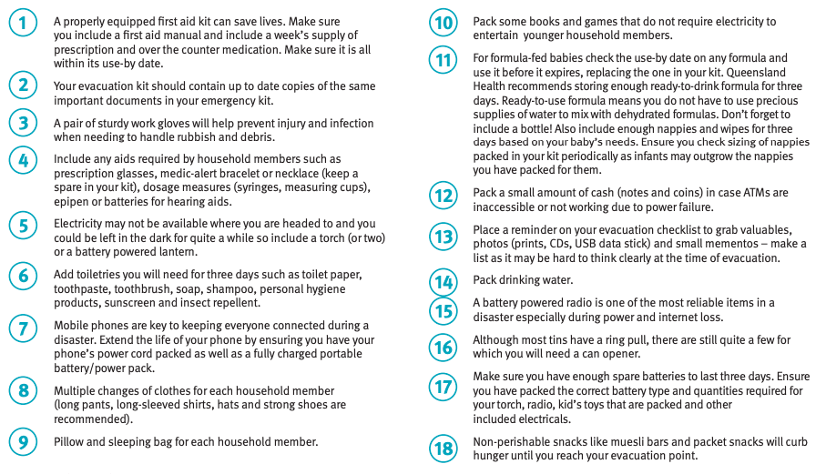

Step 3: Make sure the Client’s covered
The third step is to make sure the Client’s home and contents insurance cover is up to date. Client’s who are both renters and homeowners should be covered for disasters and should be familiar with their coverage details.

  - Workers should check with their Client to see what their policy covers in the event of an emergency.

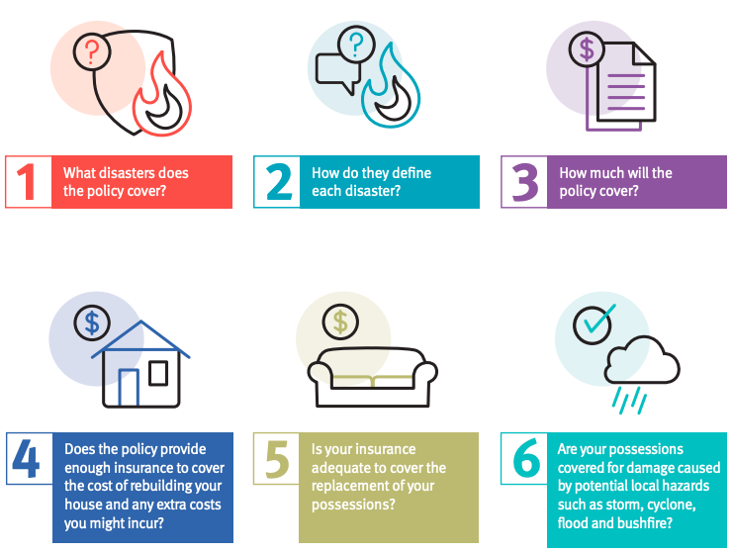

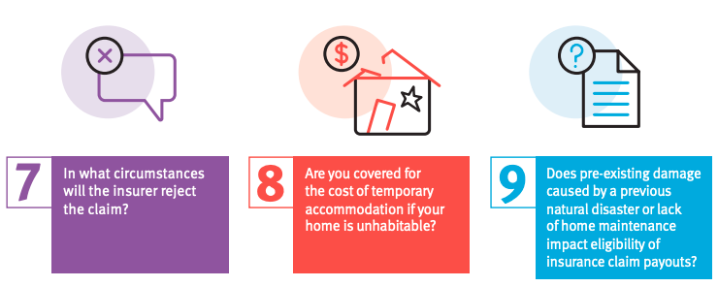

Fire Emergency
    - you and your support network should do what is reasonably practicable to ensure that fire equipment is installed in each residence or building where it works which is suitable for risks specific to the relevant residence or building.

    - Fire equipment will be placed away from heat sources and regularly maintained.

Floods
In preparation for a flood, you and your support network should:

    - obtain a copy of the local council's flood plan, which should show the location of problem areas, evacuation routes and relief centres.
    - work out what the safest route to leave each of the residences and buildings where it works would be, and if the route could be cut off by floodwaters.
    - ensure arrangements are made to obtain sandbags to protect the residences and buildings where it works.
    - know the kind of flooding the general area is prone to.
    - If a flood is likely, tune in to the local ABC Radio station and keep listening for advice and warnings.
    - identify the safest route to the nearest relief centre and leave well before roads are closed by water.
    - get ready to move vehicles, outdoor equipment, garbage, chemicals and poisons to higher locations.
    - work out which indoor items you want to put in a higher spot.
    - ensure you have prepared an Emergency Kit,
    - raise furniture, clothing and other valuables onto beds, tables and into roof spaces.
    - empty freezers and refrigerators, leaving doors open.
    - turn off power, water and gas.
    - lock the residence or building and take the safest evacuation route out of the area.
    - not drive through floodwater.

Storms
In preparation for a storm, you and your support network should:

    - Check fences, roofs and gutters; make any repairs that are needed.
    - Trim branches near power lines.
    - Clean gutters and downpipes regularly; also secure loose roof tiles/sheets.
    - Move cars undercover and away from trees.
    - Put away or secure loose items like outdoor furniture and pot plants.
    - Disconnect all electrical items.
    - stay tuned to your local ABC Radio station, listen online or via the ABC listen app, and/or check ABC Emergency Twitter and Facebook for updates, warnings and advice.
    - While conditions are severe, stay indoors and keep away from windows.
    - Check on and assist Clients to see if they are safe and prepared.
    - Assist Clients to evacuate.
    - Don't drive into flood water.
    - Stay clear of creeks, drains and other waterways as there is a risk of flooding, including flash floods.
    - Be careful of fallen trees, powerlines and damaged buildings.

COVID-19

General
    - You and your support network should comply with the state government’s advice.
    - You should follow these simple steps to help stop the spread of germs:
      - You should wash your hands often with soap and running water or use an alcohol-based hand rub.
      - Make sure there are enough tissues and bins available.
      - Keep a distance of at least 1.5 metres from others where possible.
      - Clean often during the day, paying particular attention to frequently touched surfaces in common areas.
      - Limit visitors as much as possible.
      - Anyone who has COVID-19 symptoms should be isolated into a single room straight away. Arrange a medical review as soon as possible.

Personal Protective Equipment
Where possible you should wear a surgical mask.

General

Relevant Legislation, Regulations, Rules and Guidelines
Legislation, Rules, Guidelines and Policies apply to this Policy and Related Documentation as set out in the Legislation Register.

Inconsistency
If and to the extent that the terms of this Policy are or would be inconsistent with the requirements of any applicable law, this Policy is deemed to be amended but only to the extent required to comply with the applicable law.

