The Mealtime Management Plan – assists allied health professionals (AHP) and support workers to record the client’s mealtime management requirements and preferences. Where required, the GP or AHP should add or subtract sections to suit the person’s support needs.
Name: |  |  | Insert Image:
Date of Birth: | ____ / ____ /____
Address
Phone Number:
Worker Name:
☐ This is a new plan | Date: ____ / ____ /____ | ☐ This is a review | Date: ____ / ____ /____

Mealtime Management Plan prepared by
Name |  | Profession
Contact Details
Name |  | Profession
Contact Details
Name |  | Profession
Contact Details

Summary of important issues

Allergies
Precautions | In CAPITAL LETTERS, list any food allergies here
Response Strategies
PRN Medication | All PRN medication for allergy must be administered as per GP or specialist recommendations

Medications
Refer to the person’s medication chart or Webster-pak® signing sheet for medication preparation and timing.
Special support required to receive medication

Description: | Eating | Drinking
Consistency | 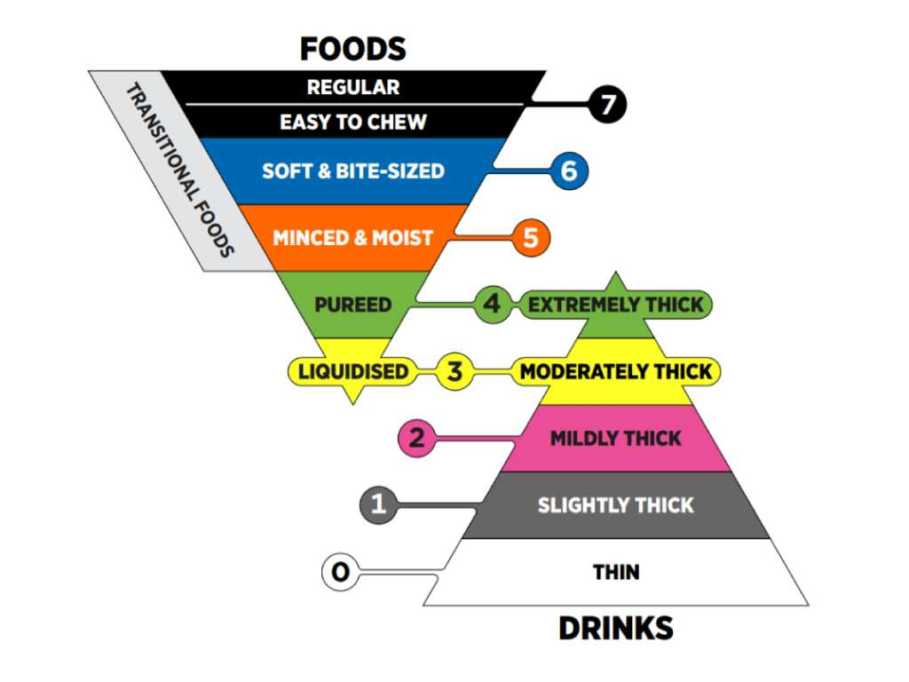

Description | Eating | Drinking
Alertness | Comments regarding level of alertness at mealtimes
Amounts | Refer to dietetic recommendations | Refer to dietetic recommendations
Special diet | Examples: Weight reduction, Weight maintenance, Phenylketonuria
Utensils / equipment (insert photos if appropriate)

Description | Eating | Drinking
Positioning (insert photos if appropriate) | During meals:
 | After meals:
Assistance required (insert photos if appropriate)
Likes
Dislikes
Religious and cultural preferences
Oral care

Communication
This is how the person communicates | Feeling full:
 | Would like more to eat or drink:
 | Needing help:
 | Likes something:
 | Dislikes something:
 | Other:

Behaviour
This is how the person usually behaves | Before meals:
 | During meals:
 | After meals:
 | Other:
Supervision required during mealtimes | While eating and drinking:
 | To prevent grabbing food and fluids:
 | To prevent sharing food with others:

Preferences
Time taken to eat meals | Breakfast:
 | Lunch:
 | Dinner:
 | Snacks:
 | Drinks:
 | Other:
Environment / atmosphere | Noise level:
 | Table setting:
 | Position at the table:
 | Companions:
 | Lighting:
 | Furniture layout:
 | Other:
Participation | Menu planning:
 | Meal preparation:
Eating out | Best atmosphere:
 | Favourite meal:
 | Favourite drink:
 | Favourite venues:
 | Support items to take:

Photograph
This is how it looks to support the person to eat their meals in the best way possible.
Insert a photo(s) of the person to document:
- safe and appropriate position for eating and drinking
- equipment required, use of clothing protectors, utensils and aids.
Date photo taken: |  | Photo taken by:

Review of Plan
☐ Set Review | Date | Profession (AHP)
Signature
☐ As needed review This plan will be reviewed following a problem being identified, re-completion of the Nutrition and Swallowing Risk Checklist, and advice from the person’s GP

Note: if the person appears to have difficulty with any support prescribed, immediately contact the health professional responsible for the development of the plan for advice.

Plan endorsement
The person (if they are able): |  | Date:
Family/Guardian or person responsible: |  | Date:
Profession:
Name: | Signature:
Profession:
Name: | Signature:
Profession: |  | Date:
Name: | Signature:
Worker (position): | Name:
Signature: | Date:

A copy of the Mealtime Management Plan must be provided to any person(s) or organisation(s) who provides support to the person during mealtimes.

Support Provider | Date Provided | Provided to (name)
Day Placement
School / education centre
Family
Friends
Centre based respite
holiday provider
Other - list below

Consent for sharing this information should be obtained from the person or person responsible

Support worker endorsement

☐ I have read and understood the Mealtime Management Plan and am able to implement it.
☐ I have received practical training in mealtime management as per requirements in this plan.
☐ I understand my duty of care regarding positioning, support and monitoring of risk for this person.
Name: |  | Signature: |  | Date:
Name: |  | Signature: |  | Date:
Name: |  | Signature: |  | Date:
Name: |  | Signature: |  | Date:
Name: |  | Signature: |  | Date:
Name: |  | Signature: |  | Date:
Name: |  | Signature: |  | Date:
Name: |  | Signature: |  | Date:
Name: |  | Signature: |  | Date:
Name: |  | Signature: |  | Date:
Name: |  | Signature: |  | Date:
Name: |  | Signature: |  | Date:
Name: |  | Signature: |  | Date:
Name: |  | Signature: |  | Date:
Name: |  | Signature: |  | Date:
Name: |  | Signature: |  | Date:
Name: |  | Signature: |  | Date:
Name: |  | Signature: |  | Date:
Name: |  | Signature: |  | Date:
Name: |  | Signature: |  | Date:
Name: |  | Signature: |  | Date:
Name: |  | Signature: |  | Date:
Name: |  | Signature: |  | Date:
Name: |  | Signature: |  | Date:

A new page must be completed anytime this person’s Mealtime Management Plan changes.

